Budget Rent A Car 
of British Columbia

Global Information System

Contracts Part 1 Business Design

Version 2.00

Note: The information contained in this document is confidential and may not be disclosed to any parties outside of Budget Rent a Car of British Columbia without written consent by one of its officers.
Copyright (C) 2000 Budget Rent a Car of British Columbia
Table of Contents
1. Functional Area Business Design 1
1.1. Contracts 1
1.1.1. Process Description 1
1.1.1.1. The Contract Life Cycle 1
1.1.1.2. The Use of contract screens during the Contract Life Cycle 2
1.1.1.3. Outstanding Issues and Questions for Business Design Phase 3
1.1.2. Screens 4
1.1.2.1. Contract Open/Check Out 4
1.1.2.1.1. Renter Tab 23
1.1.2.1.2. Rate Tab 33
1.1.2.1.3. Payment Tab 45
1.1.2.1.3. Payment Tab 45
1.1.2.1.4. Comments Tab 58
1.1.2.2. Changes During Rental Screen 61
1.1.2.2.1. Extension Tab 69
1.1.2.2.2. Replace Vehicle Tab 75
1.1.2.2.3. Rate and Coverage Tab 87
1.1.2.2.4. Renter Tab 95
1.1.2.2.5. Comments Tab 99
1.1.2.2.6. Payment Tab 102
1.1.2.3. Contract Check In Screen 114
1.1.2.3.1. Check In Vehicle Tab 124
1.1.2.3.2. Payment Tab 130
1.1.2.3.2. Payment Tab 130
1.1.2.3.3. Rate and Coverage Tab 143
1.1.2.3.4. Comments Tab 150
1.1.2.3.5. Renter Tab 153
1.1.2.4. Walk Up Information Screen 158
1.1.2.5. Additional Driver Screen 165
1.1.2.6. Truck Rental Availability Screen 173
1.1.2.7. Location Vehicle Availability screen 175
1.1.2.8. Foreign Vehicle Availability Screen 179
1.1.2.9. Make Vehicle Available Screen 181
1.1.2.10. Rate Details Screen 187
1.1.2.11. Other Extras Screens 192
1.1.2.11.1. Other Extras Screen (Contract Open) 192
1.1.2.11.2. Other Extras (After Open & Check Out) 199
1.1.2.11.3. Other Extra History Sub-Screen 205
1.1.2.12. Manual Credit Card Transaction Screen 207
1.1.2.13. Direct Bill Search Screen 210
1.1.2.14. Rental Charge Billing Screen 212
1.1.2.14.1. Alternate Payment Details Sub-Screen (Loss of Use) 221
1.1.2.14.2. Alternate Payment Details Sub-Screen (Direct Bill) 224
1.1.2.14.3. Alternate Payment Details Sub-Screen (Voucher) 227
1.1.2.14.4. Split Rental Charge Sub-Screen 231
1.1.2.15. Deposit/Refund Record Screen 235
1.1.2.16. Discount / Reimbursement Screen 245
1.1.2.17. Extension History Screen 249
1.1.2.18. Vehicle Replacement History Screen 251
1.1.2.19. Coverage History 253
1.1.2.20. Currency Calculator Screen 255
1.1.3. Functions 259
1.1.3.1. Calculate Pre-Authorization Amounts & Cash Rental Deposits 260
1.1.3.1. Calculate Pre-Authorization Amounts & Cash Rental Deposits 260
1.1.3.2. Calculate Rental Charges 262
1.1.3.3. Accounting Interface Entries for Contracts 279
1.1.3.3.1. Accounting Interface Entries for Contract Open/Check Out 280
1.1.3.3.2. Accounting Interface Entries for Changes During Rental 293
1.1.3.3.3. Accounting Interface Entries for Contract Check In/Foreign Check In 294
1.1.3.3.4. Accounting Interface Entries for Contract Adjustments 314
1.1.3.3.5. Accounting Interface Entries for Interim Billing 315
1.1.3.3.6. Accounting Interface Entries for Separate Sales Accessory Sales and Refunds 317
1.1.4. Test Scenario List 318
1.1.5. Controls & Audit Trail 318
1.1.6. Security Requirements 318
1.1.7. Business Transaction Volumes 318
1.1.8. Tables without Maintenance Screens 319
1.1.9. Lookup Table Entries 319
1.1.10. Data Model 321
1.1.10.1. Data Model –Billing, Charges & Payment 321
1.1.10.2. Data Model – Everything Except Billing, Charges & Payment 322
2. Revision History 323
2.1. Version 2.00 323

Functional Area Business Design

Contracts

Process Description

The Contract Life Cycle

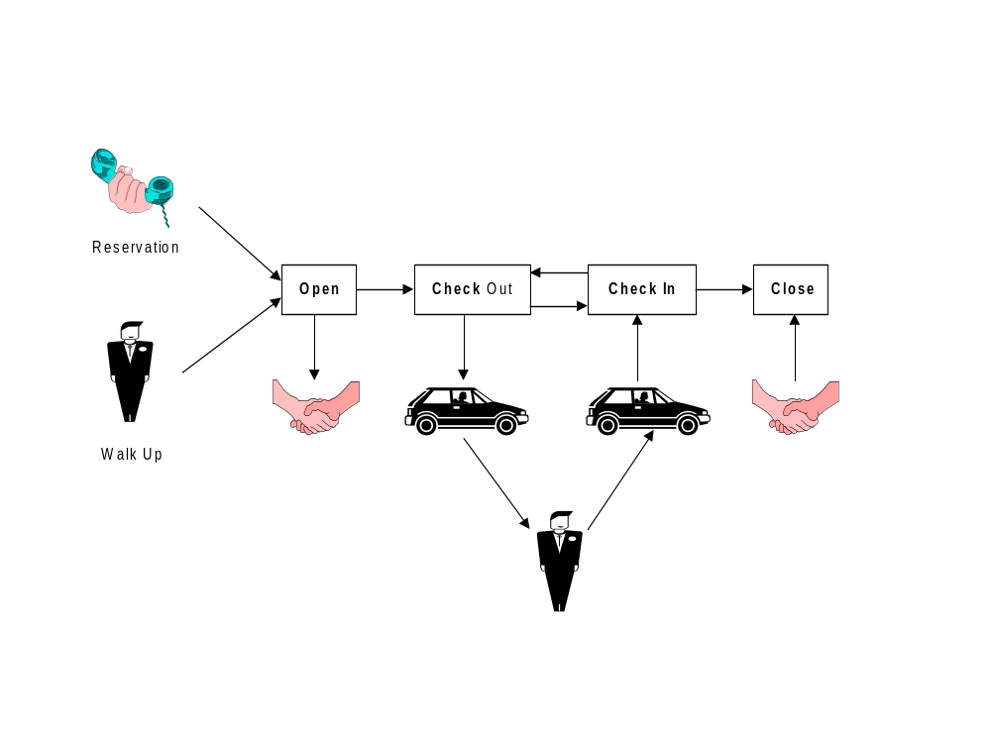

The Use of contract screens during the Contract Life Cycle

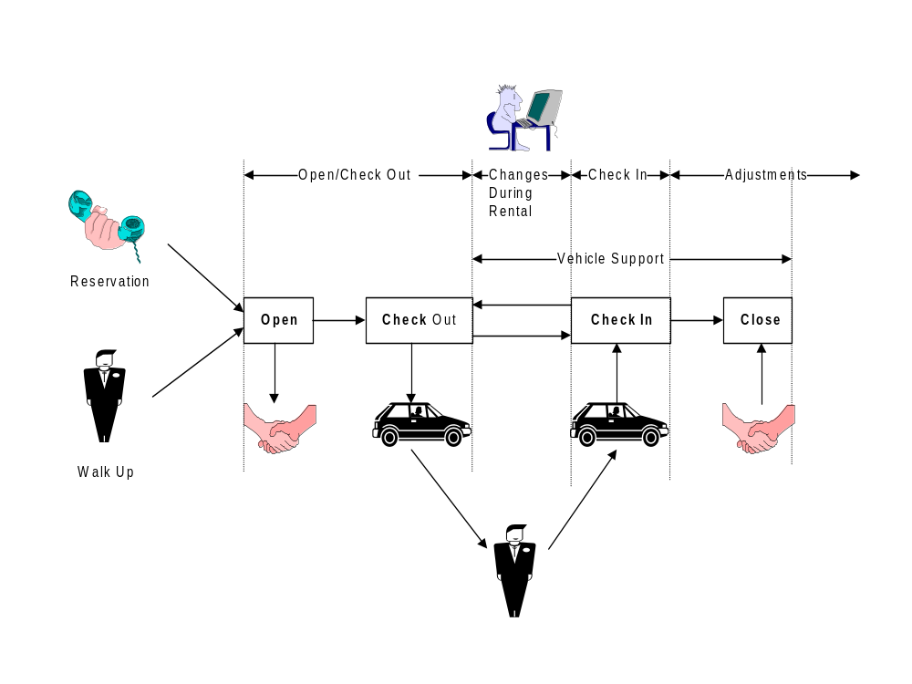

Outstanding Issues and Questions for Business Design Phase
- PST Rate
PST rate can vary by vehicle model, which means that different models within the same vehicle class could have different PST rates.
  - What PST rate should be used if a vehicle is switched part way through a rental and the two models have different PST rates?
The PST rate for the most recent vehicle on the contract will be used for the entire contract.
  - How do we calculate the pre-authorization amount for a contract before a vehicle has been selected for check out. Until a vehicle has been chosen, we won’t know what the model is and won’t know for sure what PST rate will be used. Should we use the highest PST rate for any model within that vehicle class?
The contract charges and the pre-authorization amount will be calculated using the base PST rate unless a vehicle where the model has a different rate has already been assigned to the contract.

Screens

Contract Open/Check Out
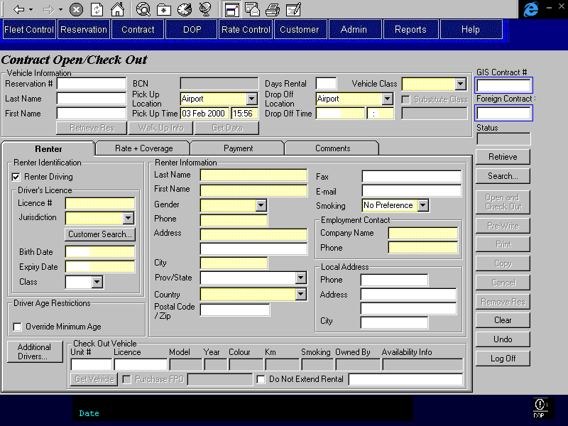
Purpose
The Contract Open/Check Out screen is used for the opening of contracts and check out for vehicle rentals. Once a contract is opened and a vehicle is checked out, changes to the contract can only be made through the Changes During Rental screen.
The screen is organized into five areas: the base screen and four tabs. The base screen allows the CSR to populate the contract from an existing reservation and to view and/or enter the customer name, pick up and drop off locations and times, the vehicle class requested, and the contract number and status. The tabs contain the remaining required contract information and are categorized as follows:
Renter: Where the renter and additional driver information is entered and where a vehicle to be checked out on the contract is selected. For walk up truck contracts, the CSR can also access a truck rental availability screen which shows whether the requested truck class can be rented or not.
Rate: Where the information that determines the amount to be charged for the rental is entered and displayed. The base rate used for the contract can be viewed and/or entered. Coverages may be added or applied to the base rate, and insurance transfer details may be entered for rates where insurance transfer is allowed. Frequent Flyer information can also be recorded. Buttons are available to:
- View the details for the selected rate.
- Select a walk up rate from a list of available rates for the location and date (and the customers BCD number, if any).
- Sell other optional extras and sales accessories and apply discounts.
Payment: Where the party responsible for the rental is identified and payment and authorization information is entered. Buttons are available to:
- Identify alternate payment organizations and assign rental charges to them.
- Record details of cash deposits, credit card deposits and refunds.
Comments: Where comments may be selected and entered by the CSR and any comments from the reservation may be viewed. There are two types of comments, those which will show on the printed contract and those which will not.
Retrieve, Search, Pre-Write, Open & Check Out, Check Out, Print, Copy, Cancel, Remove Res, Clear and Undo buttons are available on the far right.
If a BCN is populated from the reservation, the fields associated with the BCN will be locked. If any of these fields require updating, the BCN must be removed. Removing the BCN will leave the information for the BCN in place but will allow it to be updated.
Screen Hierarchy

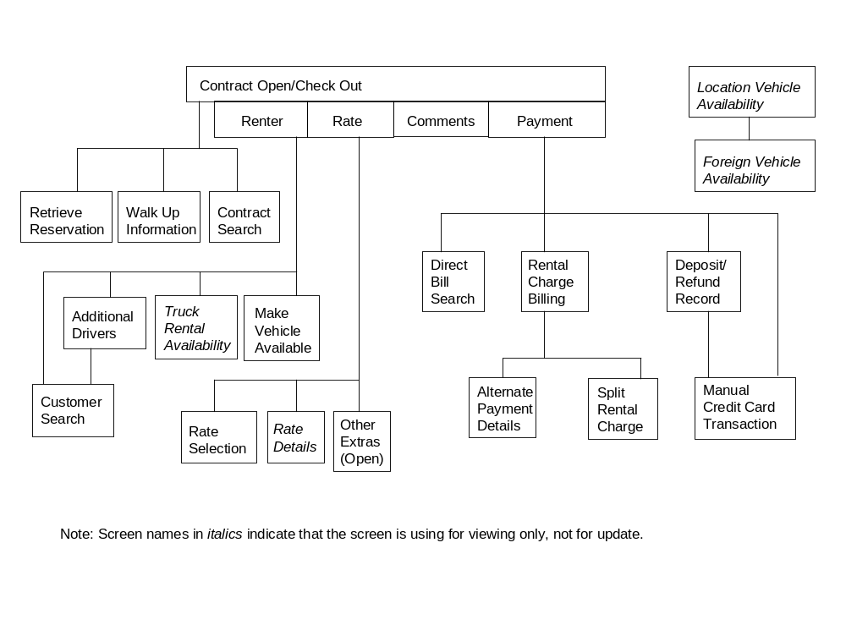
Navigation
N/A
Functions
Retrieve Searches for a reservation using the confirmation number or the customer’s first
Reservation: and last name. If one is found, the contract will be populated from the reservation information. If more than one is found, the reservation search results screen will be displayed and the contract will be populated from the reservation selected on that screen (if any). A reservation can only be used if the reservation status is ‘active’ . For more information on populating a contract from a reservation, see the notes at the end of this section.
Walk Up Info: Opens the Walk Up Information screen so that the CSR can populate the contract with information for a body shop or hotel referral, a BCN customer or a corporate customer.
Retrieve: Retrieves the contract for the contract number entered and uses it to populate the Contract Open/Check Out screen. If no contract number is entered and a contract number has been placed in the GIS Selected Contract registry by the Contract Search screen, the number from the registry is retrieved instead.
Enabled when the screen is first opened or when the screen has been cleared using Clear or Cancel. Disabled when the screen is populated with contract information using the Retrieve Reservation, Walk Up Info, Retrieve or Search buttons.
When this screen is first opened, a Retrieve is done automatically if a contract number has been placed in the GIS Selected Contract registry by the Contract Search screen.
The contract cannot be retrieved if it has any primary or alternate billing parties that are no longer active on Platinum.
Search: Opens the Contract Search screen. When the CSR selects a contract from the contract search screen, the Contract Open/Check Out screen will be populated with the contract information.
Enabled when the Contract Open/Check Out screen is first opened and when the screen has been cleared using Clear or Cancel. Disabled when the Contract Open/Check Out screen is populated with contract information using the Retrieve Reservation, Walk Up Info, Retrieve or Search buttons.
Pre-Write: Checks that all required information has been entered and then generates a contract number, saves the contract, and prints the contract. Returns the screen to the Renter tab and does not clear the screen.
The following edits will be performed before the contract can be saved.
- If the contract is a walk up for truck, there must be a truck available for the location, vehicle class and rental period. This can be overridden by a location manager or supervisor (as in reservations).
- All driver licence numbers entered will be checked against the Customer Profile to ensure that the ‘Do Not Rent’ flag is not on.
- All driver licence expiry dates entered must be greater than or equal to the drop off date. The renter driver licence will not be checked if the expiry date is null.
- If any driver licence expiry dates are on the drop off date, the Do Not Extend Rental flag on the Availability tab must be checked.
- All drivers where the birth date has been entered must meet the minimum age requirement for the vehicle class being rented. If the Override Minimum Age Override flag is turned on, the minimum age overrides for the Minimum Age Override BCD organization will be used. Otherwise, there may be an override on the Organization customer profile if the contract is being opened for an organization.
This override will apply to the renter, and to spousal and other company additional drivers, but it will not apply to other additional drivers.
This override will still apply if the corporate rate is being used for personal use.
- If the renter or any other additional drivers are below the LDW age requirement then one of the following must be true:
- the rate being used includes LDW
- an optional extra with type LDW is selected
- LDW has been declined and the LDW Declined Reason on the Rate tab, Coverages sub-tab is not ‘No Coverage’
Note: spousal and other company additional drivers are not included in the LDW age check
- If a reservation has been retrieved into the contract, it will be checked to ensure that it has not changed since it was retrieved into the contract (the last updated on field in the reservation record will be checked to ensure that it is the same value as when the reservation was retrieved into the contract). If the reservation has changed then the user will be advised in an error message, the transaction will not be completed and the reservation will be removed from the contract. See the Remove Reservation function for details of how a reservation is removed from a contract.
When the contract is saved.
- If Membership Discounts Allowed is No for the rate selected or if the Apply check box is not checked, no membership discount information will be saved with the contract.
- If Frequent Flyer Plans Honoured is No for the rate selected, no frequent flyer plan information will be saved with the contract.
- If Insurance Transfer Allowed is No for the rate selected, no insurance transfer information will be saved with the contract.
- For each direct bill organization (Contract Billing Party with Billing Method ‘Direct Bill’, ‘Loss of Use’ or ‘Voucher’) that is being billed for all or part of the rental charges:
- If the Contract Billing Party is authorizing the rental (Billing Type ‘Primary’), the Amount Removed from Available Credit will be set to the authorization amount required (displayed on the Payment tab)
- If the Contract Billing Party is an alternate payment organization (Billing Type ‘Alternate’), the Amount Removed from Available Credit will be set to the total amount being billed to the organization (displayed on the Rental Charge Billing screen)
- Add the Amount Removed from Available Credit to the expected open contract charges for the organization (AR GIS Customer Info, Expected Open Contract Charges).
- For a truck rental, update the truck rental availability for the pick up location as follows:
- If there was a reservation, on open increase the truck availability by 1 for the period of the reservation.
- Decrease the current truck class truck availability by 1 for the period of the contract.
- Increase the previous truck class truck availability by 1 and decrease the new truck class availability by 1 if a change in truck class has been made since the last save.
- Generate Accounting Interface entries for any cash deposits received or refunds issued. For details, see the section on Account Interface Entries for Contract Open/Check Out.
- If the contract has been opened based on a reservation the reservation status will be changed to “opened”.
Check Out: Creates a Vehicle On Contract record for the check out unit # and changes the vehicle condition status for that vehicle to “On Rent”. Does not clear the screen.
Open and Combination of the functions performed by the Pre-Write , Save and
Check Out: Check Out buttons.
Print: Saves and prints the contract. Disabled until the contract is opened.
Copy: Copies the contract just opened into a new contract which can be altered and then opened. The copied contract will be subject to all the same edits as the original contract and will be flagged as a copied contract. For more information on copy contract see the notes at the end of this section.
Cancel: For contracts that have not yet been opened and where no credit card authorization or deposit or cash rental deposit has been processed:
- Prompts CSR to select a reason as to why contract was not opened
- Ends process and does not save contract
- Saves cancellation reason, date, and user ID in Turndown Contract
- Clears the Contract Open/Check Out screen.
- If the contract was opened from a reservation, the reservation status remains Active.
For contracts that have been opened, and for contracts that have not yet been opened but where a credit card authorization or deposit or cash rental deposit has been processed:
- If a cash rental deposit has been collected:
- The CSR must record a cash refund on the Deposit/Refund Record sub-tab. The type will be either ‘Direct Refund’ (the payment has been returned to the customer or ‘Mail Refund’. If the contract has not yet been opened and the deposit is from the reservation then the CSR may press the remove reservation button instead of refunding the deposit.
- Prints the contract so that the customer can sign for a direct refund and to give the customer a record of a mail refund owed to them.
- If a credit card deposit has been collected:
- The CSR must record a credit card refund on the Deposit/Refund Record sub-tab.
- Prints the contract so that the customer can sign for the deposit and the refund.
- If a credit card authorization has been processed:
- The CSR will phone the credit card company and have the authorization cancelled. This will be manual process and no information will be recorded on GIS.
- Saves the contract with a status of ‘Cancelled’. Note that the CSR will have to provide all the information normally required to open a contract (pick up and drop off location and time, vehicle class, renter name and identification, the rate to be used, etc.)
- Clears the Contract Open/Check Out screen.
Remove Res: Removes the retrieved reservation from the contract. The following will be removed when the reservation is removed:
- reservation confirmation number,
- reservation rate
- BCD organization
- referral organization and referral employee
- IATA number
- reservation deposit
- reservaton comments.
This function is only available for reservations that have been retrieved into new contracts (not yet opened). This means that contracts that have been prewritten or opened/checked out cannot have their reservations removed.
Clear: Disabled once a credit card authorization or a credit card or cash deposit has been processed.
Undo: Disabled once a credit card authorization or a credit card or cash deposit has been processed.
Controls
Req*: Y – always mandatory
N – always optional
S – sometime optional (see Comments for details)
D – display only
Field | Source | Req* | Validation | Comments
Above Tabs
Reservation # | Contract, Confirmation Number | N
Last Name | Contract, Last Name | N |  | The same value as is entered in the Renter tab.
First Name | Contract, First Name | N |  | The same value as is entered in the Renter tab.
BCN | Contract, Customer Program Number | N | Value controlled by Customer table. | Set from Reservation if present, locked and no default otherwise.  If this is cleared, all the fields that are locked because a BCN is present will be unlocked and the BCN will be locked.
Pick Up Location | Contract, Pick Up Location ID | Y | Value controlled by Pick Up/Drop Off Location table.  If the user is at a rental location, selection will be limited to the current location and to non-GIS rental locations. Otherwise selection will be limited to all rental locations. | Location name displayed.  Set from Reservation if present, set from current location otherwise.
Pick Up Time | Contract, Pick Up On | Y | Date & Time  Pick up time must be within the business hours of the selected pick up location for the day of the week of the pick up date. | Defaults to current date & time. If there is more than a pre-set difference from the Reservation pick up date/time then display a warning message showing the reservation pick up date/time. The difference will be stored in the system value table.
Days Rental |  | Y | Difference between Pick Up Time and Drop Off Time.  Numeric for cars. Numeric or AM, PM, OV, A/P, P/O, O/A for trucks. | Defaults from Reservation if present.  Either Drop Off Time or Days Rental is entered. One will be automatically calculated from the other.
Drop Off Location | Contract, Drop Off Location ID | Y | Value controlled by Pick Up/Drop Off Location table. | Location name is displayed.  Defaults from Reservation if present, to Pick Up Location otherwise.
Drop Off Time | Contract, Drop Off On | Y | Date & Time | Either Drop Off Time or Days Rental is entered. One can be automatically calculated from the other.
Vehicle Class | Contract, Vehicle Class Code | Y | Value controlled by Location Vehicle Class table (for the specified pick up location). | Vehicle Class Name is displayed.  Defaults from Reservation if present, no default otherwise.
Substitute Class | Contract, Substitute Vehicle Class | N |  | Disabled unless the contract is opened from a reservation and the vehicle class is changed.  If BCN is populated and the vehicle class is changed from the reserved class then substitute class should be automatically checked  See technical notes below for details.
Rez Comments | Reservation, Special Comments and Reservation Comments, Standard Reservation Comment ID | D |  | If Reservation, Special Comments or Reservation Comments, Standard Reservation Comments exist for the retrieved reservation then display ‘Rez Comments’.
GIS Contract # | Contract, Contract Number | N | Not updateable after creation. | Unlocked when the screen is first opened or when the screen has been cleared using Clear or Cancel. Locked when the screen has been populated with contract information using the Retrieve or Search buttons.  Automatically populated upon saving contract.
Foreign Contract # | Contract, Foreign Contract Number | N | Not updateable after creation. | Unlocked when the screen is first opened or when the screen has been cleared using Clear or Cancel. Locked when the screen has been populated with contract information using the Retrieve or Search buttons.  See the Rentback Changes Business Design Document for more details.
Status | Contract, Status | D
Populating Contract Information from a Reservation
Screen Header
Set the information on the screen header from the reservation, including the BCN if there is one. If the reservation has a BCN, change the background colour of the BCN to red and lock the Vehicle Class.
Renter Tab
Set the information on the Renter tab from the reservation. If the reservation is linked to a customer profile, set the information on the Renter tab from the customer profile as well, except for the Driver Licence information.

If the reservation has a BCN, set the Driver Licence information from the customer profile as well. Disable the Additional Drivers and Customer Search buttons and lock all the fields on the Renter tab except for company information and local contact information.
Rate Tab
Set the Referring Organization ID, Referring Employee ID and IATA Number from the reservation (if present).

Set the rate information from the rate associated with the reservation.

If Insurance Transfer is available for the rate, make the Insurance Transfer information visible, otherwise, make it invisible.

Make the LDW information visible. If LDW is included with the rate, set LDW to Yes, set the LDW Type and Deductible from the rate and set the amounts to zero. If an optional extra with Type LDW was requested for the reservation, set LDW to Yes, populate the rest of the LDW information from the reservation.

If an optional extra with Type Buydown was requested for the reservation, set Deductible Buydown to Yes and populate the rest of the Deductible Buydown information from the reservation. Otherwise, if LDW is yes make the Deductible Buydown information invisible.

If PAI is included with the rate, set PAI to Yes, and set the amounts to zero. If an optional extra with Type PAI was requested for the reservation, set PAI to Yes, populate the rest of the PAI information from the reservation.

If PEC is included with the rate, set PEC to Yes, and set the amounts to zero. If an optional extra with Type PEC was requested for the reservation, set PEC to Yes, populate the rest of the PEC information from the reservation.

If Cargo Insurance is included with the rate, set Cargo Insurance to Yes, and set the amounts to zero. If an optional extra with Type Cargo Insurance was requested for the reservation, set Cargo Insurance to Yes, populate the rest of the Cargo Insurance information from the reservation.

If the reservation is linked to a customer profile, populate the frequent flyer information from the customer profile.

If the reservation has a BCN, lock all fields on this tab.
Other Extras Screen
Populate the member discount from the reservation (leave the Apply check box off).

Populate the optional extras with any optional extras included in the rate (except for those with type LDW, Buydown, PAI, PEC and Cargo Insurance) and set the amounts to zero. The information will not be locked, as the customer may not want to take the optional extra and we need to record whether they physically took possession of it or not.

Populate the optional extras with any optional extras requested for the reservation (except for those with type LDW, Buydown, PAI, PEC and Cargo Insurance).

Populate the sales accessories with any sales accessories included in the rate and set the amounts to zero. The information will not be locked, as the customer may not want to take the sales accessory and we need to record whether they physically took possession of it or not.

Populate the sales accessories with any sales accessories requested for the reservation.

Populate the flex discount from the reservation.

If the reservation has a BCN, lock all the fields on this screen.
Comments Tab
Populate Reservation Comments from the reservation.
Payment Tab
Populate Rental Pre-Authorization method from the Payment Method in the reservation.
- If the Payment Method is ‘Credit Card’ set Rental Pre-Authorization Method to ‘Credit Card’.
- If the Payment Method is ‘Cash’ set Rental Pre-Authorization Method to ‘Cash’.
- If the Payment Method is ‘Direct Bill’ set Rental Pre-Authorization Method to ‘Direct Bill’.

If the pre-authorization method is Credit Card, populate the Credit Card Type from the reservation.

If the reservation has a BCN, populate all the credit card information from the customer profile.

Invoke the Calculate Rental Charges function, based on the information from the reservation. For details on the calculation process, see the Calculate Rental Charges function description in this document. Populate all the amount fields using the results of the Calculate Rental Charges function.

If the reservation has a BCN, lock all the fields on this tab.
Rental Charge Billing Screen
Populate all fields on this screen using the results of the Calculate Rental Charges function.

If the reservation has a BCN, lock all the fields on this screen.
Deposit Record Screen
If a reservation deposit was taken, populate the credit card or cash deposit information on the Deposit Record screen from the reservation.

If the reservation has a BCN, lock all the fields on this screen.
Copy Contract
The copy function copies the contract just opened into a new contract which can be altered and then opened. The copied contract will be subject to all the same edits as the original contract and will be flagged as a copied contract. Details of which fields are copied are described below.
Above the Tabs
Copy:
- Reservation #
- Pick Up Location
- Pick Up Time
- Days Rental
- Drop Off Location
- Drop Off Time
- Vehicle Class
If the original contract has a substituted vehicle class, copy the original contract’s substituted vehicle class (contract.vehicle class) as the copied contract’s contract.vehicle class, copy the original contract’s current vehicle class (vehicle on contract.substitute vehicle) as the copied contract’s current or substitute vehicle class and then check the substitute vehicle class checkbox
- Internal comments
Do Not Copy:
- Contract #
- Status
Disable:
- Disable ‘Retrieve Res’ and ‘Walk Up Info’ buttons
Renter Tab
Copy:
- All Renter Identification fields
- All Renter Information fields
- The Purchase FPO checkbox
- All Additional Driver information
Do Not Copy:
- Any Check Out Vehicle information (except Purchase FPO checkbox)
Rate Tab
Copy:
- The selected rate (rate and level). If the original contract rate was opened from a reservation, then the same rate should be applied (same rate assigned date).
- The BCD # if populated
- All Coverage information if Insurance Transfer information was not entered in the original contract. The coverage fields include LDW, Deductible Buydown, and Other Coverage
- Frequent Flyer information
- Other Extras, which includes Other Optional Extras (other than coverages) and Sales Accessories
- Membership Discount – check applied box if checked on original contract
- Flex Discount
Do Not Copy:
- Insurance Transfer Information
- Coverage Information if Insurance Transfer Information was entered in the original contract. In this case the CSR will be required to accept or decline all coverages as in a new contract.
Comments Tab
Copy:
- All Printed Comments
- All Internal Comments
- All Reservation Comments if the original contract was opened from a reservation.
Payment Tab
Copy:
- Rental Pre-Authorized By information
- The following Credit Card Authorization Information (if applicable):
      - Credit Card Type
      - Credit Card Number
      - Credit Card Last Name
      - Credit Card First Name
      - Credit Card Expiry
- The following Cash Rental Information (if applicable):
  - Payment Method
- The following for Direct Bill Authorization Information (if applicable):
  - Direct Bill Company
  - Authorized Renter (populated from direct bill company)
  - PO Required (populated from direct bill company)
  - PO Number
  - Issue Interim Bills Checkbox
- Rental Charge Billing Information (see Rental Charge Billing Section below)

Do Not Copy:

- Expected Rental Cost information (this is calculated)
- Taxi Reimbursement
- The following Credit Card Authorization Information (if applicable):
      - Preauthorization Amount Required (this is calculated)
      - Amount Already Preauthorized (this will be zero)
      - Pre-authorization amount (this is calculated)
      - Authorization # (no authorization has taken place for the copied contract)
- The following Cash Rental Information (if applicable):
      - Total Deposit Due (this is calculated)
      - Deposit Amount (this is calculated)
      - Currency
      - Deposit Amount (Cdn) (this is calculated)
      - Exchange
      - Approval/Debit Card #
- The following for Direct Bill Authorization Information (if applicable):
      - Preauthorization Amount Required (this is calculated)
      - Credit Available (this is calculated)
- Any Deposit/Refund Record entries (no deposits or refunds have taken place for the copied contract)

Rental Charge Billing
Copy:
- Copy all the Alternate Payment methods and Organizations (including their details) identified for the original contract. The total billed and credit available are individually calculated and therefore not copied.

Do Not Copy:
- Rental Charge Billing Items are not copied since they will be automatically generated from the copied contract information. The Bill To fields will default to the Renter as in any new contract. The CSR will have to reassign the charge to an alternate billing party if required.
- Manual Rental Charge billing functionality is not available at open and check out and therefore is not copied.
Technical Notes
Pick Up/Drop Off Times:
A check is required to ensure that a pick up time is not specified outside the specified location’s hours of service. For the specified date and location, the pick up time will be verified against the following table fields: Hours of Service, Day of Week; Hours of Service, Opens At; and Hours of Service, Closes At. If an invalid pick up time is selected an alert will be displayed and the user will be forced to correct the time before continuing. The check should occur as soon as it technically feasible to minimize disruption to the open contract process.
Optional Extras Included in the Rate:
If an optional extra is being saved with the contract because it is included with the rate, the ‘Included in Rate’ flag should be set to yes on the Contract Optional Extra record.
Substitute Vehicle Class:
When the substitute vehicle class is checked on, the original or upgraded vehicle class applied prior to the substitution will be used for the rate. The actual vehicle class checked out is used for all other values including LDW deductible, taxes, age restrictions, and truck availability. The original/upgrade and substitute vehicle classes are stored as follows:
Contract Table
- Vehicle Class Code - used to store the vehicle class that is applicable to the rate; this is the actual vehicle class rented out if the substitute vehicle class code is null
- Substitute Vehicle Class - used to store the vehicle class rented out in place of the original vehicle class requested; this is the actual vehicle class rented out if not null
Vehicle On Contract Table
- Actual Vehicle Class Code - used to store the actual vehicle class code of the unit being checked out (denormalized)
Example scenario of vehicle class changes in Contract Open/Check Out:
(Renter makes reservation for vehicle class A)
Scenario Description | Contract Table |  | Vehicle On Contract Table
 | Veh Class | Sub Veh Class | Actual Veh Class
Open/Check Out with requested vehicle class (A) from reservations. | A |  | A
Customer is substituted a class B vehicle. | A | B | B
Customer is substituted a class C vehicle. | A | C | C
Customer upgrades to a class C vehicle. | C |  | C
Customer upgrades a second time to a class D vehicle. | D |  | D
Customer is then substituted a class E vehicle | D | E | E

History of Changes for Contract Open and Check Out
All credit card authorizations, and credit card or cash payments and refunds will be stored and cannot be updated or deleted.
No other history of changes will be recorded between Contract Open and Check Out. This includes not keeping history of changes to pick up location or time, drop off location or time, renter information, additional driver information, selected rate, optional extras and coverages, comments, and payment information that does not include credit card authorization and credit card or cash payments or refunds.

Renter Tab
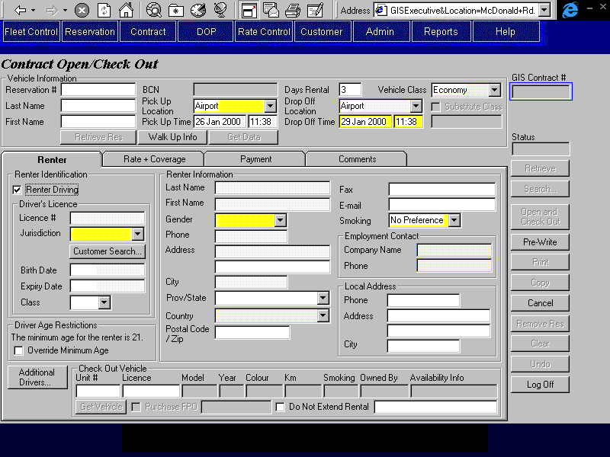

Purpose
The Renter tab allows the CSR to enter renter and additional driver information and to select the vehicle to be checked out on the contract.
Renter and Additional Driver Information
First, the CSR will specify whether the renter is driving or not driving and record information on the ID provided by the renter. If driving, driver licence information must be entered, otherwise, the ID provided by a non-driving renter will be recorded.
If the customer information is not already populated from the reservation or from a BCN, the CSR will then select the Customer Search button. This will search for the customer’s driver licence number (or name, for a non-driving renter) against a list of known customers. A list with extra identifying information will be presented to the CSR so that they may confirm and select the appropriate customer from the list. The list will include last name, first name, driver licence #, address, phone number, birth date, and whether or not the customer is flagged as ‘do not rent’. Upon selecting a customer from the list, the remaining customer information fields will be automatically populated. If no match is found, then the CSR will be required to enter the renter’s name and address information and their company name and phone number.
Next, the CSR will be able to record information about any additional drivers by pressing the “Additional Drivers” button. If the renter is not driving, at least one additional driver must be specified.
Checks will be run on the renter and on all additional drivers to ensure that they are not unwanted customers.
Check Out Vehicle
If a vehicle is being checked out, the CSR will be able to enter the unit number and licence plate number of the vehicle.
If the contract is a walk up for a truck, the CSR must first ensure that it is possible to rent a vehicle of the vehicle class requested at that location at the current time. The Truck Availability button will bring up a screen showing truck availability. A CSR cannot open a walk up contract for a truck class that is not available (availability is negative or zero). A supervisor may override this restriction and rent a truck for a truck class that is showing no availability.
Once a vehicle is selected for check out, the CSR can turn the Do Not Extend Rental flag on if desired. If any turnback warnings for the vehicle are displayed in the availability information, the Do Not Extend Rental flag will be turned on automatically and will be locked.
Navigation
Additional Drivers: Opens the Additional Drivers screen so that additional drivers can be added to the contract. Disabled if BCN is populated.
Truck Availability: Opens the Truck Rental Availability sub-screen, using the pick up
location, pick up time and vehicle class for the contract. Only visible if the vehicle class selected has a type of Truck.
Functions
Customer Search Customer Profile using the driver licence number if entered and the last
Search: and first names otherwise. Display list with extra customer information to ensure correct match. The list will include last name, first name, driver licence #, phone number, birth date, and whether the customer is flagged as ‘Do Not Rent’. Return information for selected customer to the contract screen (except for driver licence information and credit card information, which must be swiped from card or entered manually). Disabled if BCN is populated.
Get Vehicle: Checks unit number and licence plate number entered in the Check Out Vehicle information, selects the unit number for check out and populates the other fields in Check Out Vehicle with the information for the vehicle selected.
The unit number entered must meet all the criteria described in the notes in the section for the Location Vehicle Availability Screen, except for the Vehicle Rental Status, which can be “On Rent” or “In Transit” as well as “Available”. If the Vehicle Rental Status is ‘On Rent’ the expected drop off location must be the location where the current contract is being opened and the check out time for the current vehicle on contract must be less than the pick up time for the new contract. If the Vehicle Rental Status is ‘In Transit’ the receiving location for the movement must be the location where the current contract is being opened. If any of these conditions are not met, a message will be displayed stating why the vehicle can’t be checked out.
If the unit number is currently on rent or in transit and the conditions above are met, the Make Vehicle Available screen will be opened to give the CSR the ability to check in the vehicle or complete the vehicle movement. If the CSR does not check in the vehicle or complete the movement, the vehicle cannot be checked out on the new contract.
If the Warranty Repair Rate flag is on for the rate is selected, the manufacturer for the unit number must match the manufacturer in the rate.
If there is more than one vehicle that match the unit number and licence plate that meet the criteria described above, a search results grid will be displayed with all vehicles returned. The user would then select the vehicle from the search results grid and that record would populate the vehicle section of the tab.
Controls
Req*: Y – always mandatory
N – always optional
S – sometime optional (see Comments for details)
D – display only
Field | Source | Req* | Validation | Comments
Renter Identification
Driving/  Not Driving | Contract, Renter Driving | N |  | Default: Driving  Locked if BCN populated
Driver’s Licence |  | S |  | Required when renter is driving; Renter Driving = Yes.  Locked if BCN populated.
Licence # | Renter Driver Licence, Number | S | Required unless BCN is populated. | Not populated from customer profile unless the contract is being set up from a reservation with a BCN.  Locked if BCN populated.
Jurisdiction | Renter Driver Licence, Jurisdiction | Y | Value controlled by Province/State and Country tables. | Not populated from customer profile unless the contract is being set up from a reservation with a BCN.  Locked if BCN populated.
Birth Date | Contract, Birth Date | Y | Date (no time) | Not populated from customer profile unless the contract is being set up from a reservation with a BCN.  Locked if BCN populated.
Expiry Date | Renter Driver Licence, Expiry | Y | Date (no time). | Not populated from customer profile unless the contract is being set up from a reservation with a BCN.  Locked if BCN populated.
Class | Renter Driver Licence, Class | S | Required if Province is BC. Must match entry on BC Driver Licence Class table. | Not populated from customer profile unless the contract is being set up from a reservation with a BCN.  Locked if BCN populated.
Other Identification |  | S |  | Required when renter is not driving.
ID Type | Non Driving Renter ID, ID Type | Y | Value controlled by ID Type table.
ID # | Non Driving Renter ID, Number | Y
Birth Date | Contract, Birth Date | Y | Date (no time) | Not populated from customer profile.
Expiry Date | Non Driving Renter ID, Expiry | Y | Date (no time)
Driver Age Restrictions | Vehicle Class, Minimum Age and Organization Minimum Age Override, Minimum Age | D |  | Shows the age restrictions for the vehicle class requested and the organization (if any).
Override Minimum Age | Contract, Override Minimum Age | N |  | Not visible if contract is linked to a BCD organization (BCD Rate Organization ID is not null). Display only if Yes when contract is retrieved.
Renter Information
Last Name | Contract, Last Name | Y | Free form text | Populated from Reservation or customer profile if possible.  Locked if BCN populated.
First Name | Contract, First Name | Y | Free form text | Populated from Reservation or customer profile if possible.  Locked if BCN populated.
Gender | Contract, Gender | Y | Selection Only  Male, Female | Populated from customer profile if possible.  Locked if BCN populated.
Phone | Contract, Phone Number | Y |  | Populated from reservation or customer profile if possible.  Locked if BCN populated.
Address | Contract, Address 1, Address 2 | Y |  | Populated from customer profile if possible.  Locked if BCN populated.
City | Contract, City | Y |  | Populated from customer profile if possible.  Locked if BCN populated.
Prov/State | Contract, Province/State | S | Required if Country is Canada or US. Entry assisted by Province table. Must match a value on the Province table if Country is Canada or US. | Populated from customer profile if possible.  Locked if BCN populated.
Country | Contract, Country | Y | Entry controlled by Country table. | Populated from customer profile if possible.  Locked if BCN populated.
Postal Code/Zip | Contract, Postal Code | N | Must match Canadian postal code format if Country is Canada. | Populated from customer profile if possible.  Locked if BCN populated.
Fax | Contract, Fax Number | N |  | Populated from reservation or customer profile if possible.  Locked if BCN populated.
E-mail | Contract, Email Address | N | Free form text | Populated from customer profile if possible.  Locked if BCN populated.
Smoking | Contract, Smoking/Non-Smoking | Y | Selection only  No Preference, Smoking, Non-Smoking | Populated from reservation or customer profile if possible. Default to ‘No Preference’ otherwise.  Locked if BCN populated.
Employment Contact
Company Name | Contract, Company Name | Y |  | Populated from Customer Profile if possible.
Phone | Contract, Company Phone Number | Y |  | Populated from the organization on Customer Profile if possible
Local Address
Phone | Contract, Local Phone Number | N
Address | Contract, Local Address 1 and Local Address 2 | N
City | Contract, Local City | N
Check Out Vehicle
Unit # | Vehicle On Contract, Unit Number | S | For the validation rules that apply see the notes on the Get Vehicle function. | Mandatory for check out, optional for open.
Licence | Vehicle, Current Licence Plate | S | Must match the vehicle licence plate that is in effect for the unit number on the current date. | Mandatory for check out, optional for open.
Model | Vehicle, Vehicle Model ID | D |  | Model Name is displayed
Year | Vehicle, Vehicle Model ID | D |  | Model Year is displayed
Colour | Vehicle, Exterior Colour | D
Km | Vehicle, Current Km | D |  | If an override check in or movement completion was done and Km was entered, this field will be set to the Km entered there instead.
Smoking | Vehicle, Smoking | D
Owned By | Vehicle, Vehicle Owning Company | D
Availability Information |  | D |  | See the notes in the section on the Location Vehicle Availability screen.
FPO Purchased | Vehicle On Contract, FPO Purchased | N |  | Disabled unless Unit # is entered.
(FPO amount) |  | D |  | Calculated by GIS. Shows the FPO charge based on the FPO price per litre at the pick up location and the tank size of the vehicle model selected by Get Vehicle.
Do Not Extend Rental | Contract, Do Not Extend Rental | N
(Do Not Extend Rental Reason) | Contract, Do Not Extend Rental Reason | Y |  | Required if Do Not Extend Rental is On

Rate Tab
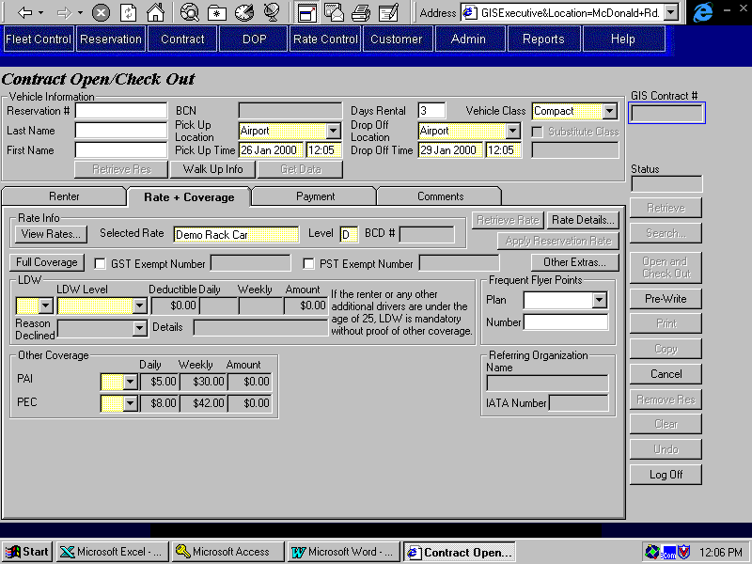

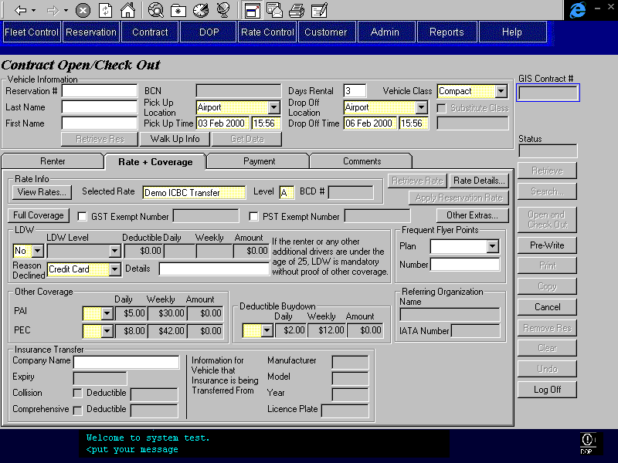
Purpose
This tab allows the CSR to select a suitable rate for the customer and add coverages, optional extras and sales accessories as required.
Rate Viewing and Selection
If no rate was populated when the contract was opened (from a reservation, BCD number or body shop referral), a rate will be automatically selected and displayed based on the previously entered contract information (pick up location, pick up time, days rental, drop off location, vehicle class). If the CSR wishes to see other available rates, they may select the View Rates button to select another rate from a limited list of rates. The rates displayed for selection are determined by previously entered information in the contract and settings determined in the Location Maintenance screen. Upon selecting another rate from the list, the new rate information will be displayed in the Rate tab. If the CSR wishes to use a specific rate that does not appear on the list, they may enter the rate name and level and then press the retrieve button.
Only the rate name and level and the customer’s BCD number (if any) are displayed on this tab. If the CSR wishes to view rate details, they can use the Rate Details button to open the Rate Details screen where all dollar rate information, late charges, km cap and charges, inclusions, and restrictions are displayed. Also displayed are whether or not LDW and third party insurance are included, whether frequent flyer plans are honoured and member discounts are allowed.
Coverages (LDW, Deductible Buydown, PAI, PEC and Cargo Insurance) may be added or applied to the base rate, and insurance transfer details may be entered for rates where insurance transfer is allowed. Frequent Flyer information can also be recorded.
Insurance Transfer
If the rate selected allows insurance transfer, the insurance transfer information will be visible on this tab and can be entered by the CSR.
LDW
The LDW information will be invisible if the rate allows insurance transfer and the insurance transferred includes both collision and comprehensive coverage. The LDW information will remain visible until all the insurance transfer information with both collision and comprehensive coverage is entered.
If the LDW information is visible, the CSR must specify whether LDW is being accepted or declined. If LDW is declined, a reason must be entered. If the renter or any other additional drivers are under the age limit for mandatory LDW, the reason for declining LDW cannot be ‘No Coverage’. Note: spousal and other company additional drivers are not included in the age check for mandatory LDW. If the reason for declining LDW is ‘Credit Card’ the Rental Authorized By on the Payment tab must be Renter and the Renter Pre-Authorization Method must be Credit Card. After ‘Credit Card’ is selected as the reason for declining LDW, these fields will be locked.
Deductible Buydown
The Deductible Buydown information will be visible under the following conditions:
- The rate includes LDW and the deductible is not zero
- There is an insurance transfer for the contract, and the insurance being transferred includes both collision and comprehensive coverage and one or both of the deductibles is not zero.
- LDW has been declined and the reason is not ‘No Coverage’
If the Deductible Buydown information is visible, the CSR must specify whether Deductible Buydown is being accepted or declined.
Other Coverages
PAI information will always be visible unless it is not available for the selected vehicle class. If it is visible, the CSR must specify whether PAI is being accepted or declined.
Depending on the vehicle type either PEC or Cargo Insurance information will be visible. If it is visible, the CSR must specify whether it is being accepted or declined.
Full Coverage
The CSR can specify that full coverage is being accepted. If so, all the coverages currently visible on the tab will be accepted and applied to the contract.
For example:
- For a contract for a car where the rate includes LDW and has a $200 deductible, Deductible Buydown, PAI and PEC will be applied to the contract.
- For a loss of use contract for a car where an insurance transfer with a non-zero deductible is being done (and the insurance includes both collision and comprehensive coverage), Deductible Buydown, PAI and PEC will be applied to the contract.
- For a contract for a truck where LDW is not included, LDW, PAI and Cargo Insurance will be applied to the contract.
Frequent Flyer Plans
If the renter has a frequent flyer plan, the CSR can select the plan from a list of the frequent flyer plan that Budget honours and enter the renter’s plan membership number.
If the rate selected does not allow use of frequent flyer plans, these fields will be invisible.
Referring Organization
If the contract has an associated Referring Organization or IATA number, it will be displayed in this section. This information is entered in the reservation or in the walk up information.
Other Extras and Discounts
In order to sell other optional extras and sales accessories or to record discounts, the CSR will use the Other Extras button to open to the Other Extras screen.
Navigation
View Rates: Opens the Rate Selection screen for walk up rates and returns the selected rate information to the Contract Open/Check Out screen.
Rate Details: Opens the Rate Details screen for the selected rate.
Other Extras: Opens the Other Extras screen for the contract.
Functions
Retrieve Rate: Retrieves the rate information based on an exact match found for the rate name and level entered. This button is disabled unless the user types in the rate name/level fields. No wild card search is provided.
The rate specified must not have any restrictions that prevent it from being used for the vehicle class, pick up and drop off locations and pick up and drop off times specified for the contract.
Apply Reverts to the rate specified in the reservation. Disabled unless contract is being
Reservation opened from a reservation.
Rate:
Full Coverage: See the description above.
Controls
Req*: Y – always mandatory
N – always optional
S – sometime optional (see Comments for details)
D – display only
Field | Source | Req* | Validation | Comments
Selected Rate | Contract, Rate ID  OR  Contract, Quoted Rate ID | Y | Free form text.  Rate name displayed. | Automatically determined or determined by rate selection screen. User may enter name and level as well but is then forced to press retrieve button. Rate name or Quoted Vehicle Rate Name displayed.
Selected Rate Level | Contract, Rate Level | Y | Valid values A to Z. | Automatically determined or determined by rate selection screen. User may enter name and level as well but is then forced to press retrieve button.
BCD # | Contract, BCD Rate Organization ID | D |  | If a BCD organization was selected in the Walk Up screen or in the Reservation, the BCD # for the organization will display here.
GST Exempt |  | N |  | When an existing contract is retrieved, will be set on if GST Exemption Number is populated.
Number | Contract, GST Exemption Number | S | Required if GST Exempt is turned on.
PST Exempt |  | N |  | When an existing contract is retrieved, will be set on if PST Exemption Number is populated.
Number | Contract, PST Exemption Number | S | Required if PST Exempt is turned on.
Insurance Transfer
Company Name | Insurance Transfer, Company Name | N
Expiry | Insurance Transfer, Expiry | S | Date  Must be greater than or equal to the drop off date. | Required if Company Name is entered, locked otherwise.
Collision |  | N |  | When retrieving an existing insurance transfer, set to Yes if Collision Deductible is not null and No otherwise
Deductible | Insurance Transfer, Collision Deductible | S | Currency | Required if Collision is checked, locked otherwise.
Comprehensive |  | N |  | When retrieving an existing insurance transfer, set to Yes if Comprehensive Deductible is not null and No otherwise
Deductible | Insurance Transfer, Comprehensive Deductible | S | Currency | Required if Comprehensive is checked, locked otherwise.
Manufacturer | Insurance Transfer, Vehicle Manufacturer | S |  | Required if Company Name is entered, locked otherwise.
Model | Insurance Transfer, Vehicle Model | S |  | Required if Company Name is entered, locked otherwise.
Year | Insurance Transfer, Vehicle Year | S | Year | Required if Company Name is entered, locked otherwise.
Licence Plate | Insurance Transfer, Vehicle Licence Plate | S |  | Required if Company Name is entered, locked otherwise.
LDW |  |  |  | Locked if BCN populated.
LDW |  | Y | Selection Only  Yes/No | Set to Yes if Full Coverage button is selected.
Level of LDW | Contract Optional Extra, Optional Extra ID | S | Selection Only  Value controlled by Optional Extra table (Type = LDW) and Optional Extra Restriction table | Optional Extra name is displayed.  Required if LDW is Yes, Disabled otherwise.
Deductible | LDW Deductible, LDW Deductible. | D |  | For Selected LDW level (Optional Extra with Type = LDW) and Vehicle Class.
Daily | Contract Optional Extra, Daily Rate | D |  | For selected LDW level (Optional Extra with Type = LDW). Rate will not vary with quantity.
Weekly | Contract Optional Extra, Weekly Rate | D |  | For selected LDW level (Optional Extra with Type = LDW). Rate will not vary with quantity.
Amount |  | D |  | Calculated if LDW is Yes. Zero if LDW is included in the rate, otherwise based on rental period and quantity. Displays cheapest combination of daily and weekly rates.
Reason Declined | Contract, LDW Declined Reason | S | Value controlled by LDW Declined Reason table. Cannot be ‘No Coverage’ if the renter or any other additional drivers are under the age limit for mandatory LDW. | Required if LDW is No
Details | Contract, LDW Declined Details | N
Deductible Buydown |  |  |  | Invisible if the Optional Extra with type Deductible Buydown is restricted for the Vehicle Class selected.
Deductible Buydown |  | Y | Selection Only  Yes/No
Daily | Contract Optional Extra, Daily Rate | D |  | For Optional Extra with Type = Buydown.
Weekly | Contract Optional Extra, Weekly Rate | D |  | For Optional Extra with Type = Buydown.
Amount |  | D |  | Calculated if Deductible Buydown is Yes. Based on rental period and quantity. Displays cheapest combination of daily and weekly rates.
Other Coverage |  |  |  | Locked if BCN populated.
PAI |  | Y | Selection Only  Yes/No | Disabled if an Optional Extra with type PAI is included in the rate. Invisible if the Optional Extra with type PAI is restricted for the Vehicle Class selected.  Otherwise, set to Yes if Full Coverage button is selected.
PEC |  | Y | Selection Only  Yes/No | Disabled if an Optional Extra with type PEC is included in the rate. Invisible if the Optional Extra with type PEC is restricted for the Vehicle Class selected.  Otherwise, set to Yes if Full Coverage button is selected.
Cargo Insurance |  | Y | Selection Only  Yes/No | Disabled if an Optional Extra with type Cargo Insurance is included in the rate. Invisible if the Optional Extra with type Cargo Insurance is restricted for the Vehicle Class selected.  Otherwise, set to Yes if Full is Yes.
For PAI, PEC, and Cargo Insurance
Daily | Contract Optional Extra, Daily Rate | D |  | For Optional Extra with Type = PAI, PEC or Cargo Insurance.
Weekly | Contract Optional Extra, Weekly Rate | D |  | For Optional Extra with Type = PAI, PEC or Cargo Insurance.
Amount |  | D |  | Calculated if coverage selected is Yes. Zero if the coverage is included in the rate, otherwise based on rental period and quantity. Displays cheapest combination of daily and weekly rates.
Corporate Responsibility | Quoted Vehicle Rate, Corporate Responsibility | D |  | Bot the field and label are only visible when the contract has been opened from a reservation passed from Maestro, using the quoted rate and when there is a value in the Corporate Responsibility field for the quoted rate.
Frequent Flyer Points |  |  |  | Not visible unless Frequent Flyer Plans Honoured is Yes for the rate selected.  Locked if BCN populated.
Plan | Contract, Frequent Flyer Plan ID  Frequent Flyer Plan Member, Frequent Flyer Plan ID | N | Value controlled by Frequent Flyer Plan table | Frequent Flyer Plan name is displayed.
Number | Contract, Frequent Flyer Member Number  Frequent Flyer Plan Member, Member Number | S | Create Frequent Flyer Plan Member Record if does not already exist. | Required if Plan is entered. If there is already a Frequent Flyer Member for the Frequent Flyer Plan and the Customer with a Type of Preferred, defaults to that Member Number, defaults to blank otherwise.
Referring Organization
Name | Contract, Referring Organization ID | D |  | Display Organization Name.
IATA Number | Contract, IATA Number | D
Technical Notes

Payment Tab
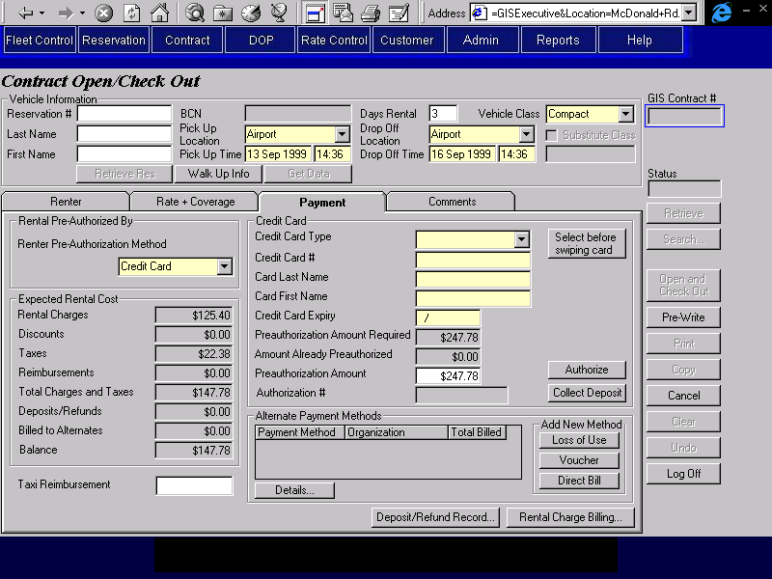

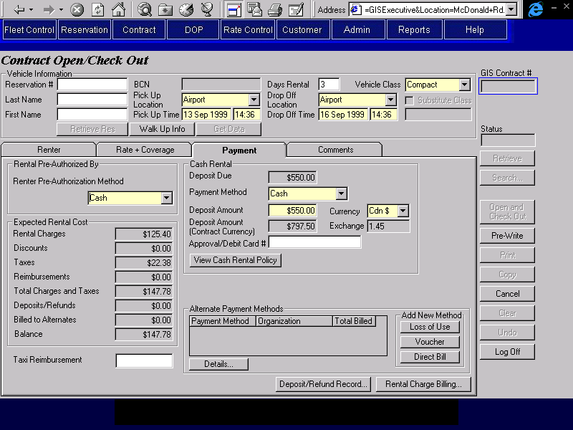

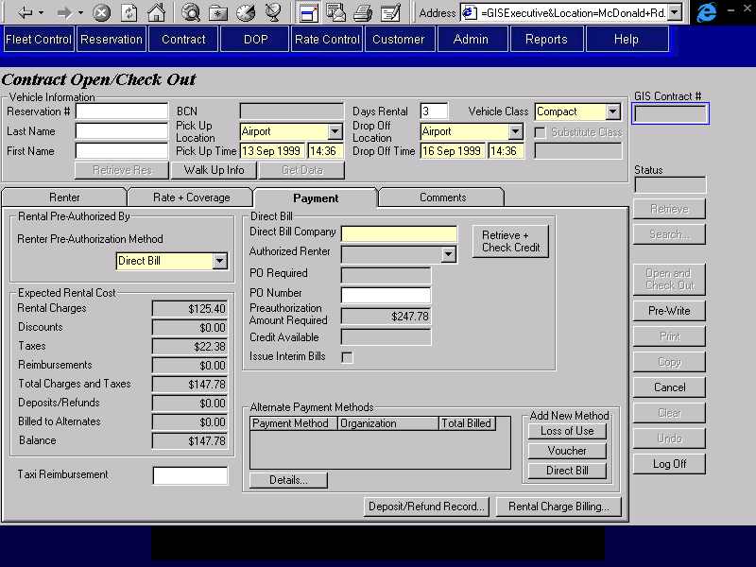
Purpose
This tab is used to identify the party responsible for the rental, perform credit checks and enter credit card authorization and cash deposit details.
First, the CSR will specify whether the rental is being authorized by credit card, cash or by a direct bill company. This will determine who is responsible for the rental charges and for pre-authorizing the rental. A lease card is treated as a credit card Next, the CSR will enter the details of the authorization method being used and GIS will calculate the authorization amount required for the rental. For details on how this calculation is performed, see the description of the Calculate Pre-Authorization Amounts and Cash Rental Deposits function.
If the customer took a taxi to the location, the CSR can enter a reimbursement for the amount of the taxi fare.
If all the rental charges are being billed to the party authorizing the rental and no additional deposits are being made at contract open, then the CSR can complete the rental authorization by doing one of the following:
- Authorizing the entire pre-authorization amount against the renter’s credit card for credit card rentals
- Collecting a cash rental deposit qualification form and collecting a cash deposit for cash rentals.
- Checking the pre-authorization amount against the credit limit for direct bill companies.
If any alternate payment organizations are being billed for all or part of the rental, the CSR will use the Rental Charge Billing button to record the alternate payment details, specify which charges should be billed to each alternate payment method and check the total charges being billed to each alternate payment method against the organization’s credit limit.
If any cash or credit card deposits are being made at Contract Open, the CSR will record the details on the Deposit/Refund Record screen.
Once any alternate payment billing details and additional deposits have been entered, the CSR will return to this tab and complete the rental authorization as described above.
Navigation
View Cash Opens a window displaying Budget’s cash rental policy for the CSR to
Rental Policy: review.
Retrieve & Search for a direct bill organization using the organization name entered. If
Check Credit: a single exact match is found, the available credit, PO required flag and a list of authorized renters will be displayed in the tab, otherwise the direct bill search results screen will be displayed and the same information will be populated from the organization selected on that screen (if any).
Rental Charge Opens the Rental Charge Billing screen so that the CSR can view details
Billing: of the contract rental charges, enter alternate payment details and assign rental charges to alternate payment organizations. The Manual Rental Charge Billing section on this screen will not be visible when invoked from Contract Open/Check Out.
Deposit/Refund Opens the Deposit/refund Record screen so that the CSR can record cash and
Record: credit card deposits and/or refunds and view the details of any reservation deposit collected.
Details: Opens the appropriate alternate payment details screen (Loss of Use, Voucher or Direct Bill) for the selected alternate payment organization so that the CSR can view or update the required details.
Loss of Use: Opens the Loss of Use details screen so that the CSR can enter a new Loss of Use alternate payment organization.
Voucher: Opens the Voucher details screen so that the CSR can enter a new Voucher alternate payment organization.
Direct Bill: Opens the Direct Bill details screen so that the CSR can enter a new Direct Bill alternate payment organization.Functions
Authorize: Perform a credit card authorization for the credit card and pre-authorization
(Credit Card) amount specified. If the authorization is declined, clears all the credit card fields. If the authorization is accpeted, locks the credit card details so that any further authorizations will be restricted to the same credit card. For details on the credit card authorization process, see the Credit Card Authorization function description in this document.
If the automated authorization facility is not available or the credit card type has no automatic authorization, opens the Manual Credit Card Transaction screen and populates it with the credit card and authorization amount information from this tab. After the screen is closed, the authorization number returned will be displayed on this tab.
Collect Collect a deposit payment for the credit card and pre-authorization
Deposit: amount specified. If the authorization is declined, clears all the credit card fields. For details on the credit card deposit process, see the Credit Card Payment function description in this document.
If the automated payment facility is not available or the credit card type has no automatic payment, opens the Manual Credit Card Transaction screen and populates it with the credit card and authorization amount information from this tab. After the screen is closed, the authorization number returned will be displayed on this tab.
Generate Accounting Interface entries for the deposit. For details, see the section on Accounting Interface Entries for Contract Open/Check Out.
Controls
Req*: Y – always mandatory
N – always optional
S – sometime optional (see Comments for details)
D – display only
Field | Source | Req* | Validation | Comments
Rental Authorized By |  |  |  | Locked if BCN populated.
Renter Pre-Authorization Method | Contract, Authorized By | Y | Selection only  Credit Card/Cash/Direct Bill  Must be Credit Card, if LDW has been declined and the reason is ‘Credit Card’. | Defaults to Credit Card.  Will be locked if LDW has been declined and the reason is ‘Credit Card’.
Credit Card | Renter Primary Billing, Renter Authorization Method |  | Use existing credit card if exists, otherwise create new Credit Card record. | Locked if BCN populated. Save Renter Primary Billing, Renter Authorization Method = Credit Card.
Credit Card Type | Renter Primary Billing, Credit Card Key  Credit Card, Credit Card Type ID | Y | Value controlled by Credit Card Type table. | Populated from Customer Profile if a BCN customer with a reservation, otherwise selected manually.  Locked after an authorization is done, or when the contract is Pre-Written or Saved and the field is populated.  Display Credit Card, Credit Card Type
Credit Card # | Renter Primary Billing, Credit Card Key  Credit Card, Credit Card Number | Y |  | Populated from Customer Profile if a BCN customer with a reservation, other wise populated from credit card swipe (if done).  Locked after an authorization is done, or when the contract is Pre-Written or Saved and the field is populated.  Display Credit Card, Credit Card Number
Card Last Name | Renter Primary Billing, Credit Card Key  Credit Card, Last Name | Y |  | Populated from Customer Profile if a BCN customer with a reservation, other wise populated from credit card swipe (if done).  Locked after an authorization is done, or when the contract is Pre-Written or Saved and the field is populated.  Display Credit Card, Last Name
Card First Name | Renter Primary Billing, Credit Card Key  Credit Card, First Name | Y |  | Populated from Customer Profile if a BCN customer with a reservation, other wise populated from credit card swipe (if done).  Locked after an authorization is done, or when the contract is Pre-Written or Saved and the field is populated.  Display Credit Card, First Name.
Credit Card Expiry | Renter Primary Billing, Credit Card Key  Credit Card, Expiry | Y | Date (month and year) | Populated from Customer Profile if a BCN customer with a reservation, other wise populated from credit card swipe (if done).  Locked after an authorization is done, or when the contract is Pre-Written or Saved and the field is populated.  Display Credit Card, Expiry
Preauthorization Amount Required |  | D |  | Calculated by GIS. See Calculate Pre-authorization Amounts & Cash Rental Deposit Function.
Amount Already Preauthorized |  | D |  | Calculated by GIS from the sum of all the authorizations already performed.
Preauthorization Amount | Credit Card Authorization, Amount Authorized | Y |  | Defaults to Preauthorization Amount Required minus Amount Already Preauthorized.  Reset to zero once authorization is complete.
Authorization # | Credit Card Authorization, Authorization Number | D |  | Populated only when authorization completed.
Cash Rental | Renter Primary Billing, Renter Authorization Method |  |  | Save Renter Primary Billing, Renter Authorization Method = Cash
Deposit Due |  | D |  | Calculated by GIS. See Calculate Pre-authorization Amounts & Cash Rental Deposit Function.
Payment Method | Cash Payment, Cash Payment Type | Y | Selection only  Value controlled by Cash Payment Method table | Defaults to Cash
Deposit Amount | Cash Payment, Foreign Currency Amount Collected | Y |  | Defaults to Deposit Due
Currency | Cash Payment, Currency ID | Y | Selection only  Value controlled by Currency table | Defaults to Cdn $  Display Currency Name.
Deposit Amount (Contract Currency) | Contract Payment Item, Amount | D |  | Converted from Deposit Amount into Cdn $.
Exchange | Cash Payment, Exchange Rate | D |  | Defaults to current exchange rate for Currency
Approval/Debit Card # | Cash Payment, Identification Number | N
Direct Bill
Direct Bill Company | Contract Billing Party, Customer Code | Y |  | AR Customer Master, Address Name is displayed
Authorized Renters | AR Customer Master, Address Name | D |  | Populated with all AR Customer Master records for the same Customer Code with an Address Type of 1.
PO Required | Budget AR Customer Master, Purchase Order Required | D
PO Number | Direct Bill Primary Billing, PO Number | S |  | Required if purchase orders are required for the direct bill account.
Preauthorization Amount Required | Contract Billing Party, Amount Removed from Available Credit | D |  | Calculated by GIS. See Calculate Pre-authorization Amounts & Cash Rental Deposit Function.
Credit Available | (see comments) | D |  | A/R Customer Master, Credit Limit minus the sum of A/R Customer Activity, Amount Balance, A/R Credit Authorization, Daily Contract Total and A/R Credit Authorization, Expected Open Contract Charges.
Issue Interim Bills | Direct Bill Primary Billing, Issue Interim Bills | D |  | Set to Yes if the rental period is 60 days or longer, set to No otherwise.
Expected Rental Cost
Rental Charges |  | D |  | Calculated by GIS. Sum of all charges excluding discounts and reimbursements on Rental Charge Billing sub-screen.
Discounts |  | D |  | Calculated by GIS. Sum of all discounts applied to contract, including member discounts.
Taxes |  | D |  | Calculated by GIS, based on rental charges less discounts. Sum of all GST, PST, and PVRT amounts on the Rental Charge Billing sub-screen.
Reimbursements |  | D |  | Calculated by GIS. Sum of all reimbursements applied to contract.
Totals Charges and Taxes |  | D |  | Calculated by GIS. Sum of rental charges, discounts, taxes and reimbursements (four fields directly above).
Deposits/Refunds |  | D |  | Calculated by GIS. Sum of all deposits and refunds applied to contract (sum of all deposit and refund entries in the Deposit/Refund Record sub-screen).
Billed to Alternates |  | D |  | Calculated by GIS. Sum of all rental charges and taxes billed to alternate payment organizations (sum of the Total Billed column in the Alternate Payment Methods grid).
Balance |  | D |  | Total Charges and Taxes, less Deposits/Refunds and Billed to Alternates (three fields directly above).
Taxi Reimbursement | Contract Reimbursement and Discount, Flat Amount | N | Currency | Contract Reimbursement and Discount.Type = Reimbursement.  Reason will be set to ‘Taxi’
Alternate Payment Methods |  |  |  | Show one row for each Contract Billing Party record where Billing Type = Alternate.
Payment Method | Contract Billing Party, Billing Method | D
Organization | Contract Billing Party, Customer Code | D |  | Display A/R Customer Master, Address Name
Total Billed | Contract Billing Party, Amount Removed from Available Credit | D |  | Calculated by GIS, sum of all charge items in the Rental Charge Billing sub-screen that are assigned to the selected Contract Billing Party. Saved to Amount Removed from Available Credit.
Technical Notes
Exchange Rate
When calculating the exchange rate for cash deposits in foreign currency, use the exchange rate for the location if there is one; otherwise use the standard exchange rate.
Interim Billing
If Issue Interim Bills is on for a direct bill authorization, create Interim Bill records for the contract when it is saved. Create one record for each 30 day period following the pick up date, up to but not including the expected drop off date. Do not populate any fields except the Bill Date.
For example: a contract starting on Aug. 14, 1998 with an expected drop off date of Nov. 30, 1998 will have the following Interim Bill records created at Contract Open
Sept. 12, 1998
Oct. 12, 1998
Nov. 11, 1998

Comments Tab
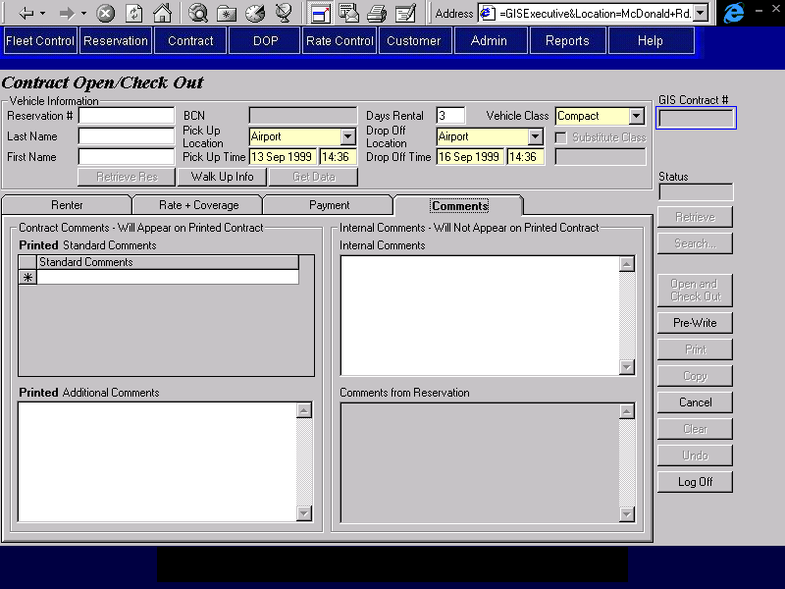
Purpose
The Comments tab is used to view comments entered by the agent who made the reservation and to view and enter comments about the contract. This will facilitate communication between different CSRs who may work on the same contract. Two types of comments can be entered, comments which will appear on the printed contract and comments that will not appear on the printed contract. The reservation comments will not appear on the printed contract.
Navigation
N/A
Functions
N/A
Controls
Req*: Y – always mandatory
N – always optional
S – sometime optional (see Comments for details)
D – display only
Field | Source | Req* | Validation | Comments
Contract Comments – Will Appear on Printed Contract
Printed Standard Comments | Contract Print Comment, Standard Print Comment | N | Values controlled by Contract Print Standard Comment table.
Printed Additional Comments | Contract, Print Comment | N | Free form text. Maximum length 255 characters.
Internal Comments – Will Not Appear on Printed Contract
Internal Comments | Contract Internal Comment, Comments | N | Free form text. Maximum length 255 characters.
Comments from Reservation | Reservation, Special Comments and Reservation Comment, Standard Reservation Comment ID | D |  | Concatenation of Standard Reservation Comments for the reservation and Reservation, Special Comments
Technical Notes
When a contract is opened or checked out, the user ID of the person who entered or changed the internal comments must also be saved.

Changes During Rental Screen
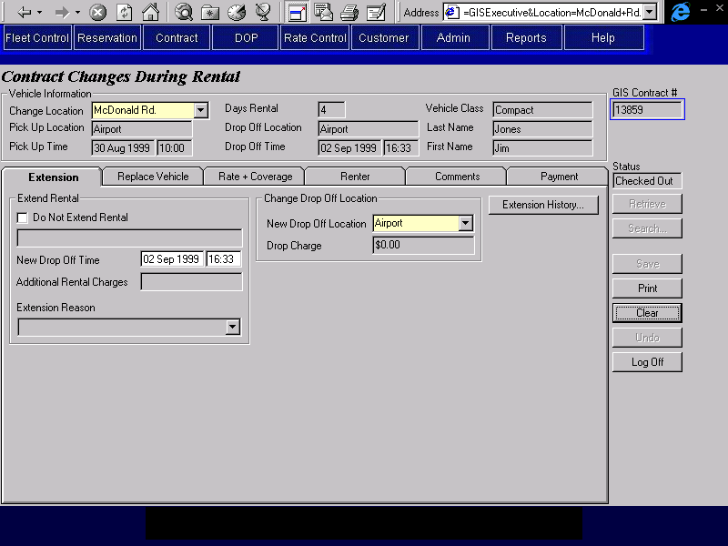
Purpose
The Contract Changes During Rental screen is used for viewing and making changes to contracts before final check in.
The screen is organized into seven areas: the base screen and six tabs. The base screen allows the user to select the location where the change is being made and displays pick up and drop off locations and times, the vehicle class requested, the customer name and BCN (if applicable) and the contract number and status. The tabs contain the remaining required contract information and are categorized as follows:
Extension: Where the current drop off time and location can be changed and where the extension change history for the contract can be viewed. If the rental extension involves a truck, truck rental availability will be available for viewing.
Replace Vehicle: Where the current vehicle checked out on a contract can be checked in and a new vehicle can be selected and checked out.
Rate + Coverage: Where the rate name and level used for the rental is displayed. Coverages may be viewed, added or ended. Insurance transfer details and frequent flyer information may be viewed for rates where insurance transfer and frequent flyer plans are allowed respectively. Buttons are available to:
- View the details for the selected rate.
- View, add or end other optional extras, and apply discounts.
Renter: Where the renter and additional driver information is viewed and updated.
Comments: Where comments may be selected and entered by the CSR and any comments from the reservation may be viewed. There are two types of comments, those that will show on the printed contract and those that will not.
Payment: Where the party responsible for the rental is displayed and payment and authorization information is displayed and entered. Buttons are available to:
- Identify alternate payment organizations and assign rental charges to them.
- Record details of cash deposits, credit card deposits and refunds, and credit card authorizations.
Retrieve, Search, Save, Print, Clear and Undo buttons are available on the far right.
Screen Hierarchy

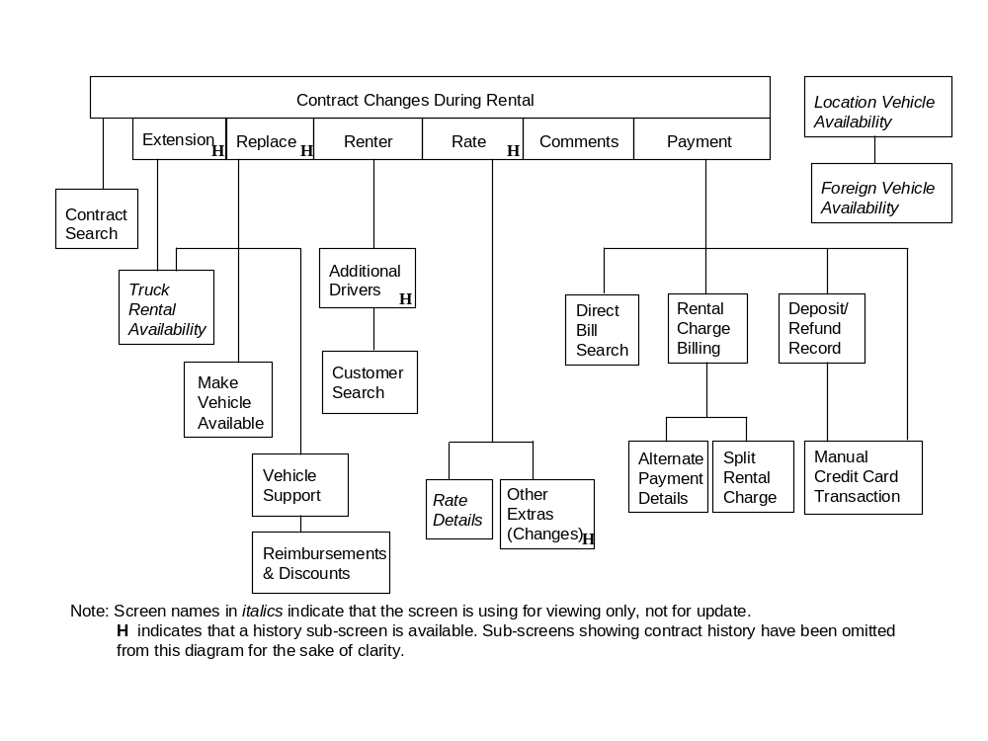
Navigation
N/A
Functions
Retrieve: Retrieves the contract for the contract number entered and uses it to populate the Changes During Rental screen. If no contract number is entered and a contract number has been placed in the GIS Selected Contract registry by the Contract Search screen, the number from the registry is retrieved instead.
Enabled when the screen is first opened or when the screen has been cleared using Clear or Undo. Disabled when the screen is populated with contract information using the Retrieve or Search buttons.
When this screen is first opened, a Retrieve is done automatically if a contract number has been placed in the GIS Selected Contract registry by the Contract Search screen.
The contract cannot be retrieved if it has any primary or alternate billing parties that are no longer active on Platinum.
Search: Opens the Contract Search screen. When the CSR selects a contract from the contract search screen, the Changes During Rental screen will be populated with the contract information.
Enabled when the Changes During Rental screen is first opened and when the screen has been cleared using Clear. Disabled when the Changes During Rental screen is populated with contract information using the Retrieve or Search buttons.
Save: Checks that all required information has been entered and then saves the updated contract.
The following edits will be performed before the contract can be saved.
- If the rental is being extended for a truck, there must be a truck available for the location, vehicle class and additional rental period. This can be overridden by a location manager or supervisor (as in reservations).
- Any driver licence numbers entered for new additional drivers will be checked against the Customer Profile to ensure that the ‘Do Not Rent’ flag is not on.
- All driver licence expiry dates entered must be greater than or equal to the drop off date. This edit must be done for new additional drivers and for all drivers if the drop off date is extended. The renter driver licence will not be checked if the expiry date is null.
- If any driver licence expiry dates are on the drop off date, the Do Not Extend Rental flag on the Extension tab must be checked.
- All drivers where the birth date has been entered must meet the minimum age requirement for the vehicle class being rented. If the Override Minimum Age Override flag is turned on, the minimum age overrides for the Minimum Age Override BCD organization will be used. Otherwise, t here may be an override on the Organization customer profile if the contract is being opened for an organization.
This override will apply to the rental, and to spousal and other company additional drivers, but it will not apply to other additional drivers.
This override will still apply if the corporate rate is being used for personal use.
This edit will be done for all new additional drivers and for all drivers if the vehicle class is being upgraded.
- If any new other additional drivers are below the LDW age requirement then LDW must be added unless one of the following is true:
- the rate being used includes LDW
- LDW is already on the contract
- the LDW Declined Reason on the Rate tab, Coverages sub-tab is entered and is not ‘No Coverage’
Note: spousal and other company additional drivers are not included in the LDW age check
- If the renter or any other additional drivers are below the LDW age requirement then LDW cannot be terminated unless the LDW Declined Reason on the Rate tab, Coverages sub-tab is entered and is not ‘No Coverage’.
Note: spousal and other company additional drivers are not included in the LDW age check
- For each direct bill organization (Contract Billing Party with Billing Method ‘Direct Bill’, ‘Loss of Use’ or ‘Voucher’) that is being billed for all or part of the rental charges:
- If the Contract Billing Party is authorizing the rental (Billing Type ‘Primary’), the Amount Removed from Available Credit will be set to the authorization amount required (displayed on the Payment tab)
- If the Contract Billing Party is an alternate payment organization (Billing Type ‘Alternate’), the Amount Removed from Available Credit will be set to the total amount being billed to the organization (displayed on the Rental Charge Billing screen)
- Subtract the Amount Removed from Available Credit prior to the changes from the expected open contract charges for the organization (AR GIS Customer Info, Expected Open Contract Charges)
- Add the new Amount Removed from Available Credit to the expected open contract charges for the organization (AR GIS Customer Info, Expected Open Contract Charges).
- For a truck rental:
- If the truck has been replaced with a truck of a different vehicle class, update truck rental availability as follows:
- Increase the truck availability for the previous truck class and the pick up location by 1 for the remaining period of the rental.
- Decrease the truck availability for the new truck class and the switch location for the remaining period of the contract.
- If the rental period has been extended, update truck rental availability as follows:
- Decrease the truck availability for the truck class and pick up location by 1 for the period between the previous drop off time and the new drop off time.
- If the rental period has been shortened, update truck rental availability as follows:
- Increase the truck availability for the truck class and pick up location by 1 for the period between the new drop off time and the previous drop off time.
- Generate Accounting Interface entries for any cash deposits received or refunds issued. For details, see the section on Account Interface Entries for Contract Changes During Rental.
- If terminal used to make the change is a rental location terminal, and there has been a coverage, optional extra, or additional driver change, then display a message advising the CSR to obtain a signature from the renter.
Print: Saves and prints the contract.
Clear: Disabled once a credit card authorization or deposit has been processed.
Undo: Disabled once a credit card authorization or deposit has been processed.
Controls
Req*: Y – always mandatory
N – always optional
S – sometime optional (see Comments for details)
D – display only
Field | Source | Req* | Validation | Comments
Above Tabs
Change Location |  | Y | Selection only.  Value controlled by Location table. Only the user’s current location and foreign locations are displayed. | Location name is displayed.  Defaults to user’s current location.
Pick Up Location | Contract, Pick Up Location ID | D |  | Location name displayed.
Pick Up Time | Contract, Pick Up On | D
Days Rental |  | D |  | Difference between Pick Up Time and Drop Off Time.  Numeric, round up to the nearest whole number.
Drop Off Location | Contract, Drop Off Location ID | D |  | Location name is displayed.
Drop Off Time | Contract, Drop Off On | D
Vehicle Class | Contract, Vehicle Class Code | D |  | Vehicle Class Name is displayed.
Customer Last Name | Contract, Last Name | D
First Name | Contract, First Name | D
GIS Contract # | Contract, Contract Number | N |  | Unlocked when the screen is first opened or when the screen has been cleared using Clear. Locked when the screen has been populated with contract information using the Retrieve or Search buttons.
Foreign Contract # | Contract, Foreign Contract Number | N |  | Unlocked when the screen is first opened or when the screen has been cleared using Clear. Locked when the screen has been populated with contract information using the Retrieve or Search buttons.  See Rentback Changes Business Design Document for more details about foreign contracts.
Contract Status | Contract, Status | D

Extension Tab
Purpose
The extension tab allows the CSR to change the drop off time or location. Buttons are available to access the Extension history for the contract and, if a truck rental, Truck Rental Availability.
Change Drop Off Time
The CSR can enter a new drop off time for the rental and any change in rental charges will be calculated. When changing the drop off time the CSR must enter a reason. Any optional extras that have not already been removed will automatically have their end date changed to the new drop off time. Additional or reduced rental charges as a result of the drop off time change will be displayed (this will include the violation rate if applicable).
For a truck rental where the drop off time is being extended, the CSR must ensure that it is possible to extend the rental for that truck vehicle class. The Truck Rental Availability button will bring up a screen showing truck availability, depending on the vehicle class requested. A CSR cannot extend the rental for a truck that is not available (availability = No or 0) for the period of the rental extension. A supervisor may override this restriction and extend the rental even if there is no availability.
The CSR can also turn the Do Not Extend Rental flag on if desired. If the CSR turns the flag on the system will prompt for a reason to be entered. If any turnback warnings for the vehicle are displayed in the availability information, the Do Not Extend Rental flag will be turned on automatically and will be locked. The Do Not Extend rental flag may be overridden with administrative level authority.
If, by changing the drop off time, a restriction on the contract rate (i.e. maximum days rental) has been violated so that a violation rate is invoked then a message alerting the CSR will appear on the screen. The CSR cannot save the changes until either the drop off time has been changed so that the violation rate is not invoked or the Renter Acknowledged flag is turned on to indicate that the renter is aware of the violation rate use.
Change Drop Off Location
The CSR can select a new drop off location for the rental and the drop off charge (authorized or unauthorized) for the new location will be displayed. If an unauthorized drop off location has been selected a message alerting the CSR will be displayed. The CSR cannot save the changes until either an authorized drop off location has been selected or the Renter Acknowledged flag is turned on to indicate that the renter is aware of the unauthorized drop off location and its associated charge.
Navigation
Truck Rental Opens the Truck Rental Availability sub-screen, using the pick up
Availability: location, pick up time and vehicle class for the contract. Only visible when vehicle class is a truck.
Extension History: Opens the Extension History screen and displays the history for the current contract. Disabled if no history exists.
Violation Rate Opens the Rate Details screen and displays the details of the violation rate
Details: that applies for the rental extension. Only visible when the new drop off time violates a rate restriction for the contract.
Functions
N/A
Controls
Req*: Y – always mandatory
N – always optional
S – sometime optional (see Comments for details)
D – display only
Field | Source | Req* | Validation | Comments
Extend Rental
Do Not Extend Rental | Contract, Do Not Extend Rental | N |  | Checked if the Do Not Extend Rental flag is on for the contract. Can only be unchecked with supervisor authority. When manually checked on prompt user for reason.
Do Not Extend Reason | Contract, Do Not Extend Rental Reason | S |  | Required if the Do Not Extend Rental flag is turned on by the CSR. Set by GIS if the Do Not Extend Rental flag is turned on by GIS. See technical notes below
New Drop Off Time | Contract, Drop Off On | N | Date/Time | Defaults to the current Drop Off Time.  Locked if the Do Not Extend Rental flag is on for the contract.
Additional Rental Charges |  | D |  | Calculated by GIS. See technical notes below.
Extension Reason | Drop Off History, Reason | S | Free form text or selected from the Extension Reason table. | Required if New Drop Off Time is entered
Extension Message |  | D |  | This displays if the extension causes a violation rate to be used on the contract.
Renter Acknowledged (Extension) |  | S |  | Must be checked if violation rate is to be used as the contract rate.
Change Drop Off Location
New Drop Off Location | Contract, Drop Off Location ID | Y | All rental locations are displayed in the selection list. | Location name is displayed.  Defaults to the current Drop Off Location.
Drop Charge |  | D |  | No charge if the drop off location is included in the rate, displays the authorized or unauthorized drop charge for the pick up and drop off location otherwise.
Drop Off Message |  |  |  | This displays if the new drop off location causes an unauthorized drop charge to be used.
Renter Acknowledged (Drop Off) |  | S |  | Must be checked if unauthorized drop off location is to be saved as the drop off location.
Technical Notes
Do Not Extend Reason
If Do Not Extend Rental flag is manually checked then a reason will be supplied by the CSR and displayed in this field.
The Do Not Extend Rental flag will be turned on by GIS and the Do Not Extend Reason will be set by GIS at Check Out under the following conditions:
- For program cars if:
- Current kilometre reading is within a set number of Km of ‘Do Not Rent Past Km’
- Number of days since vehicle status was set to ‘Owned’ is within a set number of days of ‘Do Not Rent Past Days’
- Current date is within a set number of days of Turn Back Deadline
See the Fleet Business Design (Movement Screen Technical Notes) for the wording to use and the exact conditions under which the messages should be displayed.
- For trucks if:
- Current kilometre reading is within a set number of Km of Next Scheduled Maintenance
Additional Rental Charges
Additional rental charges will be the difference between the charges for the rental prior to the drop off time change and the charges with the new drop off time. This will use the Calculate Rental Charges Function and will be invoked when a new drop off time is entered. Note that this will include any optional extras, coverages and other extras, that may be part of the contract. If a violation rate has been invoked as a result of the drop off time change, then the violation rate should be used for calculating the charges for the vehicle time and kms.
Drop Off History
Every time the drop off time or location is changed, a new Drop Off History record will be created with the new drop off time and location and the reason.
The first time that the drop off time or location is changed for a contract, an additional Drop Off History record will be created with the original drop off time and location and a reason of ‘Original’.
Drop Off Change Comment
Whenever a change to the drop off time or location is made, a standard print comment will automatically be added to the contract. The user will be able to remove this comment if they wish. Which standard print comment is to be added is identified in the Look Up table by the category Drop Off Change Comment.

Replace Vehicle Tab
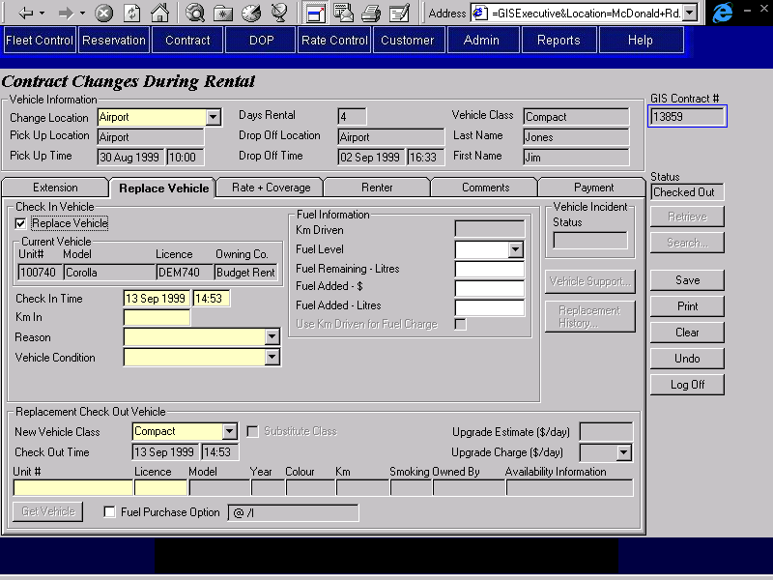
Purpose
The Replace Vehicle tab is used to switch vehicles during the rental. Buttons are available to access Vehicle Support and Replacement History. There are two sections to this tab, Check In Vehicle and Replacement Check Out Vehicle.
Check In Vehicle
The Check In Vehicle section allows for the check in of the current vehicle for the contract. This will transfer the responsibility for the vehicle from the Renter to Budget.
If the vehicle is not present then the check in will have been completed by vehicle support. In this case, the CSR will only be able to be able view the check in information. This is the only case where the Vehicle Not Present reason and location will be visible to the CSR.
If an override check in was done for the vehicle so that it could be checked out on another contract, the contract number will be displayed on the screen and the check in time, fuel level and fuel remaining fields will default from the override check in. If the CSR updates the check in time, it will be edited to ensure that it doesn’t conflict with an existing vehicle on contract.
Replacement Check Out Vehicle
The Replacement Check Out Vehicle section allows for the selection and check out of a replacement vehicle for the contract. If there is a vehicle support incident for the contract where Switch Allowed has been set to No, this section will not be visible and the text ‘Do No Replace Vehicle’ will be displayed instead.
The CSR can choose to change the vehicle class at this point provided the new vehicle class has the same vehicle type and the previous vehicle class. When a vehicle is replaced with a vehicle of another class and the Substitute Class check box is not checked, the CSR will have to select from a pre-defined list of daily upgrade charges. One of the charges on the pre-defined list should be zero, in case the customer is downgrading rather than upgrading. There will be no editing of the charge chosen. If there is no vehicle class change, or the CSR turns on the Substitute Class checkbox (because there was a problem with the vehicle, and another vehicle of the original class is not available) then the Upgrade Charge field will not be available.
Whenever there is a vehicle class change and the substitute class check box is not on, GIS will calculate the estimated daily upgrade charge. This is the average daily difference between the original vehicle class using the contract rate and the current rack rate for the new vehicle class. This is calculated by taking the current vehicle rental time charge divided by the number of days in the rental period and subtracting the current day 1 walk up rack rate for the upgrade vehicle class. If there is no day 1 walk up rack rate, the daily upgrade charge cannot be calculated and will not be displayed. If the difference is negative then 0 will be displayed. This will be used as a reference by the CSR.
If the vehicle class being downgraded at the customer’s request, the Upgrade Charge selected will be 0 and no discount or refund should be applied to the contract. If the vehicle class is being downgraded because there was a problem with the original vehicle and another vehicle of the original class is not available, the location manager or supervisor can apply a discount to the contract through the Vehicle Support screen.
If a truck vehicle class is being changed, the CSR must first ensure that it is possible to check out a vehicle of the vehicle class requested at that location at the current time. The Truck Rental Availability button will bring up a screen showing truck availability, depending on the vehicle class requested. A CSR cannot change to a truck vehicle class that is not available (availability = No or 0). A supervisor may override this restriction and check out a vehicle that is showing no availability.
Minimum age requirement and LDW deductible (if applicable) will change to meet the replacement vehicle class regardless of whether the vehicle class change is an upgrade, downgrade, or substitution.
PST will change to meet the replacement vehicle model regardless of whether the vehicle class change is an upgrade, downgrade, or substitution.
The CSR will enter the vehicle’s unit number and licence plate number and then hit the Get Vehicle button. If the vehicle is not available because it is still checked out on another contract, or has an incomplete vehicle movement a popup screen will be opened and the CSR will have the option of checking in the vehicle from the previous contract or completing the movement.
If any turnback warnings for the vehicle are applicable, the Do Not Extend Rental flag (located on the Extension Tab) will be turned on automatically and will be locked.
The CSR also has the option of overriding the check out time, which will default to the check in time entered in the Vehicle In screen. The override check out time will only be enterable if the vehicle being checked in is the first vehicle for the contract. It is used to enter a later check out time if the first vehicle checked out for a contract is not usable and the renter has to return to the counter to get another vehicle (vehicle not on lot, vehicle not clean, etc.). The override check out time should not be changed if the renter switches the vehicle for any other reason (doesn’t like colour, wants different vehicle options, etc.). For the second or greater vehicle on a contract, the check in time must be greater than the check out time for that vehicle.
Fuel Purchase Option
FPO may be sold at check out time, or when a vehicle replacement is done. Once sold, FPO cannot be removed from a contract.
If a vehicle replacement is done and FPO has already been sold for the contract, the FPO charge will be prorated for the vehicle it was sold for and for all subsequent vehicles checked out on the contract. This means that the ability to enter the information required to calculate fuel charges (fuel tank level, fuel added, litres of fuel remaining, etc.) will be required for vehicle replacements and check ins where FPO was sold and subsequent vehicle replacement was done.
See the Calculate FPO Charges Function for more details.
Navigation
Vehicle Support: Opens the Vehicle Support screen where vehicle incidents have been logged for the current contract. Disabled if no vehicle support incidents have been logged.
Replacement History: Displays the Vehicle Replacement history for the contract. Disabled if no history exists.
Truck Rental Availability: Opens the Truck Rental Availability screen to display truck availability for the replacement rental period. Only visible when vehicle class is a truck.
Functions
Get Vehicle: Checks unit number and licence plate number entered in the Check Out Vehicle information, selects the unit number for check out and populates the other fields in Check Out Vehicle with the information for the vehicle selected. If the Replacement Vehicle Class selected has a different Vehicle Type from the previous Vehicle Class, then an error message will be displayed.
The unit number entered must meet all the criteria described in the notes in the section for the Location Vehicle Availability Screen, except for the Vehicle Rental Status, which can be “On Rent” or “In Transit” as well as “Available”. If the Vehicle Rental Status is ‘On Rent’ the expected drop off location must be the location where the current contract is being opened and the check out time for the current vehicle on contract must be less than the pick up time for the new contract. If the Vehicle Rental Status is ‘In Transit’ the receiving location for the movement must be the location where the current contract is being opened. If any of these conditions are not met, a message will be displayed stating why the vehicle can’t be checked out.
If the unit number is currently on rent or in transit and the conditions above are met, the Make Vehicle Available screen will be opened to give the CSR the ability to check in the vehicle or complete the vehicle movement. If the CSR does not check in the vehicle or complete the movement, the vehicle cannot be checked out on the new contract.
If the Warranty Repair Rate flag is on for the rate selected, the manufacturer for the unit number must match the manufacturer in the rate.
If there is more than one vehicle that match the unit number and licence plate that meet the criteria described above, a search results grid will be displayed with all vehicles returned. The user would then select the vehicle from the search results grid and that record would populate the vehicle section of the tab.
Check In: Invoked when the save button is pressed. Checks in the currently checked out vehicle. Sets the status of the vehicle as indicated by the CSR on the screen. If the vehicle being checked in is not the first vehicle on contract, validates that the check in time is greater than the check out time for that vehicle. See Technical Notes for a description of fields that require updating with this function.
Controls
Req*: Y – always mandatory
N – always optional
S – sometime optional (see Comments for details)
D – display only
Field | Source | Req* | Validation | Comments
Check In Vehicle
Replace Vehicle |  | N |  | Disabled unless Change Location is a rental location All other fields on this tab will be locked or disabled until this is turned on.
Current Vehicle |  | D |  | Displays information for the vehicle currently checked out (Vehicle On Contract where Actual Check In is null).
Unit # | Vehicle On Contract, Unit Number | D
Model | Vehicle, Vehicle Model ID | D |  | For Unit Number identified in Vehicle On Contract. Model Name is displayed
Licence | Vehicle, Current Licence Plate | D |  | For Unit Number identified in Vehicle On Contract.  The vehicle licence plate that is in effect on the current date is shown.
Owned By | Vehicle, Vehicle Owning Company | D |  | For Unit Number identified in Vehicle On Contract.
Check In Time | Vehicle On Contract, Actual Check In | Y | Date and time.  If there is an Override Check In for the Vehicle on Contract, cannot conflict with the Vehicle On Contract for this vehicle and the Override Contract Number. | Default to Override Check In, Check In if an Override Check In exists for the Vehicle on Contract. Default to current time otherwise.
Km In | Vehicle On Contract, Km In | S | Numeric | Default to Override Check In, Km In if an Override Check In exists for the Vehicle on Contract.  Required unless vehicle is not present.
Reason | Vehicle On Contract, Check In Reason | Y | Value controlled by Check In Reason table.
Vehicle Condition | Vehicle On Contract, Vehicle Condition | Y | Value controlled by Vehicle Condition table.
Override Check In Done by Contract | Override Check In, Override Contract Number | D |  | Only visible if an Override Check In exists for the Vehicle On Contract.
Fuel Information |  | Y |  | At least one enterable field must be not null.
Km Driven |  | D |  | Vehicle On Contract, (Km In – Km Out)
Fuel Level | Vehicle On Contract, Fuel Level | N | Values are in 8ths or Full or Empty. | Default to Override Check In, Fuel Level if an Override Check In exists for the Vehicle on Contract.  Not visible if the vehicle is a foreign model (tank size may not be available for calculating amount of fuel needed to make a full tank). Not visible if Change Location is foreign (fuel price per litre may not be available to calculate charges).
Fuel Remaining – Litres | Vehicle On Contract, Litres of Fuel Remaining | N | Numeric | Default to Override Check In, Fuel Remaining In if an Override Check In exists for the Vehicle on Contract.  Not visible if the vehicle is a foreign model (tank size may not be available calculating amount of fuel needed to make a full tank). Not visible if Change Location is foreign (fuel price per litre may not be available to calculate charges).
Fuel Added - $ | Vehicle On Contract, Fuel Added $ | N | Currency
Fuel Added – Litres | Vehicle On Contract, Fuel Added Litres | N | Numeric | Not visible if Change Location is foreign (fuel price per litre may not be available to calculate charges).
Use Km Driven for Fuel Charge |  | N |  | Km Driven will be used for fuel charges if this is turned on. Only enabled when all other fuel fields are empty. Not visible if the vehicle is a foreign model (both tank size and km/litre may not be available for calculating amount of fuel needed to make a full tank). Not visible if Change Location is foreign (fuel price per litre may not be available to calculate charges).
Vehicle Not Present |  | D |  | Only visible if fields are not null. Enterable by Vehicle Support only (through the Vehicle Support screen). See Vehicle Support Business Design for more details.
Reason | Vehicle On Contract, Vehicle Not Present Reason | D | Value controlled by Vehicle Not Present Reason table.
Location | Vehicle On Contract, Vehicle Not Present Location | D
Vehicle Incident |  |  |  | Display if Vehicle Support Incident exists for the current or previous Vehicles On Contract for the current contract; otherwise hide.
Status | Vehicle Support Incident, Status | D |  | Status = Unresolved if any of the Vehicle Incidents for the currently checked out vehicle have a status of unresolved, otherwise resolved.
Replacement Check Out Vehicle |  |  |  | If Contract, Do Not Replace Vehicle is Yes, this section will not be visible and the text ‘Do No Replace Vehicle’ will be displayed instead.
New Vehicle Class | Contract, Vehicle Class Code | Y | Value controlled by Location Vehicle Class table (for the switch location). | Vehicle Class Name is displayed.
Substitute Class | Contract, Substitute Class Code | N |  | Disabled unless the vehicle class is changed.
Replacement Check Out Time | Vehicle On Contract, Checked Out | Y |  | Defaults to the Check In Time on the Vehicle In sub-tab.  Locked unless the vehicle being checked in is the first vehicle for the contract, the first vehicle check in time equals the first vehicle check out time, and the current time is within 12 hours of the first vehicle check out time.  Used to update Contract, Pick Up On if not locked and changed by the CSR.
Upgrade Estimate (/day) |  | D |  | Calculated by GIS. See technical notes.
Upgrade Charge (/day) | Vehicle On Contract, Upgrade Charge | S | Value controlled by upgrade charge table. | Defaults to Upgrade Charge from the current Vehicle On Contract (if any).  Required when vehicle class changed and substitute class is not checked, disabled otherwise.
Check Out Vehicle
Unit # | Vehicle On Contract, Unit Number | S | For the validation rules that apply when a unit number and licence number is entered here, see the Get Vehicle function notes. | Required if checking out a vehicle.
Licence | Vehicle, Current Licence Plate | Y |  | Required if Unit # entered. Must match the vehicle licence plate that is in effect for the Unit # on the current date is shown.  For Unit Number identified in Vehicle On Contract.
Model | Vehicle, Vehicle Model ID | D |  | Model Name is displayed.  For Unit Number identified in Vehicle On Contract.
Year | Vehicle, Vehicle Model ID | D |  | Model Year is displayed.  For Unit Number identified in Vehicle On Contract.
Colour | Vehicle, Exterior Colour | D |  | For Unit Number identified in Vehicle On Contract.
Km | Vehicle On Contract, Km Out | D |  | If an override check in or movement completion was done and Km was entered, this field will be set to the Km entered there instead.
Smoking | Vehicle, Smoking | D | Yes/No | For Unit Number identified in Vehicle On Contract.
Owned By | Vehicle, Vehicle Owning Company | D |  | For Unit Number identified in Vehicle On Contract.
Availability Information | N/A | D |  | See the notes in the section on the Location Vehicle Availability screen.
Fuel Purchase Option | Vehicle On Contract, FPO Purchased | N | Flag | If FPO purchased for check in vehicle then FPO purchased = Yes and cannot be updated.
(Fuel Purchase Option Price) | Vehicle On Contract, FPO Purchased | D | Currency | Dollar amount if FPO purchased is Yes, otherwise blank. See FPO Calculation Function.
Replacement Contract # | Vehicle On Contract, Replacement Contract Number | N |  | Only visible when the current and replacement vehicles have different owning companies.
Technical Notes
Drop Off Charge
See Calculate Drop Charges Function
Replace Vehicle
The Vehicle table must be updated with the values for the fields shown:
Vehicle table column: Update from the new Vehicle on Contract:
Current Km Km In
Current Location ID Actual Drop Off Location ID
Current Rental Status ‘Available’
Rental Status Effective On Actual Check In
Current Condition Status Vehicle Condition
Condition Status Effective On Actual Check In (if Current Condition Status has changed)
If the Condition Status has changed a new condition status record for the vehicle must be created, using the new Condition Status and Actual Check In:
If the Check Out Time was changed by the CSR the following fields must be set to the Check Out Time:
- Contract, Pick Up On
- each Contract Optional Extra, Rent From where Rent From equals Contract, Pick Up On
- each Additional Driver, Valid From where Valid From equals Contract, Pick Up On
Upgrade Estimate Charge
In order to help the CSR sell the upgrade and to assist them in choosing the best upgrade charge to apply, the following information will be displayed:
The difference between:
- The current vehicle rental time charge divided by the number of days in the rental period.
- The current day 1 walk up rack rate for the upgrade vehicle class.
If the difference is negative, zero will be displayed.

Rate and Coverage Tab
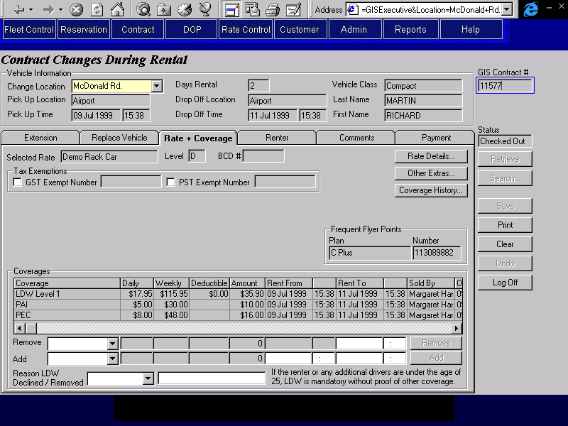
Purpose
This tab allows the CSR to view the rate, insurance transfer information, and frequent flyer plan information. Current coverages (LDW, Deductible Buydown, PAI, PEC, Cargo Insurance) may be viewed, added, or removed as required. Buttons are available to access the rate details screen, the other extras screen, and the coverage history screen.
Coverages
The CSR may remove a coverage by selecting it (which will populate the Remove section), changing the Rent To date and hitting the Apply button. If LDW is removed, a reason must be entered. If the renter or any other additional drivers are under the age limit for mandatory LDW, the reason for removing LDW cannot be ‘No Coverage’. Note: spousal and other company additional drivers are not included in the age check for mandatory LDW.
If LDW is removed and the reason is not ‘No Coverage’, a Deductible Buydown option will become visible in the Add Coverage fields and the CSR will have the option of adding the Deductible Buydown coverage.
The CSR may also add a coverage to the contract here by entering the details in the Add section and hitting the Apply button.
If any coverage is being added then a message will be displayed to prompt the CSR to check the vehicle for damage.
If coverage is being changed then a message will be displayed prompting the CSR to obtain the signature of the renter.
Navigation
Rate Details: Opens the Rate Details screen where the details of the selected rate are displayed included inclusions and restrictions.
Other Extras: Opens the Other Extras screen. The CSR may view, add or remove other extras as required. Other extra history, flex discounts, and membership discounts may also be viewed here.
Coverage History: Opens the Coverage History screen where the history of changes to coverages for the contract is displayed. Disabled if there is no history (no coverages with a termination date).
Functions
Remove: Makes the selected coverage inactive and creates a copy of the coverage
with a new Rent To date/time. The new coverage is added to the coverage list and the Remove information is cleared.
Add Adds the selected coverage to the contract. The new coverage is
added to the coverage history list and the Add information is cleared. The maximum quantity cannot be exceeded for any coverage being added.
Controls
Req*: Y – always mandatory
N – always optional
S – sometime optional (see Comments for details)
D – display only
Field | Source | Req* | Validation | Comments
Selected Rate | Contract, Rate IDand Rate Level  OR  Contract, Quoted Rate ID | D |  | Rate name and level or Quoted Rate Name are displayed.
BCD # | Contract, BCD Rate Organization ID | D |  | If a BCD organization was selected in the Walk Up screen or in the Reservation, the BCD # for the organization will display here.
Restriction /Violation Rate message |  | D |  | Display the message if a violation rate has been applied or if there is a special rate restriction that should be manually checked by the CSR.
GST Exempt |  | N |  | When an existing contract is retrieved, will be set on if GST Exemption Number is populated.
Number | Contract, GST Exemption Number | S | Required if GST Exemption is turned on.
PST Exempt |  | N |  | When an existing contract is retrieved, will be set on if PST Exemption Number is populated.
Number | Contract, PST Exemption Number | S | Required if PST Exemption is turned on.
Frequent Flyer Points |  | D |  | Visible if Frequent Flyer Plans Honoured is Yes for contract rate; otherwise not visible.
Plan | Contract, Frequent Flyer Plan ID | D |  | Display Frequent Flyer Plan, Frequent Flyer Plan
Number | Contract, Frequent Flyer Plan Member Number | D
Insurance Transfer
Company Name | Insurance Transfer, Company Name | D
Expiry | Insurance Transfer, Expiry | D
Collision |  | D |  | No if collision deductible is null; Yes otherwise.
Deductible | Insurance Transfer, Collision Deductible | D
Comprehensive |  | D |  | No if comprehensive deductible is null; Yes otherwise.
Deductible | Insurance Transfer, Comprehensive Deductible | D
Manufacturer | Insurance Transfer, Vehicle Manufacturer | D
Model | Insurance Transfer, Vehicle Model | D
Year | Insurance Transfer, Vehicle Year | D | Year
Licence Plate | Insurance Transfer, Vehicle Licence Plate | D
Coverages |  |  |  | Display only current optional extras with type = LDW, Buydown, PAI, PEC, Cargo Insurance.
Option | Contract Optional Extra, Optional Extra ID | D |  | Optional Extra name is displayed.
Daily | Contract Optional Extra, Daily Rate | D |  | Rate will not vary with quantity.
Weekly | Contract Optional Extra, Weekly Rate | D |  | Rate will not vary with quantity.
Deductible | LDW Deductible, LDW Deductible. | D |  | For Optional Extra and Vehicle Class.
Amount |  | D |  | Calculated based on rental period and quantity. Displays cheapest combination of daily and weekly rates.
Rent From | Contract Optional Extra, Rent From | D
Rent To | Contract Optional Extra, Rent To | D
Sold or Removed By/On/At | Contract Optional Extra, Sold/Removed By & Sold/Removed On & Sold At Location ID | D |  | Location Name is displayed for Sold At Location ID.
Remove |  |  |  | Populated by selecting an entry in the Option drop down list.
Option | Contract Optional Extra, Optional Extra ID | N | Selection controlled by entries in current Coverage grid (above) | Optional Extra name is displayed.
Daily | Contract Optional Extra, Daily Rate | D |  | Rate will not vary with quantity.
Weekly | Contract Optional Extra, Weekly Rate | D |  | Rate will not vary with quantity.
Deductible | LDW Deductible, LDW Deductible. | D |  | For Selected Optional Extra and Vehicle Class.
Amount |  | D |  | Calculated based on rental period and quantity. Displays cheapest combination of daily and weekly rates.
Rent From | Contract Optional Extra, Rent From | D
Rent To | Contract Optional Extra, Rent To | S | Date & Time  Must be <= Drop Off Time | Required to Remove if Remove information populated.
Reason LDW Declined/Removed | Contract, LDW Declined Reason | S | Value controlled by LDW Declined Reason table. Cannot be ‘No Coverage’ if the renter or any other additional drivers are under the age limit for mandatory LDW. | Required if LDW is removed. Only visible if LDW is or has been removed.
Details | Contract, LDW Declined Details | N |  | Only visible if LDW is or has been removed.
Add
Option | Contract Optional Extra, Optional Extra ID | N | Selection Only  Value controlled by Optional Extra table (Type = LDW, Buydown, PAI, PEC and Cargo Insurance) and Optional Extra Restriction table | Optional Extra name is displayed.
Daily | Contract Optional Extra, Daily Rate | D |  | Rate will not vary with quantity.
Weekly | Contract Optional Extra, Weekly Rate | D |  | Rate will not vary with quantity.
Deductible | LDW Deductible, LDW Deductible. | D |  | For selected Optional Extra and Vehicle Class.
Amount |  | D |  | Calculated based on rental period and quantity. Displays cheapest combination of daily and weekly rates.
Rent From | Contract Optional Extra, Rent From | S | Date & Time  Must be >= Pick Up Time. | Defaults to current date/time.  Required if an Optional Extra is selected.
Rent To | Contract Optional Extra, Rent To | S | Date & Time  Must be <= Drop Off Time | Defaults to Drop Off Time.  Required if an Optional Extra is selected.

Renter Tab
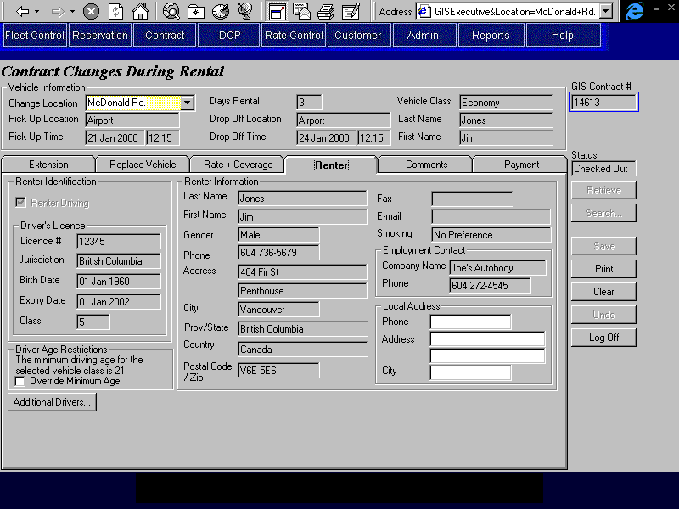
Purpose
The Renter tab allows the CSR to view renter and additional driver information, to remove and add additional drivers and to update local contact information for the renter. Checks will be run on all new additional drivers to ensure that they are not unwanted customers.
The CSR can view information about any additional drivers and terminate or add additional drivers by pressing the “Additional Drivers” button. If the renter is not driving, at least one additional driver must always be specified.
Navigation
Additional Drivers: Opens the Additional Drivers screen so that additional drivers can be removed from or added to the contract. Note that while existing additional drivers may be removed, their details may not be updated.
Functions
N/A
Controls
Req*: Y – always mandatory
N – always optional
S – sometime optional (see Comments for details)
D – display only
Field | Source | Req* | Validation | Comments
Renter Identification
Driving/  Not Driving | Contract, Renter Driving | D
Driver’s Licence |  | D |  | Display if Contract, Renter Driving is Yes; otherwise hide.
Licence # | Renter Driver Licence, Number | D
Jurisdiction | Renter Driver Licence, Jurisdiction | D
Birth Date | Contract, Birth Date | D
Expiry Date | Renter Driver Licence, Expiry | D
Class | Renter Driver Licence, Class | D
Other Identification |  | D |  | Display if Contract, Renter Driving is No; otherwise hide.
ID Type | Non Driving Renter ID, ID Type | D
ID # | Non Driving Renter ID, Number | D
Birth Date | Contract, Birth Date | D
Expiry Date | Non Driving Renter ID, Expiry | D
Driver Age Restrictions |  | D |  | Shows the age restrictions for the vehicle class requested and the organization (if any).
Override Minimum Age | Contract, Override Minimum Age | N |  | Not visible if contract is linked to a BCD organization (BCD Rate Organization ID is not null). Display only if Yes when contract is retrieved.
Renter Information
Last Name | Contract, Last Name | D
First Name | Contract, First Name | D
Gender | Contract, Gender | D
Phone | Contract, Phone Number | D
Address | Contract, Address 1, Address 2 | D
City | Contract, City | D
Prov/State | Contract, Province/State | D
Country | Contract, Country | D
Postal Code/Zip | Contract, Postal Code | D
Fax | Contract, Fax Number | D
E-mail | Contract, Email Address | D
Smoking | Contract, Smoking/Non-Smoking | D
Employment Contact |  | D
Company Name | Contract. Company Name | D
Phone | Contract, Company Phone Number | D
Local Address
Phone | Contract, Local Phone Number | N
Address | Contract, Local Address 1 and Local Address 2 | N
City | Contract, Local City | N

Comments Tab
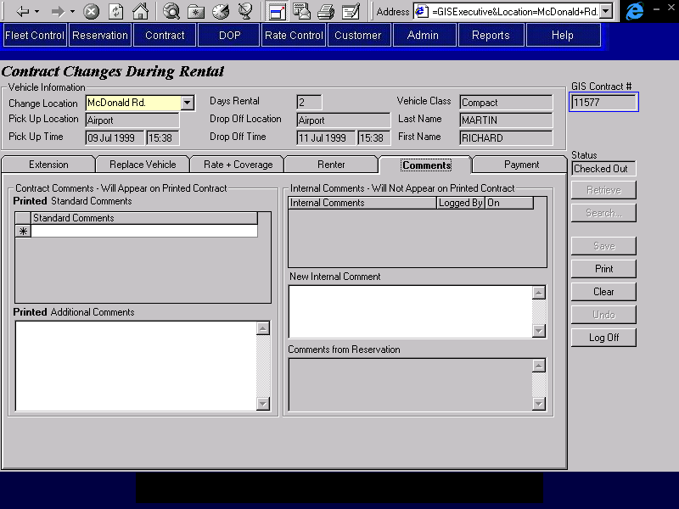
Purpose
The Comments tab is used to view comments entered by the agent who made the reservation and to view and enter comments about the contract. This will facilitate communication between different CSRs who may work on the same contract. Two types of comments can be entered; comments that will appear on the printed contract and comments that will not appear on the printed contract. The reservation comments will not appear on the printed contract.
The Contract Comments section contains the comments that will be printed on the contract. The CSR may select comments from a pre-existing list or enter free text to appear on the printed contract.
The Internal Comments section contains the comments that are for internal use only and will not appear on the printed contract. The CSR may add new comments to this section but cannot alter existing comments. Upon saving changes to the contract, the new comments will be protected and the user id that entered the comment and the time at saving will be recorded.
Navigation
N/A
Functions
N/A
Controls
Req*: Y – always mandatory
N – always optional
S – sometime optional (see Comments for details)
D – display only
Field | Source | Req* | Validation | Comments
Contract Comments- Will Appear on Printed Contract
Printed Standard Comments | Contract Print Comment, Standard Print Comment | N | Values controlled by Contract Print Standard Comment table.
Printed Additional Comments | Contract, Print Comment | N | Free form text. Maximum length 255 characters.
Internal Comments – Will Not Appear on Printed Contract
Internal Comments | Contract Internal Comment, Comments | D
Logged By | Contract Internal Comment, Logged By | D
Logged On | Contract Internal Comment, Logged On | D
New Internal Comments | Contract Internal Comment, Comments | N | Free form text. Maximum length 255 characters.
Comments from Reservation | Reservation Comment, Standard Reservation Comment ID; Reservation, Special Comments | D |  | Concatenation of Standard Reservation Comments for the reservation and Reservation, Special Comments
Technical Notes
When a new internal comment is saved to the Contract Internal Comment table, the user ID of the person who entered the comment and the date and time that the comment was entered must also be saved.

Payment Tab
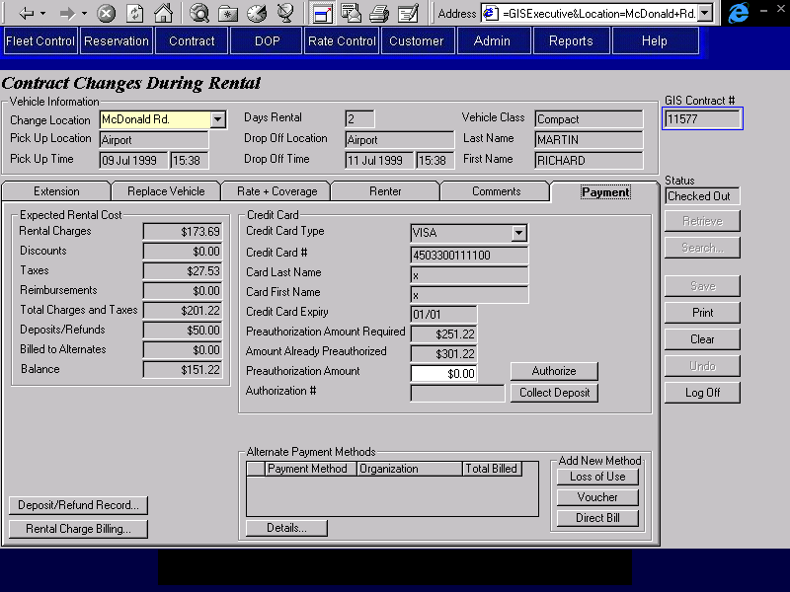

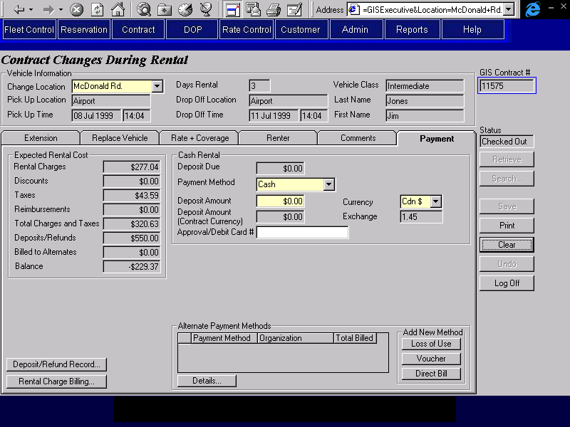

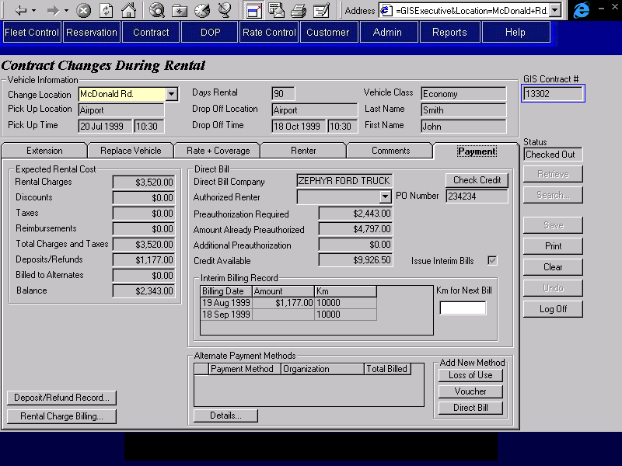
Purpose
The payment tab allows the CSR to view all payment transactions and charges for the contract.
If any changes to the contract have been made, the new amounts will display on the tab. If the pre-authorization or cash rental deposit amount required have increased, the CSR will do one of the following:
- For a rental pre-authorized by the renter with a credit card:
Authorize the additional pre-authorization amount required on the credit card used for the rental.
- For a rental pre-authorized by the renter with a cash deposit:
Record the collection of the additional deposit required.
- For a rental pre-authorized by a direct bill company:
Perform a credit check on the additional pre-authorization amount required.
If the renter chooses to make additional deposits by cash or credit card at this time, the CSR will enter them on the Deposit/Refund Record screen and they will reduce the additional pre-authorization amount or cash rental deposit required.
Buttons are available to access the Rental Charge Billing screen, where the CSR may add new alternate payment methods and re-assign rental charges to the parties paying for the rental, and the Deposit/Refund screen, where authorizations, deposits and refunds may viewed and added.
If any of the contract charges are being billed to an alternate payment organization and the rental charges are recalculated the CSR will be need to go to the Rental Charge Billing screen to re-assign the all alternate payment charges.
Navigation
Check Credit: Opens the Credit Check screen and displays credit information for the
(Direct Bill) direct bill company or alternate payment organization.
Rental Charge Opens the Rental Charge Billing screen where alternate payment billing
Billing: details are viewed and entered and where the charges for the rental items can be viewed and re-assigned to the party responsible for the rental and to any alternate payment organizations.
Deposit/Refund Opens the Deposit/Refund Record screen where the details of cash
Record: deposits and refunds, credit card deposits and refunds, and additional credit card authorizations can be viewed. Only new deposits and authorizations may be added, no refunds are allowed at this time.
Details: Opens the appropriate alternate payment details screen (Loss of Use, Voucher or Direct Bill) for the selected alternate payment organiation so that the CSR can view or update the required details.
Loss of Use: Opens the Loss of Use details screen so that the CSR can enter a new Loss of Use alternate payment organization.
Voucher: Opens the Voucher details screen so that the CSR can enter a new Voucher alternate payment organization.
Direct Bill: Opens the Direct Bill details screen so that the CSR can enter a new Direct Bill alternate payment organization.
Functions
Authorize: Perform a credit card authorization for the credit card and pre-authorization
(Credit Card) amount specified. For details on the credit card authorization process, see the Credit Card Authorization function description in this document.
If the automated authorization facility is not available or the credit card type has no automatic authorization, opens the Manual Credit Card Transaction screen and populates it with the credit card and authorization amount information from this tab. After the screen is closed, the authorization number returned will be displayed on this tab.
Collect Collect a deposit payment for the credit card and pre-authorization
Deposit: amount specified. For details on the credit card deposit process, see the Credit Card Payment function description in this document.
If the automated payment facility is not available or the credit card type has no automatic payment, opens the Manual Credit Card Transaction screen and populates it with the credit card and authorization amount information from this tab. After the screen is closed, the authorization number returned will be displayed on this tab.
Generate Accounting Interface entries for the deposit. For details, see the section on Accounting Interface Entries for Changes During Rental.
Controls
Req*: Y – always mandatory
N – always optional
S – sometime optional (see Comments for details)
D – display only
Controls (cont.)
Field | Source | Req* | Validation | Comments
Expected Rental Cost
Rental Charges |  | D |  | Calculated by GIS. Sum of all charges excluding discounts and reimbursements on the Rental Charge Billing sub-screen.
Discounts |  | D |  | Calculated by GIS. Sum of all discounts applied to contract, including member discounts.
Taxes |  | D |  | Calculated by GIS, based on rental charges less discounts. Sum of all GST, PST, and PVRT amounts on the Rental Charge Billing sub-screen.
Reimbursements |  | D |  | Calculated by GIS. Sum of all reimbursements applied to contract.
Totals Charges and Taxes |  | D |  | Calculated by GIS. Sum of rental charges, discounts, taxes and reimbursements (four fields directly above).
Deposits/Refunds |  | D |  | Calculated by GIS. Sum of all deposits and refunds applied to contract (sum of all deposit and refund entries in the Deposit/Refund Record sub-screen).
Billed to Alternates |  | D |  | Calculated by GIS. Sum of all rental charges and taxes billed to alternate payment organizations (sum of the Total Billed column in the Alternate Payment Methods grid).
Balance |  | D |  | Total Charges and Taxes, less Deposits/Refunds and Billed to Alternates (three fields directly above).
Renter Pre-Authorization – Credit Card |  |  |  | Display when Renter has pre-authorized the rental with a credit card: Contract Billing Party with Billing Type ‘Primary’ has Billing Method ‘Renter’ and Renter Primary Billing has Renter Authorization Method ‘Credit Card’. Hide otherwise.
Credit Card Type | Renter Primary Billing, Credit Card Key | D |  | Display type from Credit Card, Credit Card Type ID
Credit Card # | Renter Primary Billing, Credit Card Key | D |  | Display Credit Card, Credit Card Number
Card Last Name | Renter Primary Billing, Credit Card Key | D |  | Display Credit Card, Last Name
Card First Name | Renter Primary Billing, Credit Card Key | D |  | Display Credit Card, First Name
Credit Card Expiry | Renter Primary Billing, Credit Card Key | D |  | Display Credit Card, Expiry
Preauthorization Amount Required |  | D |  | Calculated by GIS. See Calculate Pre-authorization Amounts & Cash Rental Deposit Function.
Amount Already Preauthorized |  | D |  | Calculated by GIS from the sum of all the authorizations against the credit card on the contract (Authorization section on Deposit/Refund sub-screen).
Preauthorization Amount | Credit Card Authorization, Amount Authorized | Y |  | Defaults to Preauthorization Required minus Amount Already Preauthorized.
Authorization # | Credit Card Authorization, Authorization Number | D |  | Populated only when authorization completed, cleared if Calculate Rental Charges is executed.
Renter Pre-Authorization – Cash |  |  |  | Display when Renter has pre-authorized the rental with a cash rental deposit: Contract Billing Party with Billing Type ‘Primary’ has Billing Method ‘Renter’ and Renter Primary Billing has Renter Authorization Method ‘Cash’. Hide otherwise.
Deposit Due |  | D |  | Calculated by GIS. See Calculate Pre-authorization Amounts & Cash Rental Deposit Function.
Payment Method | Cash Payment, Cash Payment Type | Y | Selection only  Value controlled by Cash Payment Type table | Defaults to Cash
Deposit Amount | Cash Payment, Foreign Currency Amount Collected | Y |  | Defaults to Deposit Due
Currency | Cash Payment, Currency ID | Y | Selection only  Value controlled by Currency table | Defaults to Cdn $
Deposit Amount (Contract Currency) | Contract Payment Item, Amount | D |  | Converts Deposit Amount into Canadian funds.
Exchange | Cash Payment, Exchange Rate | D |  | Defaults to current exchange rate for Currency
Approval/Debit Card # | Cash Payment, Identification Number | N
Direct Bill Pre-Authorization |  |  |  | Display when the rental has been pre-authorized by a direct bill company: Contract Billing Party with Billing Type ‘Primary’ has Billing Method ‘Direct Bill’. Hide otherwise.
Direct Bill Company | Contract Billing Party, Customer Code | D |  | AR Customer Master, Address Name is displayed
Authorized Renters | AR Customer Master, Address Name | D |  | Populated with all AR Customer Master records for the same Customer Code with an Address Type of 1.
PO Number | Direct Bill Primary Billing, PO Number | D
Preauthorization Required |  | D |  | Calculated by GIS. See Calculate Pre-authorization Amounts & Cash Rental Deposit Function.Used to update Contract Billing Party, Amount Removed From Available Credit
Amount Already Preauthorized | Contract Billing Party, Amount Removed From Available Credit | D |  | Less any payments already posted to A/R for the direct bill party.(A/R Payment table).
Additional Preauthorization |  | D |  | Defaults to Preauthorization Required minus Amount Already Preauthorized. Will display zero if less than zero.
Credit Available |  | D |  | Calculated by GIS. A/R Customer Master, Credit Limit minus the sum of A/R Customer Activity, Amount Balance; A/R Credit Authorization, Daily Contract Total; and A/R Credit Authorization, Expect Open Contract Charges.
Issue Interim Bills | Direct Bill Primary Billing, Issue Interim Bills | D
Interim Billing Record |  |  |  | Display if any Interim bills have been issued or if Issue Interim Bills flag is Yes. Hide otherwise.
Billing Date | Interim Bill, Interim Bill Date | D
Amount | Contract Payment Item, Amount | D |  | From Contract Payment Item for the A/R Payment linked to Interim Bill
Km | Interim Bill, Current Km | D
Km for Next Bill | Interim Bill, Current Km | N |  | Used to update the Contract Interim Bill record that has a null Amount and that has the earliest Bill Date greater than the current date.
Alternate Payment Methods |  |  |  | Locked if BCN populated.  Show one row for each Contract Billing Party record where Billing Type = Alternate.
Payment Method | Contract Billing Party, Billing Method | D
Organization | Contract Billing Party, Customer Code | D |  | AR Customer Master, Address Name is displayed
Total Billed | Contract Billing Party, Amount Removed from Available Credit | D |  | Calculated by GIS from the charges assigned to the alternate payment organization in the Rental Charge Billing sub-screen. Saved to Amount Removed from Available Credit.
Technical Notes
Exchange Rate
When calculating the exchange rate for cash deposits in foreign currency, use the exchange rate for the location if there is one; otherwise use the standard exchange rate.
Interim Billing
If the rental period is extended for a contract with direct bill authorization where Issue Interim Bills is turned on, create Interim Bill records for each 30 day period following the pick up date that falls within the rental extension period.
For example: a contract starting on Aug. 14, 1998 with an expected drop off date of Nov. 30, 1998 will have the following additional Interim Bill records created if the drop off date is extended to Jan. 30.
Dec. 11, 1998
Jan. 10, 1999
If the rental period is shortened for a contract with direct bill authorization where Issue Interim Bills is turned on, delete the Interim Bill records that fall beyond the new rental period.
For example: a contract starting on Aug. 14, 1998 with an expected drop off date of Nov. 30, 1998 will have the following additional Interim Bill records deleted if the drop off date is shortened to Oct. 30, 1998.
Nov. 11, 1998

Contract Check In Screen
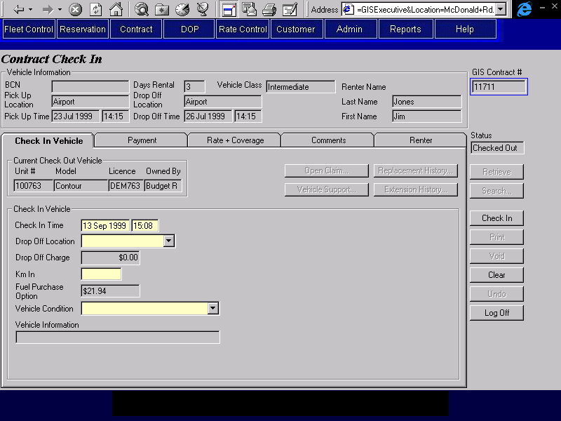
Purpose
The Contract Check In screen is used for the final check in for the vehicle rental. The Contract Check In ends the responsibility of the renter for the rental vehicle and any optional extras that may also have been rented. Payment is collected, to which adjustments may be made after Check In. Note that a contract cannot be checked in until the balance owing is zero. A printed copy of the contract may be produced from the Check In screen once check in is complete, the contract cannot be printed if check in is not complete. Finally, a contract may be voided here provided check out has occurred on the same RBR date.
If any of the data entered at check in results in the calculate rental charges being updated and if any of the updated charges were assigned to an alternate billing party, the reassigments will be cleated and the CSR will have to reassign the charges (a message will be issued).
This screen can also be used to view contracts that have a status of Checked In, Void and Cancelled. When a contract with one of these statuses is retrieved, all the enterable fields on this screen and on sub-screens opened from this screen will be locked and all buttons will be disabled except for Clear and the buttons that allow viewing of sub-screens. For reasons of clarity, this is not documented in more detail below. The rest of the documentation for this screen assumes that the contract that is retrieved has a status of Checked Out.
If the contract being retrieved has a rate that has a Km Drop Off Charge, a message will be displayed prompting the CSR to enter the drop charges manually.
The screen is organized into six areas: the base screen and five tabs. The base screen displays pick up and drop off locations and times, the vehicle class requested, the customer name and BCN (if applicable) and the contract number and status. The tabs contain the remaining required contract information and are categorized as follows:
Check In Vehicle: Where the currently checked out vehicle may be checked in.
Payment: Where the party responsible for the rental is displayed and payment and authorization information is displayed and entered. Buttons are available to:
- Identify alternate payment organizations and assign rental charges to them.
- Record details of cash deposits, credit card deposits and refunds, and credit card authorizations.
Rate + Coverage: Where the information that determines the amount to be charged for the rental is displayed. This includes the base rate, coverages, and other extras. Insurance transfer details and frequent flyer information may be viewed for rates where insurance transfer and frequent flyer plans are allowed respectively. Buttons are available to:
- View the details for the selected rate.
- View other optional extras and apply discounts.
Comments: Where comments may be selected and entered by the CSR and any comments from the reservation may be viewed. There are two types of comments, those that will show on the printed contract and those that will not.
Renter: Where the renter and additional driver information is viewed. Renter contact information may be updated here.
Retrieve, Search, Check In, Print, Void, Clear and Undo buttons are available on the far right.
Screen Hierarchy

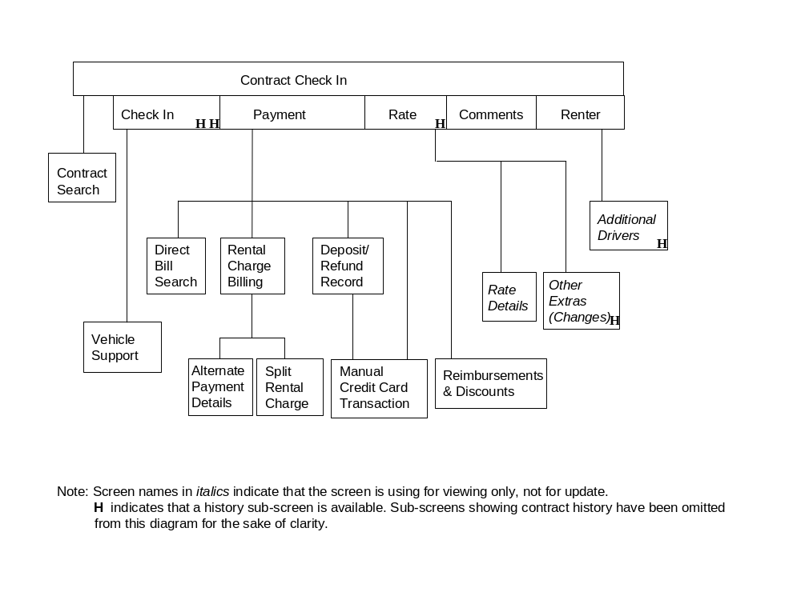
Navigation
N/A
Functions
Retrieve: Retrieves the contract for the contract number entered and uses it to populate the Check In screen. If no contract number is entered and a contract number has been placed in the GIS Selected Contract registry by the Contract Search screen, the number from the registry is retrieved instead.
Enabled when the screen is first opened or when the screen has been cleared using Clear or Undo. Disabled when the screen is populated with contract information using the Retrieve or Search buttons.
When this screen is first opened, a Retrieve is done automatically if a contract number has been placed in the GIS Selected Contract registry by the Contract Search screen.
If the contract status is Checked Out, the contract cannot be retrieved if it has any primary or alternate billing parties that are no longer active on Platinum.
Search: Opens the Contract Search screen. When the CSR selects a contract from the contract search screen, the Check In screen will be populated with the contract information.
Enabled when the Check In screen is first opened and when the screen has been cleared using Clear. Disabled when the Check In screen is populated with contract information using the Retrieve or Search buttons.
Check In: Checks in the currently checked out vehicle and saves the contract. Sets the status of the vehicle as indicated by the CSR on the screen. Disables the Retrieve, Check In, Void, and Undo buttons. Makes all fields read only. See Technical Notes for a description of vehicle fields that require updating with this function.
If contract opened from a reservation, calculate the Reservation Revenue amount using the reservation rate (used later to calculate the upsell the CSR has sold on a contract i.e. actual contract revenue less this amount). The amount includes Time and Kilometre charges net of any taxes, discounts or drop off charges. The calculation will use the actual pick and drop off dates, expected drop off date and actual kilometres from the contract, and the vehicle class and rate from the reservation.
Prints the contract.
When the contract is checked in the following must be completed:
- The balance owing must be zero.
- If Frequent Flyer Plans Honoured is No for the rate selected, no frequent flyer plan information will be saved with the contract
- For each direct bill organization (Contract Billing Party with Billing Method ‘Direct Bill’, ‘Loss of Use’ or ‘Voucher’) that is being billed for all or part of the rental charges:
- Subtract the Amount Removed from Available Credit prior to the check in from the expected open contract charges for the organization (AR GIS Customer Info, Expected Open Contract Charges).
- Set the Amount Removed from Available Credit in the Contract Billing Party for the organization to the total amount billed to that organization at Check In.
- Add the balance owing at the end of the check in to the Daily Contract Total for the organization (AR GIS Customer Info, Daily Contract Total).
- Record the balance owing at the end of the check in as an A/R contract payment (see Technical Notes for details)
- For a truck rental:
- If the check in time less than the expected drop off time, update truck rental availability as follows:
- Increase the truck availability for the truck class and pick up location by 1 for the period between the check in time and the expected drop off time.
- If the customer does not exist on the Customer Profile, add a record for the customer. If the customer does exist on the Customer Profile, update the record for the customer. See Technical Notes for details.
- Generate Accounting Interface entries for any cash deposits received or refunds issued and for each A/R contract payment. For details, see the section on Accounting Interface Entries for Contract Check In.
- Generate Accounting Interface entries for all the contract revenue. For details, see the section on Account Interface Entries for Contract Check In.
Void Disabled unless the current RBR date is the same as the check out date for the first vehicle check out where check out time is not equal to the check in time.
- Set all charges to zero.
- If sales accessories were sold on the contract, warn the CSR to either go to the Separate Accessory Sales screen and re-sell the accessories or obtain the accessories from the renter.
- If any cash deposits have been collected, the CSR must refund the net deposit amount on the Deposit Record sub-tab. The type will be either ‘Direct Refund’ (the payment has been returned to the customer or ‘Mail Refund’. The contract will then be printed so that the customer can sign for the deposit(s) and the refund.
- If any credit card deposits have been collected, the CSR must record a credit card refund for the net deposit amount on the Deposit/Refund Record sub-tab. The contract will then be printed so that the customer can sign for the deposit(s) and the refund.
- If any credit card authorizations have been processed, the CSR will phone the credit card company and have the authorizations cancelled. This will be manual process and no information will be recorded on GIS.
- Check In the vehicle, set status of vehicle to that entered on the screen. See Technical Notes for a description of vehicle fields that require updating with this function.
- For a truck rental:
- Increase the truck availability for the truck class and pick up location by 1 for the period between the current time and the expected drop off time.
- For each direct bill organization (Contract Billing Party with Billing Method ‘Direct Bill’, ‘Loss of Use’ or ‘Voucher’) that is being billed for all or part of the rental charges:
- Process as standard check in.
- Generate Accounting Interface entries for any cash deposits received or refunds issued and for each A/R contract payment. For details, see the section on Accounting Interface Entries for Contract Check In.
- The Balance Owing must be zero.
- Print the contract
- Save the contract with a status of ‘Voided’
- Clear the Check In screen.
Print: Print the contract. Disabled until contract checked in.
Clear: Disabled once a credit card payment has been processed.
Undo: Disabled once a credit card payment has been processed.
Controls
Req*: Y – always mandatory
N – always optional
S – sometime optional (see Comments for details)
D – display only
Field | Source | Req* | Validation | Comments
Above Tabs
BCN | Contract, Customer Program Number | D
Pick Up Location | Contract, Pick Up Location ID | D |  | Location name displayed.
Pick Up Time | Contract, Pick Up On | D
Days Rental |  | D | Difference between Pick Up Time and Drop Off Time.  Numeric, round up to the next whole number.
Drop Off Location | Contract, Drop Off Location ID | D |  | Location name is displayed.
Drop Off Time | Contract, Drop Off On | D
Vehicle Class | Contract, Vehicle Class Code | D |  | Vehicle Class Name is displayed.
Customer Last Name | Contract, Last Name | D
First Name | Contract, First Name | D
GIS Contract # | Contract, Contract Number | N |  | Unlocked when the screen is first opened or when the screen has been cleared using Clear or Undo. Locked when the screen has been populated with contract information using the Retrieve or Search buttons.
Foreign Contract # | Contract, Foreign Contract Number | N |  | Unlocked when the screen is first opened or when the screen has been cleared using Clear or Undo. Locked when the screen has been populated with contract information using the Retrieve or Search buttons. For more details about foreign contracts see the Contract Rentback Changes Business Design document.
Status | Contract, Status | D
Technical Notes
Check In
Upon pressing the Check In button the following fields in the Vehicle table must be updated with the values for the fields shown:
Vehicle table column: Update with value from Vehicle On Contract:
Current Km Km In
Current Location ID Actual Drop Off Location ID
Current Rental Status ‘Available’
Rental Status Effective On Actual Check In
Current Condition Status Vehicle Condition
Condition Status Effective On Actual Check In (if Current Condition Status has changed)
If the Condition Status has changed a new condition status record for the vehicle must be created, using the new Condition Status and Actual Check In:
A/R Contract Payment
For every alternate payment organization (each Contract Billing Party with Billing Type ‘Alternate’), record an A/R contract payment as follows (an A/R contract payment is recorded by creating a Contract Payment Item and an A/R Payment):
- Contract Payment Item
- Set Payment Type to ‘A/R’
- Set Amount to the total amount billed for the alternate payment organization
- Set Collected On to the current date and time
- Set Collected By to the current user ID
- Set Collected At Location ID to the current location ID
- Set RBR Date to the current RBR date
- A/R Payment
- Set Contract Billing Party ID from Contract Billing Party
- Set Interim Bill Date to null
If a direct bill organization authorized the contract (Contract Billing Party with Billing Type ‘Primary’ has Billing Method ‘Direct Bill’), record an A/R contract payment as follows (an A/R contract payment is recorded by creating a Contract Payment Item and an A/R Payment):
- Contract Payment Item
- Set Payment Type to ‘A/R’
- Set Amount to the total amount billed for the direct bill organization
- Set Collected On to the current date and time
- Set Collected By to the current user ID
- Set Collected At Location ID to the current location ID
- Set RBR Date to the current RBR date
- A/R Payment
- Set Contract Billing Party ID from Contract Billing Party
- Set Interim Bill Date to null
Add/Update Customer Profile
If the contract is not linked to a customer (Contract, Customer ID is null):
- Add a new Customer record as described below
If the contract is linked to a customer (Contract, Customer ID is not null) and the customer is not a BCN customer (Customer Record, Program Number for Contract Customer ID is null):
- Update the Customer record as described below
Set the following fields when updating the customer record:
Customer table column: Use value from Contract:
Last Name Last Name
First Name First Name
Address 1 Address 1
Address 2 Address 2
City City
Province Province
Postal Code Postal Code
Country Country
Phone Number Phone Number
Email Address Email Address (if present)
Birth Date Birth Date
Gender Gender
Vehicle Class Code Vehicle Class Code
Smoking/Non-Smoking Smoking/Non-Smoking
Last Changed By ‘GIS’
Last Changed On current system date and time
Inactive ‘No’
Set the following fields as described below:
Customer table column: Use value:
Do Not Rent ‘No’ (only if customer is being added, do not update if
customer already exists)
If the renter was authorized to drive during the contract (Contract, Renter Driving is Yes):
Customer table column: Update with value from Renter Driver Licence:
Driver Licence Number Number
Driver Licence Expiry Expiry
Driver Licence Jurisdiction Jurisdiction
Driver Licence Class Class
If the renter authorized the contract (Contract Billing Party with Billing Type ‘Primary’ has Billing Method ‘Renter’):
Customer table column: Update with value from:
Payment Method Renter Primary Billing, Renter Authorization Method
Set Credit Card, Customer ID for the credit card used to authorize the contract to the Customer ID for the Customer record being added or updated.

Check In Vehicle Tab
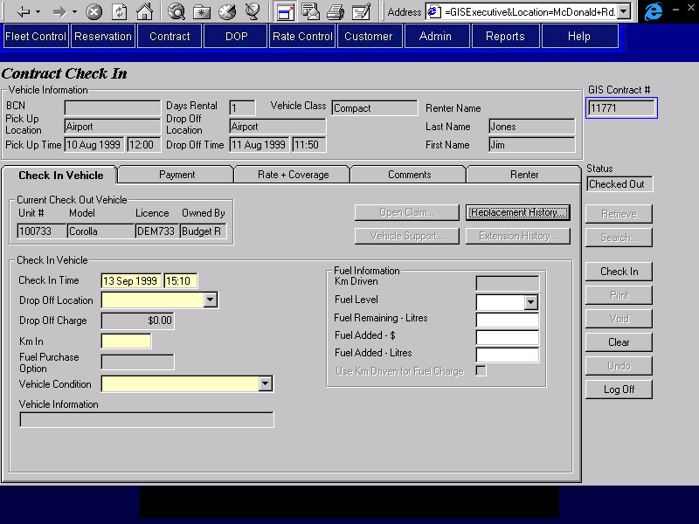
Purpose
The Check In Vehicle tab is used to complete the check in of the vehicle that is currently checked out for the selected contract. This will transfer the responsibility for the vehicle from the Renter to Budget. No other vehicle may then be checked out on the contract. All optional extras that are currently rented will also be checked in or ended at the same time as the vehicle check in.
If an override check in was done for the vehicle so that it could be checked out on another contract, the contract number will be displayed on the screen and the check in time, fuel level and fuel remaining fields will default from the override check in. If the CSR updates the check in time, it will be edited to ensure that it doesn’t conflict with an existing vehicle on contract.
Buttons are available to access the Vehicle Support, Replacement History, and the Extension History screens.
Navigation
Open Claim: Opens the Open Claim screen. This screen will be designed in the Claims business design.
Vehicle Support: Opens the Vehicle Support screen in read only mode so that the CSR may view vehicle support incidents that have been logged for the current contract. Disabled if no vehicle incidents have been logged.
Replacement History: Opens the Replacement History screen and displays all vehicle replacements for the current contract. Disabled if no replacement history exists.
Extension History: Opens the Extension History screen and displays all drop off time and location changes for the current contract. Disabled if no drop off history exists.
Functions
N/A
Controls
Req*: Y – always mandatory
N – always optional
S – sometime optional (see Comments for details)
D – display only
Field | Source | Req* | Validation | Comments
Current Check Out Vehicle |  | D |  | Displays information for the vehicle currently checked out: Vehicle On Contract. Actual Check In is null.
Unit # | Vehicle On Contract, Unit Number | D
Model | Vehicle, Vehicle Model ID | D |  | For Unit Number identified in Vehicle On Contract. Model Name is displayed
Licence | Vehicle Licence History, Licence Plate Number | D |  | For Unit Number identified in Vehicle On Contract. The vehicle licence plate that is in effect during the time that the vehicle was on this contract (Vehicle On Contract, Check Out).
Owned By | Vehicle, Vehicle Owning Company | D |  | For Unit Number identified in Vehicle On Contract.
Vehicle Incident |  |  |  | Display if Vehicle Incident exists for the contract.
Vehicle Incident Status | Vehicle Support Incident, Status | D |  | Status = Unresolved if any of the Vehicle Incidents for the currently checked out vehicle have a status of unresolved, otherwise resolved.
Check In Vehicle
Check In Time | Vehicle On Contract, Actual Check In | Y | Date and time.  If there is an Override Check In for the Vehicle on Contract, cannot conflict with the Vehicle On Contract for this vehicle and the Override Contract Number. | Default to Override Check In, Check In if an Override Check In exists for the Vehicle on Contract. Default to current time otherwise.
Drop Off Location | Vehicle On Contract, Actual Drop Off Location ID | Y | Value controlled by Location table. | If at a rental location then value defaults to that location and cannot be updated.
Drop Off Charge | Contract Charge Item, Amount | D | Currency | Charge Type = Drop Off Charge. See notes below for calculation details.
Km In | Vehicle On Contract, Km In | S | Numeric | Default to Override Check In, Km In if an Override Check In exists for the Vehicle on Contract.  Required unless vehicle is not present.
Fuel Purchase Option | Vehicle on Contract, FPO Purchased  Contract Charge Item, Amount | D | Currency | Dollar amount if Vehicle on Contract, FPO Purchased is true, otherwise Blank.  Charge Type = Fuel Charge
Vehicle Condition | Vehicle On Contract, Vehicle Condition | Y | Value controlled by Vehicle Condition table.
Vehicle Information | Contract, Do Not Extend Rental Reason | D
Restriction/  Violation Rate message |  | D |  | Display the message if a violation rate has been applied or if there is a special rate restriction that should be manually checked by the CSR.
Fuel Information |  |  |  | Only visible if FPO is blank or 0 or if a replacement has occurred after FPO was purchased (more than one vehicle on contract has FPO Purchased = Yes).
Km Driven |  | D |  | Vehicle On Contract, (Km In – Km Out)
Fuel Level | Vehicle On Contract, Fuel Level | N | Values are in 8ths or Full or Empty. | Default to Override Check In, Fuel Level if an Override Check In exists for the Vehicle on Contract.  Not visible if the vehicle is a foreign model (tank size may not be available calculating amount of fuel needed to make a full tank).
Fuel Remaining – Litres | Vehicle On Contract, Litres of Fuel Remaining | N | Numeric | Default to Override Check In, Fuel Remaining if an Override Check In exists for the Vehicle on Contract.  Not visible if the vehicle is a foreign model (tank size may not be available calculating amount of fuel needed to make a full tank).
Fuel Added - $ | Vehicle On Contract, Fuel Added $ | N | Currency
Fuel Added – Litres | Vehicle On Contract, Fuel Added Litres | N | Numeric
Vehicle Not Present |  |  |  | Only visible if fields are not null. Enterable by Vehicle Support only (through the Vehicle Support screen).
Reason | Vehicle On Contract, Vehicle Not Present Reason | D
Location | Vehicle On Contract, Vehicle Not Present Location | D
Override Check In Done by Contract | Override Check In, Override Contract Number | D |  | Only visible if an Override Check In exists for the Vehicle On Contract.
Technical Notes
Drop Off Charge
See Calculate Drop Charges Function

Payment Tab
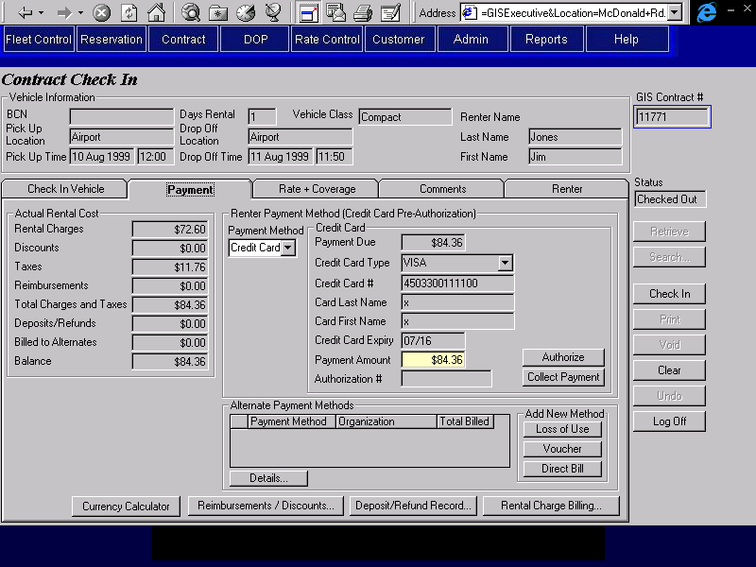

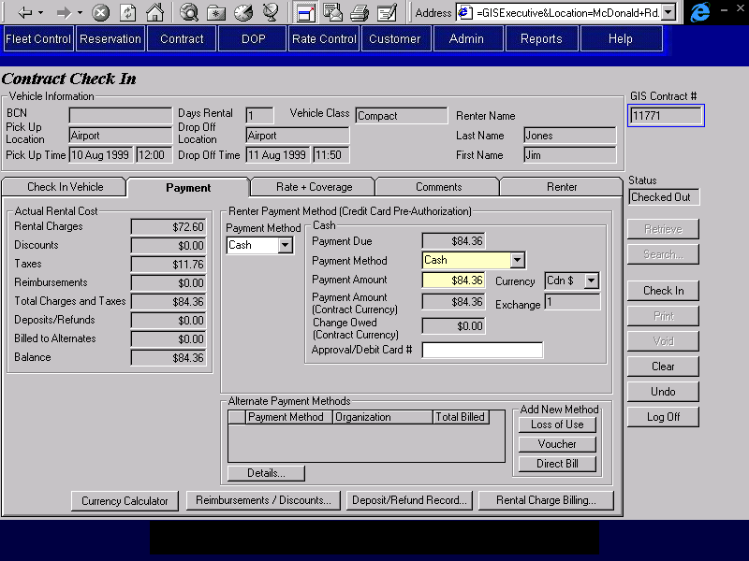

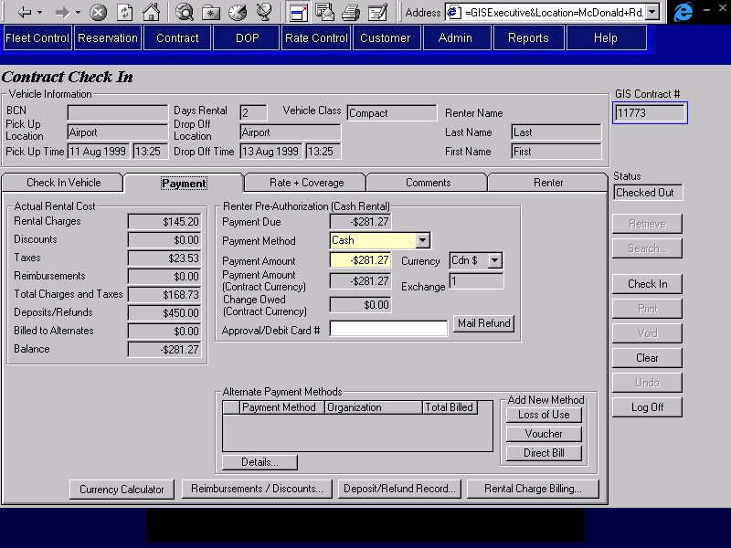

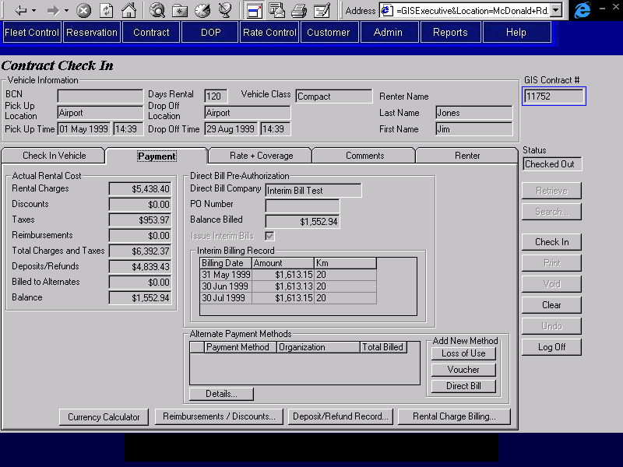
Purpose
This tab is used to view the party responsible for the rental and enter credit card or cash payments.
At this point in the contract, who is authorizing the rental will already be entered (the renter or a direct bill company). This will determine who is responsible for the rental charges and the pre-authorization amount for the rental.
- If the renter is responsible, the method of pre-authorization will have been recorded, credit card or cash deposit. The details of the pre-authorization will be shown on the Deposit Record tab.
- If the renter pre-authorized with a credit card then one of two methods of payment (credit card or cash) may be selected on this tab (additional payment methods may be added if necessary on the Deposit/Refund screen). If the payment method is credit card the information from the authorizing credit card will be defaulted and locked. The CSR may enter a different credit card if required in the Deposit/Refund screen. If the payment method is cash the CSR will enter the details of the cash payment.
- If the renter pre-authorized with cash, the CSR may collect an additional deposit or process a refund. If the renter owes money (the balance is greater than zero), additional cash deposits may be collected to bring the balance owed to zero. If money is owed to the renter (balance is less than zero) then the CSR may issue a mail refund, by pressing the Issue Mail Refund button, to bring the balance owing to zero.
- If the rental is pre-authorized by direct bill, then the direct bill company will be billed for the rental balance at this time.
If any alternate payment organizations are being billed for all or part of the rental, the CSR will record the details on the Rental Charge Billing tab and then specify which charges should be billed to each alternate payment method. This may already have been prior to check in. If it has, the CSR can still add new alternate payment organizations and redistribute the charges.
If any refunds or contract discounts are being applied to the rental the CSR will record the details on the Refunds and Discounts screen.
If any other cash or credit card payments are being made, the CSR will record the details on the Deposit/Refund screen.
Once any alternate payment billing details, refunds, contract discounts and payments have been entered, the CSR will return to this tab and complete the rental payment as described above.
Navigation
Rental Charge Billing: Opens the Rental Charge Billing screen where alternate payment billing details are entered and the charges for the rental items are assigned to the party responsible for the rental or to any of the alternate payment organizations identified.
Reimbursements/ Opens the Reimbursement and Discounts screen where reimbursements
Discounts: and discounts to be applied to the rental charges are viewed and entered.
Deposit/Refund Opens the Deposit/Refund screen where the details of cash
Record: deposits and refunds, credit card deposits and refunds, and additional credit card authorizations can be viewed and entered.
Currency Calculator: Opens the Currency Calculator sub-screen where amounts may be converted from one currency to another. No payments or refunds occur in this sub-screen.
Details: Opens the appropriate alternate payment details screen (Loss of Use, Voucher or Direct Bill) for the selected alternate payment organization so that the CSR can view or update the required details.
Loss of Use: Opens the Loss of Use details screen so that the CSR can enter a new Loss of Use alternate payment organization.
Voucher: Opens the Voucher details screen so that the CSR can enter a new Voucher alternate payment organization.
Direct Bill: Opens the Direct Bill details screen so that the CSR can enter a new Direct Bill alternate payment organization.
Functions
Collect Payment: Collects payment for the credit card using the authorization number
(Credit Card) generated from the first credit card authorization performed and captures the amount specified on the screen. For details on the credit card payment process, see the Credit Card Payment function description in this document.
Generate Accounting Interface entries for the payment. For details, see the section on Accounting Interface Entries for Contract Check In

Issue Mail Refund: For rentals pre-authorized by cash, refunds the amount owed to the renter via a mail refund. This essentially enters a refund of type mail refund in the cash deposit/refund section of the deposits and refunds screen.
Controls
Req*: Y – always mandatory
N – always optional
S – sometime optional (see Comments for details)
D – display only
Field | Source | Req* | Validation | Comments
Actual Rental Cost
Rental Charges |  | D |  | Calculated by GIS. Sum of all charges excluding discounts and reimbursements on Rental Charge Billing sub-screen.
Discounts |  | D |  | Calculated by GIS. Sum of all discounts applied to contract, including member discounts.
Taxes |  | D |  | Calculated by GIS, based on rental charges less discounts. Sum of all GST, PST, and PVRT amounts on the Rental Charge Billing sub-screen.
Reimbursements |  | D |  | Calculated by GIS. Sum of all reimbursements applied to contract.
Totals Charges and Taxes |  | D |  | Calculated by GIS. Sum of rental charges, discounts, taxes and reimbursements (the four fields directly above).
Deposits/Refunds |  | D |  | Calculated by GIS. Sum of all deposits and refunds applied to contract (sum of all deposit and refund entries in the Deposit Refund Record sub-screen).
Billed to Alternates |  | D |  | Calculated by GIS. Sum of all rental charges and taxes billed to alternate payment organizations (sum of the Total Billed column in the Alternate Payment Methods grid).
Balance |  | D |  | Total Charges and Taxes, less Deposits/Refunds and Billed to Alternates (the three fields directly above).
Renter Payment Method (Credit Card Pre-Authorization) |  |  |  | Display when Renter has pre-authorized the rental with a credit card: Contract Billing Party with Billing Type ‘Primary’ has Billing Method ‘Renter’ and Renter Primary Billing has Renter Authorization Method ‘Credit Card’. Hide otherwise.
Payment Method | Contract Payment Item, Payment Type | Y | Credit Card, Cash
Credit Card  (Credit Card Pre-Authorization) |  |  |  | Display if Payment Method is Credit Card. Hide otherwise. Default to credit card used for pre-authorization.
Payment Due |  | D |  | Set to Balance.
Credit Card Type | Renter Primary Billing, Credit Card Key  Credit Card, Credit Card Type ID | D | Value controlled by Credit Card table. | Display Type for Credit Card, Credit Card Type ID
Credit Card # | Renter Primary Billing, Credit Card Key  Credit Card, Credit Card Number | D |  | Display Credit Card, Credit Card Number
Card Last Name | Renter Primary Billing, Credit Card Key  Credit Card, Last Name | D |  | Display Credit Card, Last Name
Card First Name | Renter Primary Billing, Credit Card Key  Credit Card, First Name | D |  | Display Credit Card, First Name
Credit Card Expiry | Renter Primary Billing, Credit Card Key  Credit Card, Expiry | D | Date (month and year) | Display Credit Card, Expiry.
Payment Amount | Contract Payment Item, Amount | N |  | Defaults to Payment Due.
Authorization # | Credit Card Payment, Authorization Number | D |  | Populated only when payment completed, cleared if Calculate Rental Charges is executed.
Payment Method Cash  (Credit Card Pre-Authorization) |  |  |  | Display if Payment Method is Cash. Hide otherwise.
Payment Due |  | D |  | Calculated by GIS. Set to Balance.
Payment Method | Cash Payment, Cash Payment Type | Y | Selection only  Value controlled by Cash Payment Type table | Defaults to Cash
Payment Amount | Cash Payment, Foreign Currency Amount Collected | Y |  | Defaults to Payment Due.
Currency | Cash Payment, Currency ID | D |  | Defaults and locks to contract currency.  Currency is displayed
Payment Amount (Contract Currency) | Contract Payment Item, Amount | D
Exchange | Cash Payment, Exchange Rate | D |  | Defaults to current exchange rate for Currency (since currency is locked to contract currency will be 1).
Change Owed (Contract Currency) |  | D |  | Calculated by GIS: Payment Amount (Contract Currency) – Payment Due. Red if negative.
Approval/Debit Card # | Cash Payment, Identification Number | N
Renter Pre-Authorization – Cash Rental |  |  |  | Display when Renter has pre-authorized the rental with a cash rental deposit: Contract Billing Party with Billing Type ‘Primary’ has Billing Method = Renter and Renter Primary Billing has Renter Authorization Method ‘Cash’. Hide otherwise.
Payment Due |  | D |  | Set to Balance.
Payment Method | Cash Payment, Cash Payment Type | Y | Selection only  Value controlled by Cash Payment Type table | Defaults to Cash
Payment Amount | Cash Payment, Foreign Currency Amount Collected | N |  | Defaults to Payment Due.
Currency | Cash Payment, Currency ID | D |  | Defaults and locks to contract currency.  Currency is displayed
Payment Amount (Contract Currency) | Contract Payment Item, Amount | D
Exchange | Cash Payment, Exchange Rate | D |  | Defaults to current exchange rate for Currency (since currency is locked to contract currency will be 1).
Change Owed (Contract Currency) |  | D |  | Calculated by GIS: Payment Amount (Contract Currency) – Payment Due. Red if negative.
Approval/Debit Card # | Cash Payment, Identification Number | N
Direct Bill |  |  |  | Display when the rental has been pre-authorized by a direct bill company: Contract Billing Party with Billing Type ‘Primary’ has Billing Method ‘Direct Bill’. Hide otherwise.
Direct Bill Company | Contract Billing Party, Customer Code | D |  | AR Customer Master, Address Name is displayed
PO Number | Direct Bill Primary Billing, PO Number | D
Balance Billed |  | D |  | Calculated by GIS: Set to Balance less the sum of Bill Amount from any interim bills issued (Amount column in Interim Billing Record grid).
Issue Interim Bills | Direct Bill Primary Billing, Issue Interim Bills | D
Interim Billing Record |  |  |  | Display if any interim bills exist or if Interim Bill Issued flag checked, otherwise hide.
Billing Date | Interim Bill, Interim Bill Date | D
Amount | Contract Payment Item, Amount | D |  | From Contract Payment Item for the A/R Payment linked to Interim Bill
Km | Interim Bill, Current Km | D
Alternate Payment Methods |  |  |  | Show one row for each Contract Billing Party record where Billing Type = Alternate.
Payment Method | Contract Billing Party, Billing Method | D
Organization | Contract Billing Party, Customer Code | D |  | Display A/R Customer Master, Address Name
Total Billed | Contract Billing Party, Amount Removed from Available Credit | D |  | Calculated by GIS. Sum of all charge items in the Rental Charge Billing sub-screen that are assigned to the selected Contract Billing Party. Saved to Amount Removed from Available Credit.
Technical Notes
Exchange Rate
When calculating the exchange rate for cash deposits in foreign currency, use the exchange rate for the location if there is one; otherwise use the standard exchange rate.
Interim Billing
It is not necessary to delete any Interim Bill records that fall beyond the check in date as the interim bill background process will only issue interim bills for contracts that are open.

Rate and Coverage Tab
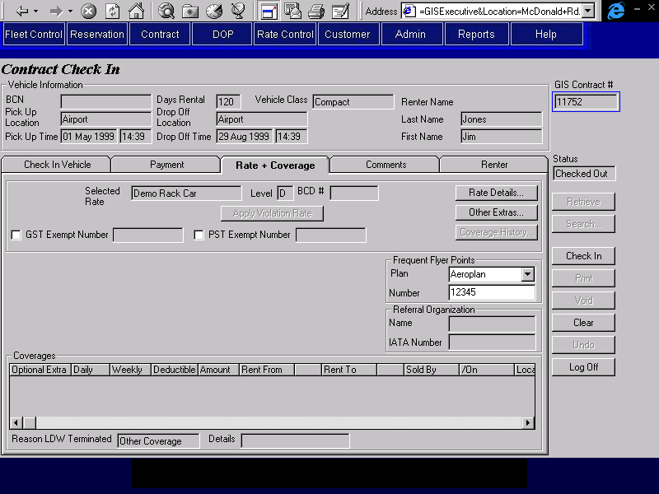
Purpose
The Rate and Coverage tab allows the CSR to view the applied rate name and level, insurance transfer information and to view the selected coverages that were applied to the contract (LDW, Deductible Buydown, PAI, PEC and Cargo Insurance). Insurance transfer fields will only be visible if the selected rate allows insurance transfer. Frequent flyer plan and referral organization information is also displayed. Frequent flyer plan information may be updated. Buttons are available to access the rate details screen, the other extras screen, and the coverage history screen.
If required the CSR may manually apply or rescind the violation rate on this tab.
Navigation
Rate Details: Opens the Rate Details screen where the details of the selected rate are displayed included inclusions and restrictions.
Other Extras: Opens the Other Extra screen where other optional extras, flex discounts, and member discounts, which have been added or applied to the base rate, are displayed. Other extra history may also be accessed from here.
Coverage History: Opens the Coverage History screen where the history of changes to coverages for the contract is displayed. Disabled if there is no coverage history (coverages with a Termination Date).
Functions
Apply Violation Rate: Applies the violation rate associated with the contract rate. Sets Contract, Apply Violation Rate to Yes. This button is only enabled if a Violation Rate exists for the contract rate and Contract, Apply Violation Rate is No.
Rescind Violation Rate: Applies the original contract rate that was in use prior to the violation rate being applied. Sets Contract, Apply Violation Rate to No. This button is only enabled if a Violation Rate exists for the contract rate and Contract, Apply Violation Rate is Yes.
Controls
Req*: Y – always mandatory
N – always optional
S – sometime optional (see Comments for details)
D – display only
Field | Source | Req* | Validation | Comments
Selected Rate | Contract, Rate ID and Rate Level  OR  Contract, Quoted Rate ID | D |  | Rate name and level or Quoted Rate Name are displayed.
BCD # | Contract, BCD Rate Organization ID | D
Restriction /Violation Rate message |  | D |  | Display the message if a violation rate has been applied or if there is a special rate restriction that should be manually checked by the CSR.
GST Exempt |  | N |  | When a contract is retrieved, will be set on if Contract, GST Exemption Number is populated.
Number | Contract, GST Exemption Number | S | Required if GST Exempt is turned on.
PST Exempt |  | N |  | When a contract is retrieved, will be set on if Contract, PST Exemption Number is populated.
Number | Contract, PST Exemption Number | S | Required if PST Exempt is turned on.
Frequent Flyer Plan |  |  |  | Visible if Frequent Flyer Plans Honoured is Yes for contract rate; otherwise not visible. If visible, enabled if Contract, Frequent Flyer Assigned Date is null or is equal to the current RBR date, otherwise disabled.
Plan | Contract, Frequent Flyer Plan ID  Frequent Flyer Plan Member, Frequent Flyer Plan ID | N | Value controlled by Frequent Flyer Plan table. | Frequent Flyer Plan name is displayed.
Number | Contract, Frequent Plan Member Number  Frequent Flyer Plan Member, Member Number | S | Create Frequent Flyer Plan Member record if does not already exist. | Required if Plan is entered.  If there is already a Frequent Flyer Plan Member for the Frequent Flyer Plan and the Customer with a Type of Preferred, default to that Member Number, default to blank otherwise.
Referring Organization
Name | Contract, Referring Organization ID | D |  | Display Organization Name.
IATA Number | Contract, IATA Number | D
Insurance Transfer
Company Name | Insurance Transfer, Company Name | D
Expiry | Insurance Transfer, Expiry | D
Collision |  | D |  | No if collision deductible is null; Yes otherwise.
Deductible | Insurance Transfer, Collision Deductible | D
Comprehensive |  | D |  | No if comprehensive deductible is null; Yes otherwise.
Deductible | Insurance Transfer, Comprehensive Deductible | D
Manufacturer | Insurance Transfer, Vehicle Manufacturer | D
Model | Insurance Transfer, Vehicle Model | D
Year | Insurance Transfer, Vehicle Year | D
Licence Plate | Insurance Transfer, Vehicle Licence Plate | D
Coverages |  |  |  | Display only current optional extras with type = LDW, Buydown, PAI, PEC, Cargo Insurance.
Optional Extra | Contract Optional Extra, Optional Extra ID | D |  | Optional Extra name is displayed.
Daily | Contract Optional Extra, Daily Rate | D |  | Rate will not vary with quantity.
Weekly | Contract Optional Extra, Weekly Rate | D |  | Rate will not vary with quantity.
Deductible | LDW Deductible, LDW Deductible. | D |  | For Optional Extra and Vehicle Class.
Amount |  | D |  | Calculated based on rental period and quantity. Displays cheapest combination of daily and weekly rates. Display 0 if included in rate.
Rent From | Contract Optional Extra, Rent From | D
Rent To | Contract Optional Extra, Rent To | D
Sold or Removed By/On/At | Contract Optional Extra, Sold/Removed By & Sold/  Removed On & Sold At Location ID | D |  | Location Name is displayed for Sold At Location ID.
Reason LDW Terminated | Contract, LDW Declined Reason | D |  | Only visible if LDW has been removed.
Details | Contract, LDW Declined Details | D |  | Only visible if LDW has been removed.
Corporate Responsibility | Quoted Vehicle Rate, Corporate Responsibility | D |  | Bot the field and label are only visible when the contract has been opened from a reservation passed from Maestro, using the quoted rate and when there is a value in the Corporate Responsibility field for the quoted rate.
Technical Notes
Apply Violation Rate
If any restrictions associated with the contract rate have been violated then Contract, Apply Violation Rate should be set to Yes. This may also be set to Yes manually by pressing the Apply Violation Rate Button.
If Contract, Apply Violation Rate is Yes then all vehicle rate information displayed and all vehicle rate calculations should be based on the Violation Rate associated with the Contract Rate.
Rescind Violation Rate
Set Contract, Apply Violation Rate to No. If Contract, Apply Violation Rate is No then all vehicle rate information displayed and all vehicle rate calculations should be based on the contract rate not the violation rate associated with the contract rate.

Comments Tab
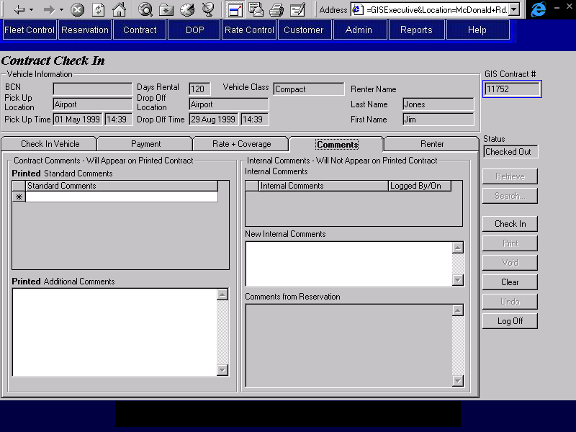
Purpose
The Comments tab is used to view comments entered by the agent who made the reservation and to view and enter comments about the contract. This will facilitate communication between different CSRs who may work on the same contract. Two types of comments can be entered; comments that will appear on the printed contract and comments that will not appear on the printed contract. The reservation comments will not appear on the printed contract.
The Contract Comments section contains the comments that will be printed on the contract. The CSR may select comments from a pre-existing list or enter free text to appear on the printed contract.
The Internal Comments section contains the comments that are for internal use only and will not appear on the printed contract. The CSR may add new comments to this section but cannot alter existing comments. Upon saving changes to the contract, the new comments will be protected and the user id that entered the comment and the time at saving will be recorded.
Navigation
N/A
Functions
N/A
Controls
Req*: Y – always mandatory
N – always optional
S – sometime optional (see Comments for details)
D – display only
Field | Source | Req* | Validation | Comments
Contract Comments- Will Appear on Printed Contract
Printed Standard Comments | Contract Print Comment, Standard Print Comment | N | Values controlled by Contract Print Standard Comment table.
Printed Additional Comments | Contract, Print Comment | N | Free form text. Maximum length 255 characters.
Internal Comments – Will Not Appear on Printed Contract
Internal Comments | Contract Internal Comment, Comments | D
Logged By | Contract Internal Comment, Logged By | D
Logged On | Contract Internal Comment, Logged On | D
New Internal Comments | Contract Internal Comment, Comments | N | Free form text. Maximum length 255 characters.
Comments from Reservation | Reservation Comment, Standard Reservation Comment ID; Reservation, Special Comments | D |  | Concatenation of Standard Reservation Comments for the reservation and Reservation, Special Comments
Technical Notes
When a new internal comment is saved to the Contract Internal Comment table, the user ID of the person who entered the comment and the date and time that the comment was entered must also be saved.

Renter Tab
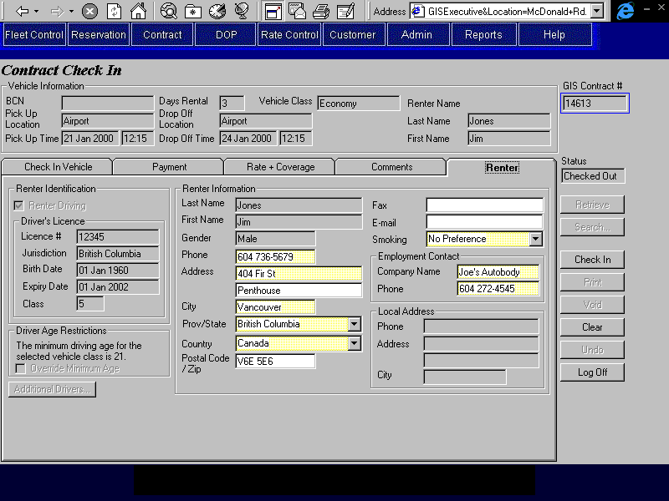
Purpose
The Renter tab allows the CSR to view renter and additional driver information. Updates may be made to the Renter’s contact information. The information on this tab is laid out in the order in which it was available in the Contract Open and Check Out screen. By pressing the “Additional Drivers” button, the CSR may view the additional driver information.
Navigation
N/A
Functions
Additional Drivers: Opens the Additional Drivers screen in read only mode so that the additional driver information can be viewed. Disabled if no additional drivers are specified for the contract.
Controls
Req*: Y – always mandatory
N – always optional
S – sometime optional (see Comments for details)
D – display only
Field | Source | Req* | Validation | Comments
Renter Identification
Driving/  Not Driving | Contract, Renter Driving | D
Driver’s Licence |  | D |  | Display when renter is driving (Contract, Renter Driving = Yes).
Licence # | Renter Driver Licence, Number | D
Jurisdiction | Renter Driver Licence, Jurisdiction | D
Birth Date | Contract, Birth Date | D
Expiry Date | Renter Driver Licence, Expiry | D
Class | Renter Driver Licence, Class | D |  | .
Other Identification |  | D |  | Displayed when renter is not driving (Contract, Renter Driving = No).
ID Type | Non Driving Renter ID, ID Type | D
ID # | Non Driving Renter ID, Number | D
Birth Date | Contract, Birth Date | D
Expiry Date | Non Driving Renter ID, Expiry | D
Driver Age Restrictions |  | D |  | Shows the age restrictions for the vehicle class requested and the organization (if any).
Override Minimum Age | Contract, Override Minimum Age | D |  | Not visible if contract is linked to a BCD organization (BCD Rate Organization ID is not null).
Renter Information
Last Name | Contract, Last Name | D
First Name | Contract, First Name | D |  | .
Gender | Contract, Gender | D
Phone | Contract, Phone Number. | Y | .
Address | Contract, Address 1, Address 2 | Y |  | Second Address Line is optional.
City | Contract, City | Y
Prov/State | Contract, Province | Y | Required if Country is Canada or US. Entry assisted by Province table. Must match a value on the Province table if Country is Canada or US.
Country | Contract, Country | Y | Value controlled by Country table.
Postal Code/Zip | Contract, Postal Code | N | Must match Canadian postal code format if Country is Canada.
Fax | Contract, Fax Number | N
E-mail | Contract, Email Address | N | Free form text
Smoking | Contract, Smoking/Non-Smoking | Y | Selection only  No Preference, Smoking, Non-Smoking
Employment Contact
Company Name | Contract, Company Name | Y
Phone | Contract, Company Phone Number | Y
Local Address
Phone | Contract, Local Phone Number. | D
Address | Contract, Local Address 1, Local Address 2 | D
City | Contract, Local City | D

Walk Up Information Screen
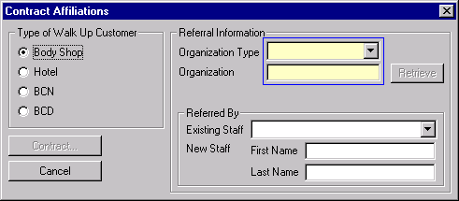

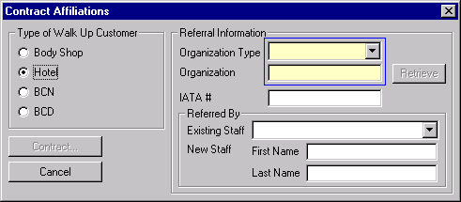

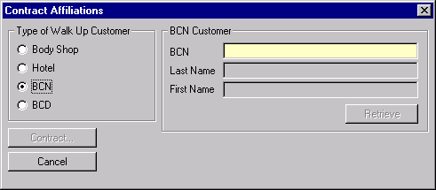

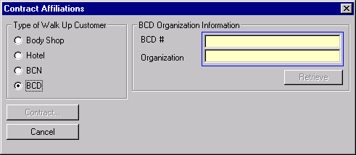
Purpose
The Walk Up Information screen allows the CSR to retrieve information to populate a walk up contract from any of the following sources.
- A referral from a body shop
- A referral from a hotel
- A BCN customer profile
- A corporate customer
Navigation
N/A
Functions
Contract: Close the Walk Up Information Screen and populate the Contract Open/Check
Out screen with the following information, depending on the type of walk up customer selected.
- Body Shop
Populate the Rate tab with the organization rate for the selected body shop and save the referral information entered with the contract.
- Hotel
Populate the Rate tab with the organization rate for the selected organization. Save the referral information entered with the contract.
- BCN
Populate the contract with all the Information from the Customer Profile for the BCN. Do not populate BCN, Driver’s Licence information or Credit Card information. For more information see the notes below.
- BCD
Populate the Rate tab with the organization rate for the selected Corporate Customer (if any). Save the BCD organization information entered with the contract.
Retrieve: Search for an organization using the organization type and/or name.
(Body Shop)
Retrieve: Search for an organization using the organization type and/or name.
(Hotel)
Retrieve: Search for a customer using the BCN.
(BCN)
Retrieve: Search for an organization using the BCD number or organization name.
(BCD)
Controls
Req*: Y – always mandatory
N – always optional
S – sometime optional (see Comments for details)
D – display only
Field | Source | Req* | Validation | Comments
Type of Walk Up Customer | N/A | Y |  | Body Shop/  Hotel/  BCN/  BCD  Default: Body Shop
Body Shop Referral Information |  | S |  | Required if Type of Walk Up Customer is Body Shop  One of Organization Type or Organization must be entered for Retrieve.  Upon contract save, the selected organization will be saved to Contract, Referring Organization ID.
Organization Type | Organization, Type | S | Value controlled by Organization type table.
Organization | Contract, Referring Organization ID | S | Must exist in the Organization table (organization field). | Required if contract is to be populated with the organization rate and referral information is to be saved.
Referred By |  |  |  | Upon contract save, the selected Referring Employee will be saved to Contract, Referring Employee ID.
Existing Staff | Contract, Referring Employee ID | N | Selection Only  Value controlled by Referring Employee table entries for selected Organization ID.
New Staff First Name/Last Name | Contract, Referring Employee ID | N | Must not match an existing entry on the Referring Employee table for selected Organization ID. | Any name entered here will also be added to the Referring Employee table for the selected Organization ID.
Hotel Referral Information |  | S |  | Required if Type of Walk Up Customer is Hotel  One of Organization Type or Organization must be entered for Retrieve.  Upon contract save, the selected organization will be saved to Contract, Referring Organization ID.
Organization Type | Organization, Type | S | Value controlled by Organization type table.
Organization | Contract, Referring Organization ID | S | Must exist in the Organization table (organization field). | Required if contract is to be populated with the organization rate and referral information is to be saved.
IATA # | Contract, IATA Number | N | 8 digit code. Last digit is a check digit. Must be valid for check digit algorithm.
Referred By |  |  |  | Upon contract save, the selected Referring Employee will be saved to Contract, Referring Employee ID.
Existing Staff | Contract, Referring Employee ID | N | Selection Only  Value controlled by Referring Employee table entries for selected Organization ID.
New Staff First Name/Last Name | Contract, Referring Employee ID | N | Must not match an existing entry on the Referring Employee table for the selected Organization ID. | Any name entered here will also be added to the Referring Employee table for the selected Organization ID.
BCN Customer |  | S |  | Required if Type of Walk Up Customer is BCN  This will populate the Contract, Customer ID.
BCN | Contract, Customer ID | Y | Must match the Program Number on a Customer record.
Last Name | Customer, Last Name | D
First Name | Customer, First Name | D
BCD Organization Information |  | S |  | Required if Type of Walk Up Customer is BCD  One of BCD # or Organization must be entered for Retrieve  Upon contract save, the selected organization will be saved to Contract, BCD Rate Organization ID.
BCD # | Contract, Referring Organization ID | S | Must exist in the Organization table (BCD Number field). | Required if contract is to be populated with the organization rate and BCD information is to be saved.
Organization | Contract, Referring Organization ID | S | Must exist in the Organization table (organization field). | Required if contract is to be populated with the organization rate and BCD information is to be saved.
Populating Walk Up Contract Information for a BCN Customer
When a walk up contract is created for a BCN customer, the information associated with the customer profile for the BCN should be populated in the screen, except for the BCN, the driver licence information and the credit card information. The BCN is not populated as we cannot provide BCN service for a walk up customer. Do not lock any of the fields that are normally locked when the BCN is populated.
Rate Tab
If Customer.LDW is Yes
- Set LDW to Yes
- Find the Optional Extra with Type LDW that has the lowest deductible for Customer.Vehicle Class Code and use it to populate the LDW information.
If Customer PAI is Yes
- Set PAI to Yes

If Customer PEC is Yes
- Set PEC to Yes

Additional Driver Screen
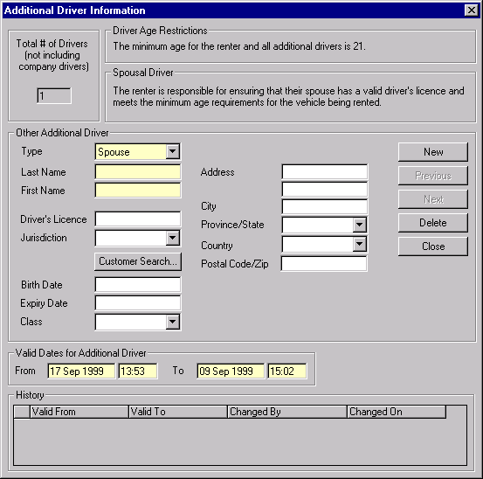

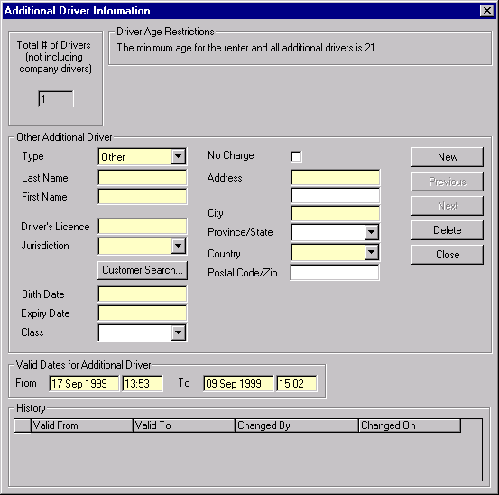

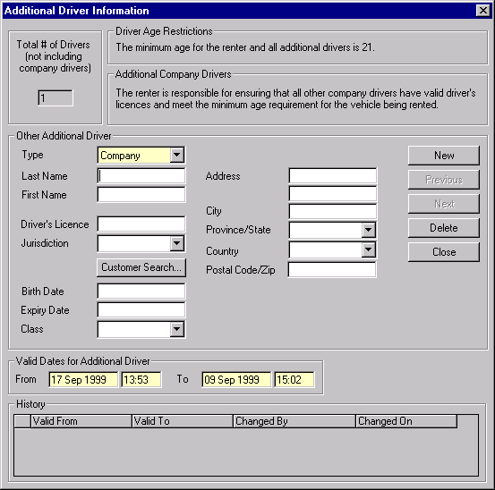
Purpose
The Additional Driver screen allows the CSR to add and remove additional drivers for a contract. There are three types of additional driver that can be added:
- Spouse
- Other
- Company
There is a maximum number of drivers for a contract at any one time, including the renter and not including Company drivers. The maximum number is stored on the system values table and is currently three.
When this screen is opened from the Contract Open/Check Out screen, the history for each additional driver will be invisible. The valid from and to dates for each driver will also be invisible and will be set to the pick up and drop off dates for the contract.
When this screen is opened from the Contract Changes During Rental screen, the history for each additional driver will be visible and information for existing additional drivers will be locked except for the Valid To date.
When this screen is opened from the Check In screen the history for each additional driver will be visible and no changes to additional drivers will be allowed.
Navigation
N/A
Functions
Customer Search Customer Profile using the driver licence number if entered and the
Search: last and first names otherwise. Display list with extra customer information to ensure correct match. The list will include last name, first name, address, phone number, driver licence #, birth date, and whether the customer is flagged as ‘Do Not Rent’. Return information for selected customer to the additional driver screen.
New: Clears the screen and allows for the entry of a new Additional Driver. Defaults the Valid From field to the current date if opened from Changes During Rental.
Next: Displays the next Additional Driver.
Previous: Displays the previous Additional Driver
Delete: Deletes the currently displayed additional driver from the contract. Will be restricted to new (unsaved) additional driver entries after the contract is checked out.
Controls
Req*: Y – always mandatory
N – always optional
S – sometime optional (see Comments for details)
D – display only
Field | Source | Req* | Validation | Comments
Total Number of Drivers |  | D | Cannot be > max number of add’l drivers on lookup table. | Total Number of all drivers for contract (not including company drivers).
Driver Age Restrictions |  | D |  | Shows the age restrictions for the vehicle class requested and the organization (if any). For Other Additional Drivers, an organization override does not apply.
Spousal Driver Message |  | D |  | Only visible when Type is Spouse.
Company Driver Message |  | D |  | Only visible when Type is Company.
No Charge Check Box | Additional Driver, No Charge | N |  | Only visible when Type is Other.
Additional Driver Details
Type | Additional Driver, Type | Y |  | Spouse/Other/Company  Default: Spouse
Last Name | Additional Driver, Last Name | S | Free form text | Required if Type is Spouse or Other.
First Name | Additional Driver, First Name | S | Free form text | Required if Type is Spouse or Other.
Driver’s Licence | Additional Driver, Driver Licence Number | S |  | Required if Type is Other.
Jurisdiction | Additional Driver, Driver Licence Jurisdiction | S | Value controlled by Jurisdiction table | Required if Type is Other,  Entry assisted by Driver Licence Jurisdiction table.
Birth Date | Additional Driver, Birth Date | S | Date (no time) | Required if Type is Other.
Expiry Date | Additional Driver, Driver Licence Expiry | S | Date (no time). | Required if Type is Other.
Class | Additional Driver, Driver Licence Class | S | Must match entry on BC Driver Licence Class table if Jurisdiction is BC. | Required if Jurisdiction is BC and Type is Other.
Address | Additional Driver, Address 1, Address 2 | S |  | Required if Type is Other.
City | Additional Driver, City | S |  | Required if Type is Other.
Province/State | Additional Driver, Province/State | S | Required if Country is Canada or US. Entry assisted by Province table. Must match a value on the Province table if Country is Canada or US. | .
Country | Additional Driver, Country | S | Value controlled by Country table. | Required if Type is Other.
Postal Code/Zip | Additional Driver, Postal Code | N | Must match Canadian postal code format if Country is Canada.
Valid Dates for Additional Driver |  |  |  | Not visible when this screen is opened from Contract Open/Check Out.
From | Additional Driver, Valid From | Y | Date/Time | Set to Contract Pick Up Time when this screen is opened from Contract Open/Check Out.
To | Additional Driver, Valid To | Y | Date/Time | Set to Contract Drop Off Time when this screen is opened from Contract Open/Check Out.
History |  |  |  | Not visible when this screen is opened from Contract Open/Check Out.  Shows all the other additional driver records for the current driver that have been replaced by the current entry (record has been terminated).
Valid From | Additional Driver, Valid From | D
Valid To | Additional Driver, Valid To | D
Changed By/On | Additional Driver, Added/Removed By and Added/Removed On | D
Technical Notes
If the Valid To date is changed for an existing additional driver, set the Termination Date for the Additional Driver record to the current date/time. Copy all the information for the additional driver to a new Additional Driver record with an Effective Date of the current date/time, a Termination Date of Dec. 31, 2078 and the new Valid To date.

Truck Rental Availability Screen
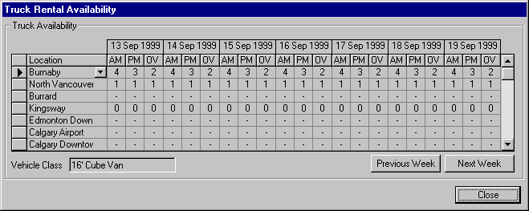
Purpose
The truck rental availability screen is used for walk up truck contracts to determine whether a truck of the requested class can be rented at the location and to allow the CSR to view truck availability at other locations.
The screen will display how many trucks are available for each time block at each location. The locations that carry trucks within the pick up location hub will be displayed first, then the other locations that carry trucks will be displayed. Seven days will be displayed at a time starting with the pick up day. The next week and previous week buttons may be used to view other time periods.
Navigation
N/A
Functions
N/A
Controls
Req*: Y – always mandatory
N – always optional
S – sometime optional (see Comments for details)
D – display only
Field | Source | Req* | Validation | Comments
Location | Contract, Pick Up Location ID | D |  | Location name displayed.
Vehicle Class | Contract, Vehicle Class Code | D |  | Values determined by actual vehicle class used for contract. If original vehicle class is substituted then substitute vehicle class is used.
Day | Truck Inventory, Date | D |  | Display seven days starting with contract pick up date.
Available – AM | Truck Inventory, AM Availability | D | Numeric (includes 0 and negative) | Value determined by pick up location, pick up time, and vehicle class.
Available – PM | Truck Inventory, PM Availability | D | Numeric (includes 0 and negative) | Value determined by pick up location, pick up time, and vehicle class.
Available – OV | Truck Inventory, OV Availability | D | Numeric (includes 0 and negative) | Value determined by pick up location, pick up time, and vehicle class.

Location Vehicle Availability screen
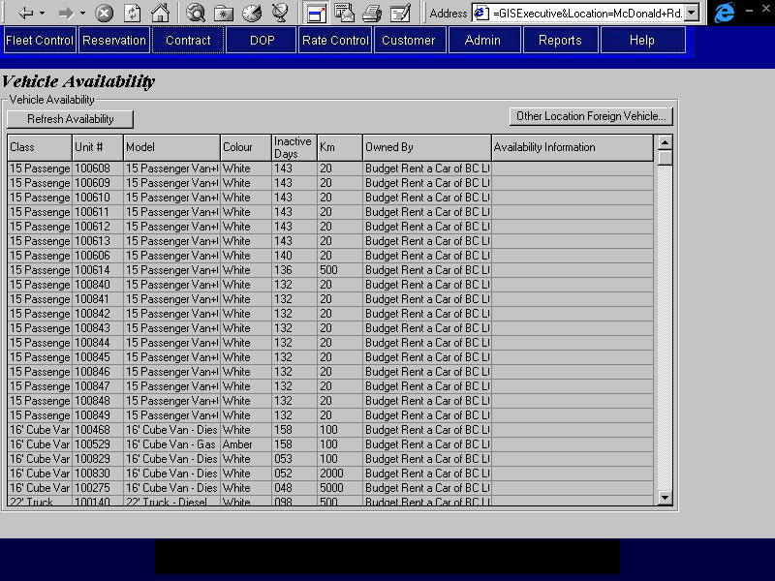
Purpose
The location vehicle availability screen is used to view information on the vehicles available for rent at a location. It is used independently of Contract Open/Check Out to select the vehicles that should be rented out first and ensure that they are easily available on the lot. It can also be used at the same time as Contract Open/Check Out to aid in the selection a specific vehicle to rent, but in most cases, the CSR will simply pick out a set of keys and enter the unit number instead of using this screen.
For a detailed description of what appears in this list, see the notes below on populating the vehicle availability list.
Navigation
Other Location Opens the Foreign Vehicle Availability sub-screen
Foreign Vehicle: .
Functions
Refresh Repopulates the Vehicle Availability list with the vehicles available for
Availability: check out at that location. This is used to eliminate vehicles that have been checked out on contracts since the screen was opened. See the notes below on Populating the Vehicle Availability List for details on how the list will be populated and sorted.
Controls
Req*: Y – always mandatory
N – always optional
S – sometime optional (see Comments for details)
D – display only
Field | Source | Req* | Validation | Comments
Class | Vehicle, Vehicle Class Code | D |  | Vehicle Class Name is displayed.
Unit # | Vehicle, Unit Number | D
Model | Vehicle, Vehicle Model ID | D |  | Model Name is displayed
Colour | Vehicle, Exterior Colour | D
Inactive Days |  | D |  | The number of days since the last contract check in or movement completion for the vehicle.
Km | Vehicle, Current Km | D
Owned By | Vehicle, Vehicle Owning Company | D
Availability Information | N/A | D |  | See the notes below on Populating the Vehicle Availability List.
Populating the Vehicle Availability List
- Vehicles to Appear on List
All vehicles (local and foreign) at the current location. Each vehicle must also meet the following criteria:
- Vehicle Status of ‘Rental’
- Vehicle Rental Status of ‘Available’
- Vehicle Condition Status of ‘OK’, ‘Claims – Rentable’, ‘O/S – Rentable’, ‘Maintenance – Rentable’, ‘Not Inspected’
With the following exceptions for program cars:
- Current kilometre reading greater than or equal to ‘Do Not Rent Past Km’
- Number of days since vehicle status was set to ‘Owned’ greater than or equal to ‘Do Not Rent Past Days’
- Current date greater than or equal to Turn Back Deadline
With the following exception for trucks:
- current kilometre reading greater than or equal to Next Scheduled Maintenance
- Information to be Displayed
The following information will be displayed for each vehicle on the availability list:
- Vehicle Class
- Unit Number
- Model
- Exterior Colour
- Inactive Days (the number of days since the last contract check in or movement completion)
- Current Km
- Owning Company
An additional message showing the vehicle status will be displayed in the list for all vehicles if:
- Vehicle Condition Status is not ‘OK’
Additional messages will be displayed in the list for program cars if:
- Current kilometre reading is within a set number of Km of ‘Do Not Rent Past Km’
- Number of days since vehicle status was set to ‘Owned’ is within a set number of days of ‘Do Not Rent Past Days’
- Current date is within a set number of days of Turn Back Deadline
See the Fleet Business Design (Movement Screen Technical Notes) for the wording to use and the exact conditions under which the messages should be displayed.
An additional message will be displayed in the list for trucks if:
- Current kilometre reading is within a set number of Km of Next Scheduled Maintenance
- Sequence
  - Vehicle Class
  - Within vehicle class, all vehicles where the owning company is Budget BC will be shown first, followed by vehicles belonging to other owning companies (in owning company sequence)
  - Within vehicle class and owning company, all vehicles with a Vehicle condition Status of ‘OK’ will be shown first, followed by vehicles with other vehicle condition statuses (in status sequence)
  - Within vehicle class, owning company and vehicle condition status, vehicles will be shown in descending sequence of Inactive Days. This is to ensure that vehicles that have gone the longest without generating revenue will be rented first.

Foreign Vehicle Availability Screen
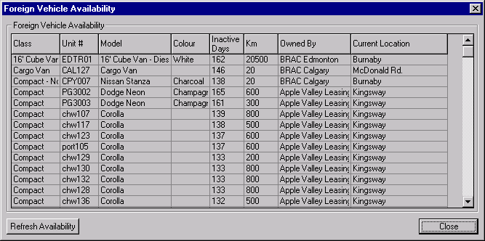
Purpose
The foreign vehicle availability screen is used to show a list of foreign vehicles at other locations than the one where the contract is being opened. The CSR will use this screen when selecting a vehicle to check out for a contract with a foreign drop off location. This screen does not provide any facilities for initiating a movement to bring a foreign vehicle from another location to the location where the contract is being opened. Arrangements to do this will have to be made with the other location and entered through the vehicle movement screen.
The selection criteria and sort sequence for this screen will be the same as that described in the notes on the Populating the Vehicle Availability List for the Availability tab with the following difference:
- Only vehicles that are currently at other locations and that are owned by a foreign company will be displayed.
- Only rental locations with the same owning company as the current location will be displayed.
Navigation
N/A
Functions
N/A
Controls
Req*: Y – always mandatory
N – always optional
S – sometime optional (see Comments for details)
D – display only
Field | Source | Req* | Validation | Comments
Class | Vehicle, Vehicle Class Code | D |  | Vehicle Class Name is displayed.
Unit # | Vehicle, Unit Number | D
Model | Vehicle, Vehicle Model ID | D |  | Model Name is displayed
Colour | Vehicle, Exterior Colour | D
Inactive Days |  | D |  | The number of days since the last contract check in or movement completion for the vehicle.
Km | Vehicle, Current Km | D
Owned By | Vehicle, Vehicle Owning Company | D
Current Location | Vehicle, Current Location ID | D |  | Location is displayed.

Make Vehicle Available Screen
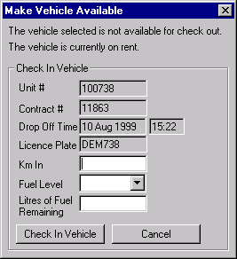

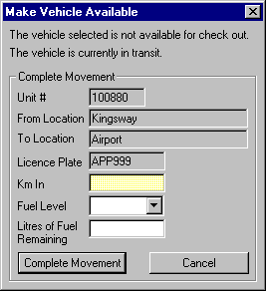
Purpose
This sub screen is used to check in or complete a movement for a vehicle so that it can be checked out on another contract. It is used when a vehicle is physically present at a location and is ready to be rented, but doesn’t show up on the vehicle availability list because the check in or movement completion has not yet been entered on GIS.
Navigation
N/A
Functions
Check In Creates an Override Check In record for the existing Vehicle On Contract
Vehicle: and for the new Contract that is checking out the vehicle. See the Technical Notes for details on what is saved in an Override Check In record.
Sets the vehicle condition status to ‘Not Inspected’
Complete Creates an Override Movement Completion for
Movement: the existing movement and the new Contract that is checking out the vehicle and completes the movement. See the Technical Notes below for details on what is saved in an override movement and how the existing movement is completed.

Sets the vehicle condition status to ‘Not Inspected’Controls
Req*: Y – always mandatory
N – always optional
S – sometime optional (see Comments for details)
D – display only
Field | Source | Req* | Validation | Comments
Check In Vehicle
Unit # | Override Check In, Unit Number  Vehicle, Foreign Vehicle Unit Number | D |  | Set to the Check Out Unit # on the Renter or Replacement tab.  If Vehicle, Foreign Vehicle Unit Number is populated then display it, otherwise display Vehicle, Unit Number.
Contract # | Override Check In, Overridden Contract Number | D |  | From the Vehicle On Contract for Unit # that has not been checked in. This is the contract that will be overridden.
Drop Off Time | Vehicle On Contract, Expected Check In | D |  | From the Vehicle On Contract record for contract that is being overridden.
Licence Plate |  | D |  | Set to the Check Out Licence Plate on the Renter tab or the Replacement tab.
Km In | Override Check In, Km In | Y
Fuel Level | Override Check In, Fuel Level | S | Selection Only | One of Fuel Level or Litres of Fuel Remaining must be entered.
Litres of Fuel Remaining | Override Check In, Fuel Remaining | S
Complete Movement
Unit # | Override Movement Completion, Unit Number | D |  | Set to the Check Out Unit # on the Renter tab or the Replacement tab.
From Location | Vehicle Movement, Sending Location ID | D |  | Location name is displayed  From the Vehicle Movement for Unit # that has not been complete. This is the movement that is being overridden.
To Location | Override Movement Completion, Receiving Location ID | D |  | Location name is displayed  From the Vehicle Movement that is being overridden. This is also the pick up location for the new vehicle on contract.
Licence Plate |  | D |  | Set to the Check Out Licence Plate on the Renter tab or the Replacement tab.
Km In | Override Movement Completion, Km In | N
Fuel Level | Override Movement Completion, Fuel Level | N | Selection Only
Litres of Fuel Remaining | Override Movement Completion, Litres of FuelRemaining | N
Technical Notes
Override Check In
When creating an override check in the following fields are populated in the override check in table:
Overridden Contract Number: The contract number of the vehicle on contract that is subject to the override check in.
Unit Number: The unit number of the vehicle that is subject to the override check in. The unit number and overridden contract number make up the primary key of vehicle on contract record that is being overridden (is subject to the override check in).
Checked Out: The check out date and time of the vehicle on contract that is being overridden.
Override Contract Number: The contract number that is checking out the vehicle that has been subject to the override check in.
Drop Off Location ID: The location at which the override check in took place. This is also the check out location of the new vehicle on contract.
Check In: The check in time of the override check in. This is the same as the check out time of the new vehicle on contract.
Km In: The Km In entered on the override check in sub-screen.
Fuel Level: The Fuel Level entered on the override check in sub-screen.
Fuel Remaining: The Fuel Remaining entered on the override check in sub-screen.
Check In By: The user who completed the override check in.
Override Movement Completion:
When creating an override movement completion the following fields are populated in the override movement completion table:
Unit Number: The unit number of the vehicle that is subject to the override movement completion. The unit number and movement out date/time make up the primary key of vehicle movement record that is being overridden (is subject to the override movement completion).
Movement Out: Date and Time that the vehicle began its movement.
Override Contract Number: The contract number that is checking out the vehicle that has been subject to the override movement completion.
Receiving Location ID: The location at which the override movement completion took place. This is also the check out location of the new vehicle on contract.
Movement In: The movement in time of the override movement completion. This is the same as the check out time of the new vehicle on contract.
Km In: The Km In entered on the override movement completion sub-screen.
Fuel Level: The Fuel Level entered on the override movement completion sub-screen.
Litres of Fuel Remaining: The Fuel Remaining entered on the override movement completion sub-screen.
When completing the movement, the following fields are updated in the movement record:
Movement In: The movement in time of the override movement completion. This is the same as the check out time of the new vehicle on contract.
Km In: The Km In entered on the override movement completion sub-screen.
When completing the movement, the following fields are updated in the vehicle record:
Current Location ID: The movement in location.
Current Km: The Km In entered on the override movement completion sub-screen.

Rate Details Screen
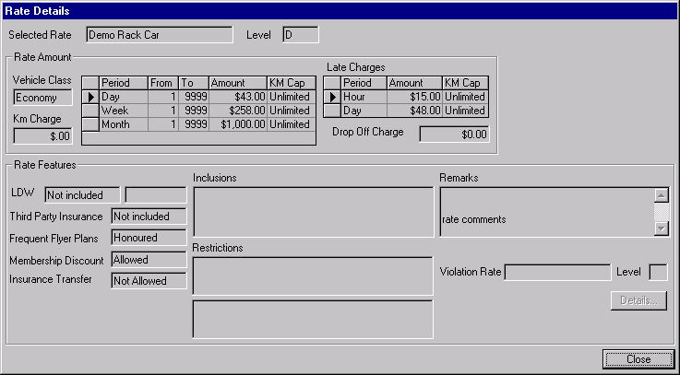
Purpose
The rate details screen is used to display detailed information about the rate selected for a contract so that the CSR may communicate the rate information to the customer.
Navigation
Details: Invokes a screen that will display the rate information for the violation rate. The violation rate screen will contain the same information that is displayed in the base rate screen with the exception of the violation rate since violation rates cannot be nested.
Functions
N/A
Controls
Req*: Y – always mandatory
N – always optional
S – sometime optional (see Comments for details)
D – display only
Field | Source | Req* | Validation | Comments
Selected Rate | Contract, Rate ID & Rate Level | D |  | Rate name & level displayed.
(tour rate message) |  | D |  | “Tour Rate: The first three Rate amount rows are for Budget confidential use only.” Only displayed when Rate Purpose is Tour.
Vehicle Class | Rate Vehicle Class, Vehicle Class Code | D |  | For selected rate. Value same as selected vehicle class in contract. Vehicle Class name displayed.
Km Charge | Rate Vehicle Class, Per Km Charge | D |  | For selected rate and vehicle class.
Period | Rate Time Period, Time Period | D |  | For selected rate and Type = Regular.
From | Rate Time Period, Time Period Start | D |  | For selected rate and time period.
To | Rate Time Period, Time Period End | D |  | For selected rate and time period.
Amount | Rate Charge Amount, Amount | D |  | For selected rate, rate level, time period, and vehicle class.
Km Cap | Rate Time Period, Km Cap | D |  | For selected rate and time period.
Late Charge Period | Rate Time Period, Time Period | D |  | For selected rate and Type = Late.
Late Charge Amount | Rate Charge Amount, Amount | D |  | For selected rate, rate level, time period (Type = Late), and vehicle class.
Late Charge Km Cap | Rate Time Period, Km Cap | D |  | For selected rate and time period.
Drop Off Charge | Pick Up/Drop Off Location, Authorized Charge  Rate Drop Off Location, Include In Rate. | D |  | ‘Km Charge’ if Rate has Km Drop Charge turned on. If Rate Drop Off Location, Included In Rate = Yes for the selected pick up and drop off locations then display 0. Otherwise show the AuthorizedCharge for specified pick up and drop off location in the Pick Up/Drop Off Location table..
LDW (included) |  | D |  | ‘Included’ if the rate has an Included Optional Extra with Optional Extra, Type = LDW, ‘Not Included’ otherwise.
LDW (deductible) | LDW Deductible, LDW Deductible | D |  | Only displays if the rate has an Included Optional Extra with Optional Extra, Type = LDW. The LDW Deductible record used is the one for the selected vehicle class and the Included Optional Extra with Optional Extra, Type = ‘LDW’.
Third Party Insurance |  | D |  | ‘Included’ if the rate has an Included Optional Extra with Optional Extra, Type = Third Party Insurance, ‘Not Included’ otherwise.
Frequent Flyer Plans | Vehicle Rate, Frequent Flyer Plans Honoured | D |  | ‘Honoured’ if Frequent Flyer Plans Honoured is Yes, ‘Not Honoured’ otherwise
Membership Discount | Vehicle Rate, Discount Allowed | D |  | ‘Allowed’ if Discount Allowed is Yes, ‘Not Allowed’ otherwise
Insurance Transfer | Vehicle Rate, Insurance Transfer Allowed | D |  | Allowed if Insurance Transfer Allowed is Yes, ‘Not Allowed’ otherwise.
Inclusions | Included Optional Extra, Optional Extra ID; and  Included Sales Accessory, Sales Accessory ID; and  Vehicle Rate, GST Included, PST Included, PVRT Included, Location Fee Included | D |  | List all inclusion names in one list (optional extras, sales accessories, and taxes). Only list tax inclusions if value is yes. Do not list included optional extras with a Type of LDW or Third Party Insurance as they are listed separately. See Technical Notes below.
Restrictions  (selected restrictions) | Rate Restriction, Restriction ID, Time of Day, Number of Days, Number of Hours | D |  | Concatenate Rate Restriction fields. See Technical Notes below.
Restrictions  (special restrictions) | Vehicle Rate, Special Restriction | D
Remarks | Vehicle Rate, Other Remarks & Contract Remarks | D |  | Concatenate Other Remarks and Contract Remarks.
Violation Rate | Vehicle Rate, Violation Rate ID | D |  | Display Rate Name.
Level | Vehicle Rate, Violation Rate Level | D
Technical Notes
Displaying Inclusions:
When the item being displayed is a flag, display the flag name if the value is Yes and nothing if the value is No.
Displaying Restrictions:
Concatenate the restriction text and any of the following fields that are required for that restriction. See the Vehicle Rate Screen business design for details on which fields are required for which restriction.
- Number of Days
- Number of Hours
- Time of Day.

Other Extras Screens
There are two versions of the Other Extras screen. One is used for Contract Open and Check Out and the other one is used for the remaining screens that cover the rest of the contract life cycle (Changes During Rental, Check In and Adjustments).

Other Extras Screen (Contract Open)
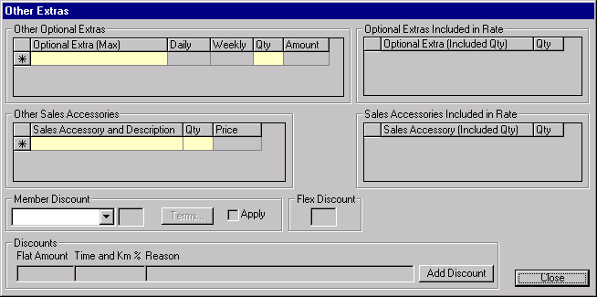
Purpose
The Other Extras screen allows the CSR to select optional extras (other than LDW, Buydown, PAI, PEC & Cargo Insurance) to be added to the contract. A member discount may be entered and applied to the contract if the rate allows the use of a member discount and the renter meets the discount terms and conditions. A contract discount can be entered here and if a flex discount was given with the reservation, the discount percentage will be displayed.
Optional Extras
If the contract was opened from a reservation, any optional extras requested when the reservation was made will be shown here. For a walk up customer with a BCN, any optional extras specified for the BCN will be shown here. The CSR can remove these optional extras and/or add new ones. Each optional extra has a Rent From and Rent To date and time which will not be visible on the screen and which will be set to the pick up and drop off times.
Sales Accessories
If the contract was opened from a reservation, any sales accessories requested when the reservation was made will be shown here. The CSR can remove these and/or add new ones.
Member Discount
If the contract was opened from a reservation, any member discount requested when the reservation was made will be shown here. The CSR can remove this or add a new one by selecting a discount from a list of discounts that Budget offers. The CSR will use the Terms button to view the terms and conditions and check the Apply box if the renter meets the terms and conditions for applying the discount. Only one member discount can be applied to a contract and member discounts are only applied to vehicle rental time and kilometre charges.
If the rate selected does not allow member discounts, these fields will be invisible.
If a flex discount was recorded with the reservation, these fields will be invisible.
Contract Discount
If desired, a contract discount can be entered here, either as a flat amount or a percentage of the time and kilometre charges. A reason must be specified and manager or supervisor approval is required.
Navigation
Terms: Displays the terms and conditions associated with the member discount selected.
Functions
Add Discount: Prompts for user ID and password before allowing access to add discounts to the rental. Invokes the Calculate Rental Charge Amount function.
Controls
Req*: Y – always mandatory
N – always optional
S – sometime optional (see Comments for details)
D – display only
Field | Source | Req* | Validation | Comments
Other Optional Extras |  |  |  | Locked if BCN populated.
Optional Extra (Max) | Contract Optional Extra, Optional Extra ID | N | Selection Only  Value controlled by Optional Extra table and Optional Extra Restriction table. | Optional Extra name and maximum quantity are displayed.  Optional Extras with Type LDW, Buydown, PAI, PEC and Cargo Insurance will be excluded from the list of optional extras available.  Optional Extras with a restriction for the selected vehicle class (in the contract) will not be displayed in the list.
Daily | Contract Optional Extra, Daily Rate | D | Currency | Value from selected Optional Extra. Rate will not vary with quantity.
Weekly | Contract Optional Extra, Weekly Rate | D | Currency | Value from selected Optional Extra. Rate will not vary with quantity.
Qty | Contract Optional Extra, Quantity | Y | Numeric | Must be less than or equal to maximum allowable quantity for the selected Optional Extra.
Amount |  | D | Currency | Calculated by GIS. Calculated based on rental period and quantity. Displays cheapest combination of daily and weekly rates.
Optional Extras Included in Rate
Optional Extra (Included Qty) | Contract Optional Extra, Optional Extra ID | D |  | Contract Optional Extra, Included in Rate = Yes. Copied from selected rate Included Optional Extras. Only show Include Optional Extras where the Optional Extra is not restricted for the selected Vehicle Class (in the contract).  Display the Optional Extra name and the Include Optional Extra, Quantity for the selected rate.
Qty | Contract Optional Extra, Quantity | S | Must be entered if Optional Extra is populated. | Defaults to Included Optional Extra, Quantity for selected rate.
Other Sales Accessories |  |  |  | Locked if BCN populated.
Sales Accessory and Description | Contract Sales Accessory, Sales Accessory ID | N | Value controlled by Sales Accessory table and Location Sales Accessory table. | Sales Accessory name and Unit Description displayed.  Only Sales Accessories available to the pick up location (Location Sales Accessory table) will be in the list.
Qty | Contract Sales Accessory, Quantity | Y | Numeric
Price |  | D | Currency | Calculated by GIS. Calculated based on quantity and Location Sales Accessory, Price (if null then use Sales Accessory Price, Price).
Sales Accessories Included in Rate
Sales Accessory (Included Qty) | Contract Sales Accessory, Sales Accessory ID | D |  | Contract Sales Accessory, Included in Rate = Yes. Copied from selected rate Included Sales Accessory. Only show Included Sales Accessories where the Sales Accessory is available for the pick up location (Location Sales Accessory table).  Display the Sales Accessory name and the Include Sales Accessory, Quantity for the selected rate.
Qty | Contract Sales Accessory, Quantity | S | Must be entered if Sales Accessory is populated. | Defaults to Included Sales Accessory, Quantity for selected rate.
Member Discount |  |  |  | Not visible unless Member Discounts Allowed is Yes for the rate selected and no flex discount is being applied to the contract.  Locked if BCN populated.
Discount | Contract, Member Discount ID | N | Value controlled by Member Discount table | Discount name is displayed.  Percent and Apply will be cleared if this field is cleared.
(Percent) | Member Discount, Percentage | D |  | For selected discount.
Apply |  | N |  | Disabled unless a Discount is selected. Discount will not be applied or saved with the contract unless this is checked.
Flex Discount | Contract, Flex Discount | D |  | Set from Reservation, Flex Discount. Will never have a value for walk up contracts.
Discounts |  |  |  | Contract Reimbursement and Discount,Type = Discount  Locked until the Add Discount button has been selected and valid user id and password entered.
Flat Amount | Contract Reimbursement and Discount, Flat Amount | N |  | Only one of Amount and % can be entered.  The discount that is actually applied will be the Flat Amount or the Rental Charges displayed on the Payment tab, whichever is less.
Time and Km % | Contract Reimbursement and Discount, Percentage | N | Must be <= 100 | Only one of Amount and % can be entered.
Reason | Contract Reimbursement and Discount, Discount Reason | N |  | Required when Flat Amount or Time and Km % is entered.
Technical Notes
Optional Extras:
The maximum quantity for an optional extra cannot be exceeded, either in a single entry, or in the sum of all the entries for that optional extra.
If an optional extra is selected that is already included in the rate or has already been selected, a warning will be issued.

Other Extras (After Open & Check Out)
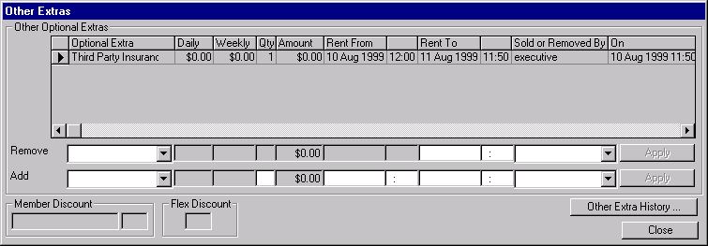
Purpose
The Other Extras (After Open & Check Out) allows the CSR to view the current optional extras for the contract and to add and remove optional extras (other than LDW, Deductible Buydown, PAI, PEC & Cargo Insurance). A button is available to view the other extra history for the contract. Member and flex discount information can be viewed here. If additional sales accessories are to be sold the Separate Accessory Sale screen will be used.
Other Optional Extras
The CSR may remove an optional extra by selecting it (which will populate the Remove section), changing the Rent To date and hitting the Apply button. The maximum quantity of the optional extra cannot be exceeded by the addition.
Navigation
Other Extra History: Displays the optional extra history for the contract for optional extras where type is other than LDW, Deductible Buydown, PAI, PEC & Cargo Insurance. Disabled if there is no other extra history (non-coverage optional extras with a Termination Date).
Functions
Apply: Makes the selected optional extra inactive and creates a copy of the optional
(remove) extra with a new Rent To date/time. The new optional extra is added to the optional extra history list and the Remove information is cleared.
Apply: Adds the selected optional extra to the contract. The new optional extra is
(add) added to the optional extra history list and the Add information is cleared. Maximum quantity for the selected optional extra will be checked to ensure that it is not exceeded by the addition.
Controls
Req*: Y – always mandatory
N – always optional
S – sometime optional (see Comments for details)
D – display only
Field | Source | Req* | Validation | Comments
Other Optional Extras |  |  |  | Display only current other extra records (records are not terminated).
Optional Extra | Contract Optional Extra, Optional Extra ID | D |  | Optional Extra name is displayed.  Optional Extras with Type LDW, Buydown, PAI, PEC and Cargo Insurance will be excluded.
Daily | Contract Optional Extra, Daily Rate | D |  | Rate will not vary with quantity.
Weekly | Contract Optional Extra, Weekly Rate | D |  | Rate will not vary with quantity.
Qty | Contract Optional Extra, Quantity | D
Amount |  | D |  | Calculated by GIS. Calculated based on rental period and quantity. Displays cheapest combination of daily and weekly rates.
Rent From | Contract Optional Extra, Rent From | D |  | Date/Time
Rent To | Contract Optional Extra, Rent To | D |  | Date/Time
Sold or Removed By | Contract Optional Extra, Sold/Removed By | D
Sold or Removed On | Contract Optional Extra, Sold/Removed On | D |  | Date/Time
Remove |  |  | Selection controlled by current Contract Optional Extra records for the selected contract (shown in grid above).
Optional Extra | Contract Optional Extra, Optional Extra ID | D | See above. | Optional Extra name is displayed.
Daily | Contract Optional Extra, Daily Rate | D |  | Rate will not vary with quantity.
Weekly | Contract Optional Extra, Weekly Rate | D |  | Rate will not vary with quantity.
Quantity | Contract Optional Extra, Quantity | D
Amount |  | D |  | Calculated by GIS. Calculated based on rental period and quantity. Displays cheapest combination of daily and weekly rates.
Rent From | Contract Optional Extra, Rent From | D
Rent To | Contract Optional Extra, Rent To | S | Date & Time  Must be <= Drop Off Time | Required if an Optional Extra is selected for removal.  Defaults to Drop Off Time
Location | Contract Optional Extra, Sold at Location ID | S | Value controlled by Location table. Rental locations only. | Required if an Optional Extra is selected for removal.  Default to current location.  Display location name.
Add
Optional Extra | Contract Optional Extra, Optional Extra ID | N | Selection Only  Value controlled by Optional Extra table and Optional Extra Restriction table. | Optional Extra name is displayed.  Optional Extras with Type LDW, Buydown, PAI, PEC and Cargo Insurance will be excluded from the list of optional extras available.  Include only optional extras that are not restricted for the selected vehicle class (contract).
Daily | Contract Optional Extra, Daily Rate | D |  | For selected Optional Extra. Rate will not vary with quantity.
Weekly | Contract Optional Extra, Weekly Rate | D |  | For selected Optional Extra. Rate will not vary with quantity.
Quantity | Contract Optional Extra, Quantity | S | Numeric | Required if an Optional Extra is selected.  Must be less than or equal to maximum allowable quantity for the selected optional extra.
Amount |  | D | Currency | Calculated by GIS. Calculated based on rental period and quantity. Displays cheapest combination of daily and weekly rates.
Rent From | Contract Optional Extra, Rent From | S | Date & Time  Must be >= Pick Up Time. | Required if an Optional Extra is selected.  Defaults to current date/time.
Rent To | Contract Optional Extra, Rent To | S | Date & Time  Must be <= Drop Off Time | Required if an Optional Extra is selected.  Defaults to Drop Off Time
Location | Contract Optional Extra, Sold at Location ID | S | Value controlled by Location table. Rental locations only. | Required if an Optional Extra is selected.  Default to current location.  Display location name.
Member Discount |  |  |  | Not visible unless Member Discounts Allowed is Yes for the rate selected.
Discount | Contract, Member Discount ID | D |  | Display Discount name.
Percent | Member Discount, Percentage | D |  | For selected Membership Discount.
Flex Discount
 | Contract, Flex Discount | D
Technical Notes
Optional Extras:
The maximum quantity for an optional extra cannot be exceeded, either in a single entry, or in the sum of all the entries for that optional extra.
If an optional extra is selected that is already included in the rate or has already been selected, a warning will be issued.

Other Extra History Sub-Screen
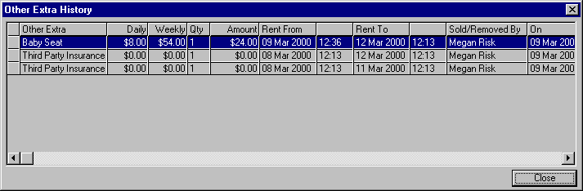
Purpose
This screen allows the CSR to view all changes that have occurred to other extras applied to the contract during the life of the contract.
Navigation
N/A
Functions
N/A
Controls
Req*: Y – always mandatory
N – always optional
S – sometime optional (see Comments for details)
D – display only
Field | Source | Req* | Validation | Comments
Other Extra History |  |  |  | Show all Contract Optional Extra records, current and terminated (except types listed below).
Other Extra | Contract Optional Extra, Optional Extra ID | D |  | Optional Extra name is displayed.  Optional Extras with Type LDW, Buydown, PAI, PEC and Cargo Insurance will be excluded.
Daily | Contract Optional Extra, Daily Rate | D |  | Rate will not vary with quantity.
Weekly | Contract Optional Extra, Weekly Rate | D |  | Rate will not vary with quantity.
Qty | Contract Optional Extra, Quantity | D
Amount |  | D | Currency | Calculated based on rental period and quantity. Displays cheapest combination of daily and weekly rates.
Rent From | Contract Optional Extra, Rent From | D |  | Date/Time
Rent To | Contract Optional Extra, Rent To | D |  | Date/Time
Sold/Removed By/On | Contract Optional Extra, Sold/Removed By & Sold/  Removed On | D |  | Date/Time

Manual Credit Card Transaction Screen
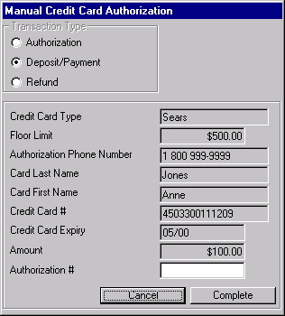
Purpose
The Manual Credit Card Transaction sub-screen is used to perform credit card transactions (authorizations, deposits, payments and refunds) when the automated facility is not available and for credit card types that have no automatic processing.
The credit card information and amount will default from the invoking screen and the floor limit and authorization telephone number for the credit card type will be displayed.
If the amount is less than or equal to the floor limit, telephone authorization doesn’t have to be performed. In that case, when this screen is closed, ‘Floor Limit’ will be displayed in the authorization number on the invoking screen. If a telephone authorization is performed, the CSR will enter the authorization number given over the phone.
Navigation
N/A
Functions
N/A
Controls
Req*: Y – always mandatory
N – always optional
S – sometime optional (see Comments for details)
D – display only
Field | Source | Req* | Validation | Comments
Transaction Type |  | Y | Authorization,  Deposit/Payment, or  Refund | Determines whether the transaction is saved as a Payment or an Authorization. Defaulted from invoking screen.
Credit Card Type | Credit Card, Credit Card Type ID | D |  | Set from invoking screen.
Floor Limit | Credit Card Type, Floor Limit | D
Authorization Phone Number | Credit Card Type, Authorization Phone Number | D
Credit Card # | Credit Card, Credit Card Number | D |  | Set from invoking screen.
Card Last Name | Credit Card, Last Name | D |  | Set from invoking screen.
Card First Name | Credit Card, First Name | D |  | Set from invoking screen.
Credit Card Expiry | Credit Card, Expiry | D |  | Set from invoking screen.
Amount | Contract Payment Item, Amount or Credit Card Authorization, Amount Authorized or Reservation Deposit Payment, Amount | Y |  | Defaults from invoking screen.
Authorization # | Credit Card Payment, Authorization Number or Credit Card Authorization, Authorization Number or Credit Card Deposit Payment, Authorization Number | S |  | Required if Amount is greater than Floor Limit.

Direct Bill Search Screen
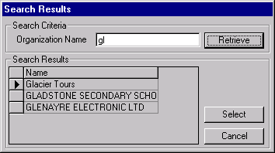
Purpose
The direct bill search-screen is used to search for a direct bill organization and return information for the selected organization to the invoking screen.
When the screen is opened, a list of the organizations that match the name passed from the invoking screen will be displayed. The CSR can select one of these and return to the invoking screen or search on a different name.
Navigation
N/A
Functions
Retrieve: Retrieves all the Accounts Receivable accounts where the name matches the Organization Name entered.
Controls
Req*: Y – always mandatory
N – always optional
S – sometime optional (see Comments for details)
D – display only
Field | Source | Req* | Validation | Comments
Search Criteria
Organization Name | A/R Customer Master, Address Name | Y |  | Defaults to the organization name passed by invoking screen.
Search Results |  |  |  | Only returns records with Address Type = 0
Name | AR Customer Master, Address Name | D

Rental Charge Billing Screen
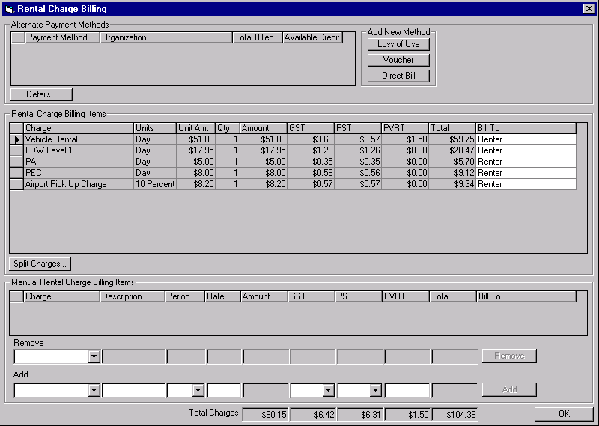
Purpose
This screen is used to enter alternate payment billing details and assign the rental charges to the to alternate payment organizations.
The CSR will enter the information for alternate payment methods for the contract.
The screen will be populated with all the rental charges for the contract. The default charge assignment for all charges will be the party responsible for the rental. This will usually be the renter, but can also be a direct bill company.
The CSR will select one of the alternate payment organizations identified on the Rental Authorization sub-tab as the party to be billed for each rental charge that is not being billed to the party responsible for the rental. If desired, the CSR can split a line for rental charge and bill the charges to two separate parties, either by time period or by amount.
If the billing is split by time period, the total time period specified must match the original time period for the rental charge. For example, if a 6 day vehicle rental is split between ICBC and a body shop, the total number of days billed to both parties must equal 6.
If the billing is split by amount, the total amount specified must match the original amount for the rental charge. For example, if a $120.00 flat rate vehicle rental is being split between a tour voucher and the renter, the total mount billed to both parties must equal $120.00.
Once the rental charges have been assigned, the CSR will check the credit for each alternate payment organization that has rental changes billed to it.
This screen can also be used to enter manual charge items such as parking tickets and drop charges for organizations that have negotiated drop charges based on the number of kilometres between the pick up and drop off locations. This facility will not be available when this screen is opened from the Contract Open/Check Out screen.
Vouchers:
When a voucher that does not include tax is assigned to a charge item, the GST and PST will be increased by 25%.
Navigation
Split Charge: Opens the Split Rental Charge sub-screen for the selected line or lines. If more than one line is selected all the lines must be from the same original rental charge billing item. After the screen is closed, a separate line for each split will be displayed in the list of rental charge billing items.
Functions
Details: Opens the appropriate alternate payment details screen (Loss of Use, Voucher or Direct Bill) for the selected alternate payment organization so that the CSR can view or update the required details.
Loss of Use: Opens the Loss of Use details screen so that the CSR can enter a new Loss of Use alternate payment organization.
Voucher: Opens the Voucher details screen so that the CSR can enter a new Voucher alternate payment organization.
Direct Bill: Opens the Direct Bill details screen so that the CSR can enter a new Direct Bill alternate payment organization.
Close Screen: At this point, a warning will be issued if there are any alternate payment organizations with no charges billed to them or where the total billed exceeds the credit available.
Add: Adds a new Manual Rental Charge Billing Item using the information entered.
Remove: Removes the selected Manual Charge Billing Item.
Controls
Req*: Y – always mandatory
N – always optional
S – sometime optional (see Comments for details)
D – display only
Field | Source | Req* | Validation | Comments
Alternate Payment Methods |  |  |  | Locked if BCN populated.  Show one line for each Contract Billing Party where Billing Type = Alternate.
Payment Method | Contract Billing Party, Billing Method | D
Organization | Contract Billing Party, Customer Code | D |  | A/R Customer Master, Address Name is displayed
Total Billed | Contract Billing Party, Amount Removed from Available Credit | D |  | Calculated by GIS from the rental charges assigned to the alternate payment organizationon the Rental Charge Billing screen..
Credit Available | (see comments) | D |  | Calculated by GIS: A/R Customer Master, Credit Limit minus the sum of Budget A/R Customer Activity, Amount Balance; A/R Credit Authorization, Daily Contract Total; and A/R Credit Authorization, Expected Open Contract Charges.
Rental Charge Billing Items |  |  |  | Displays all Contract Charge Items with Charge Item Type of Calculated (‘c’).
Charge | Contract Charge Item, Charge Description | D
Units | Contract Charge Item, Unit Type | D
Unit Amt | Contract Charge Item, Unit Amount | D
Qty | Contract Charge Item, Quantity | D
Amount | Contract Charge Item, Amount | D
GST | Contract Charge Item, GST Amount | D |  | Will not be calculated if GST is included in the rate or exempt for this charge item.
PST | Contract Charge Item, PST Amount | D |  | Will not be calculated if PST is included in the rate or exempt for this charge item.
PVRT | Contract Charge Item, PVRT Amount | D |  | Will not be calculated if PVRT is included in the rate or exempt for this charge item.
Total |  | D |  | Sum of Amount, GST, PST & PVRT
Bill To | Contract Charge Item, Contract Billing Party ID | Y |  | Defaults to the Contract Billing Party with Billing Type = ‘Primary’.  Where Contract Billing Party has Billing Type = Primary and Billing Method = Renter, Renter is displayed. Where Contract Billing Party has a Billing Type = Primary and Billing Method = Direct Bill, Direct Bill is displayed. Otherwise Contract Billing Party, Billing Method – A/R Customer Master, Address Name is displayed.
Manual Rental Charge Billing Items |  |  |  | Not visible when this screen is opened by the Contract Open/Check Out screen.  Displays all Contract Charge Items with Charge Item Type of Manual (‘m’)
Charge | Contract Charge Item, Charge Type | D
Description | Contract Charge Item, Charge Description | D
Period | Contract Charge Item, Unit Type | D
Rate | Contract Charge Item, Unit Amount | D
Amount | Contract Charge Item, Amount | D
GST | Contract Charge Item, GST Amount | D
PST | Contract Charge Item, PST Amount | D
PVRT | Contract Charge Item, PVRT Amount | D
Total |  | D |  | Sum of Amount, GST, PST & PVRT
Bill To | Contract Charge Item, Contract Billing Party ID | Y |  | Defaults to the Contract Billing Party with Billing Type = ‘Primary’.  Where Contract Billing Party has Billing Type = Primary and Billing Method = Renter, Renter is displayed. Where Contract Billing Party has a Billing Type = Primary and Billing Method = Direct Bill, Direct Bill is displayed. Otherwise Contract Billing Party, Billing Method – A/R Customer Master, Address Name is displayed.
Remove |  |  | Available items controlled by manual charge item grid (directly above).
Charge | Contract Charge Item, ChargeType | D
Description | Contract Charge Item, Charge Description | D
Period | Contract Charge Item, Unit Type | D
Rate | Contract Charge Item, Unit Amount | D
Amount | Contract Charge Item, Amount | D
GST | Contract Charge Item, GST Amount | D
PST | Contract Charge Item, PST Amount | D
PVRT | Contract Charge Item, PVRT Amount | D
Total |  | D |  | Sum of Amount, GST, PST & PVRT
Add
Charge | Contract Charge Item, Charge Type | N | Value controlled by Charge Type table (Manual category).
Description | Contract Charge Item, Charge Description | S |  | Required if Charge Item is entered.
Period | Contract Charge Item, Unit Type | Y | Selection only  Daily/Weekly/Flat | Required if Charge Item is entered
Rate | Contract Charge Item, Unit Amount | Y | Currency | Required if Charge Item is entered
Amount | Contract Charge Item, Amount | D |  | Calculated by GIS based on Period, Rate and rental period.
GST |  | Y | Selection only  Yes/No | Contract Charge Item, GST Amount will be calculated using current GST rate if Yes is selected.
PST |  | Y | Selection only  Yes/No | Contract Charge Item, PST Amount will be calculated using current PST rate if Yes is selected.
PVRT Days |  | N | Numeric | Default is null  Contract Charge Item, PVRT Amount will be calculated using number of days entered multiplied by the current PVRT rate.
Total |  | D |  | Sum of Amount, GST, PST & PVRT
Total Charges |  |  |  | Displays totals for all the charges for the following fields: Amount, GST, PST, PVRT, and Total.
Technical Notes
When calculating PST for vehicle rental or kilometre charges, use the PST rate for the vehicle model.
When creating a new Manual Charge Item:
- create contract charge item
- set Manual/Calculated to ‘Manual’
- set Billed To to the party authorizing the rental (the Contract Billing Party with Billing Type ‘Primary’)
- Set GST Included to No
- If GST is ‘No’ set GST Exempt to Yes, otherwise set it to No
- Set PST Included to No
- If PST is ‘No’ set PST Exempt to Yes, otherwise set it to No

Alternate Payment Details Sub-Screen (Loss of Use)
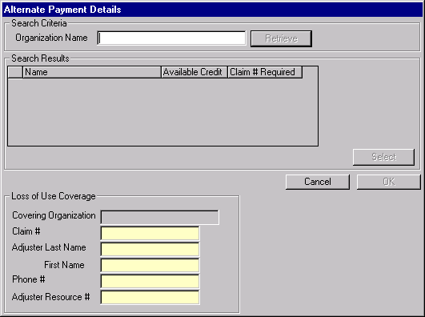
Purpose
This screen is used to retrieve the party to be billed for the loss of use portion of a rental and to record the loss of use details.
Navigation
N/A
Functions
Retrieve: Search for a direct bill organization using the organization name entered. All the
direct bill organizations that match the name entered will be displayed, along with their available credit and whether a claim # is required.
Select: Takes the selected organization name and uses it to populate the Loss of Use
Covering Organization.
Controls
Req*: Y – always mandatory
N – always optional
S – sometime optional (see Comments for details)
D – display only
Field | Source | Req* | Validation | Comments
Search Criteria
Organization Name | A/R Customer Master, Address Name | Y
Search Results |  |  |  | Only returns records with Address Type = 0
Name | A/R Customer Master, Customer Code | D |  | AR Customer Master, Address Name is displayed
Available Credit | (see comments) | D |  | A/R Customer Master, Credit Limit minus the sum of A/R Customer Activity, Amount Balance; A/R Credit Authorization, Daily Contract Total; and A/R Credit Authorization, Expected Open Contract Charges.
Claim # Required | Budget A/R Customer Master, Claim Number Required | D
Loss of Use Coverage
Covering Organization | Loss of Use Alternate Billing, Contract Billing Party ID | D |  | Set Contract Billing Party, Customer Code to selected A/R Customer Master, Customer Code.  A/R Customer Master, Address Name is displayed.
Claim # | Loss of Use Alternate Billing, Claim Number | S |  | Required if Budget A/R Customer Master, Claim Number Required is Yes for the selected Customer Code.
Adjuster Last Name | Loss of Use Alternate Billing, Adjuster Last Name | Y
Adjuster First Name | Loss of Use Alternate Billing, Adjuster First Name | Y
Phone # | Loss of Use Alternate Billing, Phone Number | Y
Adjuster Resource # | Loss of Use Alternate Billing, Adjuster Resource Number | Y

Alternate Payment Details Sub-Screen (Direct Bill)
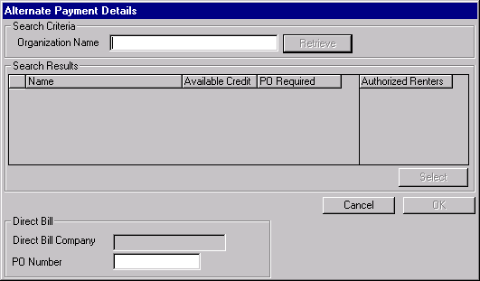
Purpose
This screen is used to retrieve the party to be billed for the direct bill portion of a rental and to record the direct bill details.
Navigation
N/A
Functions
Retrieve: Search for a direct bill organization using the organization name entered. All the
direct bill organizations that match the name entered will be displayed, along with their available credit and whether a PO is required.
Select: Takes the selected organization name and uses it to populate the Direct Bill
Company.
Controls
Req*: Y – always mandatory
N – always optional
S – sometime optional (see Comments for details)
D – display only
Field | Source | Req* | Validation | Comments
Search Criteria
Organization Name | A/R Customer Master, Address Name | Y
Search Results |  |  |  | Only returns records with Address Type = 0
Name | A/R Customer Master, Customer Code | D |  | AR Customer Master, Address Name is displayed
Available Credit | (see comments) | D |  | AR Customer Master, Credit Limit minus the sum of A/R Customer Activity, Amount Balance; A/R Credit Authorization, Daily Contract Total; and A/R Credit Authorization, Expected Open Contract Charges.
PO Required | Budget A/R Customer Master, Purchase Order Required | D
Authorized Renters | A/R Customer Master, Address Name | D |  | Where Customer Code is the same as the selected Customer Code (hilighted in grid) and Address Type = 1.
Direct Bill
Direct Bill Company | Direct Bill Alternate Billing, Contract Billing Party ID | D |  | Set Contract Billing Party, Customer Code to selected A/R Customer Master, Customer Code.  A/R Customer Master, Address Name is displayed.
PO Number | Direct Bill Alternate Billing, PO Number | S |  | Required if Budget A/R Customer Master, Purchase Order Required is Yes.

Alternate Payment Details Sub-Screen (Voucher)
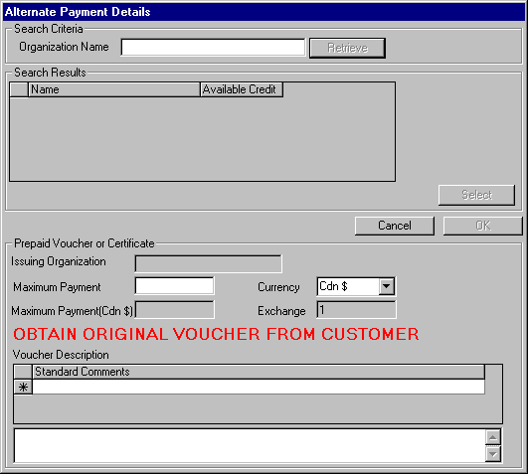
Purpose
This screen is used to retrieve the party to be billed for the voucher portion of a rental and to record the voucher details.
Navigation
N/A
Functions
Retrieve: Search for a direct bill organization using the organization name entered. All the
direct bill organizations that match the name entered will be displayed, along with their available credit.
Select: Takes the selected organization name and uses it to populate the Issuing
Organization.
Controls
Req*: Y – always mandatory
N – always optional
S – sometime optional (see Comments for details)
D – display only
Field | Source | Req* | Validation | Comments
Search Criteria
Organization Name | A/R Customer Master, Address Name | Y
Search Results |  |  |  | Only returns records with Address Type = 0.
Name | A/R Customer Master, Customer Code | D |  | AR Customer Master, Address Name is displayed
Available Credit | (see comments) | D |  | AR Customer Master, Credit Limit minus the sum of A/R Customer Activity, Amount Balance; A/R Credit Authorization, Daily Contract Total; and A/R Credit Authorization Info, Expected Open Contract Charges.
Prepaid Voucher or Certificate
Issuing Organization | Voucher Alternate Billing, Contract Billing Party ID | D |  | Set Contract Billing Party, Customer Code to selected A/R Customer Master, Customer Code.  AR Customer Master, Address Name is displayed.
Maximum Payment | Voucher Alternate Billing, Foreign Currency Maximum Payment | N
Currency | Voucher Alternate Billing, Currency ID | Y | Selection only  Value controlled by Voucher Currency table | Current Name is displayed  Defaults to Cdn $
Maximum Payment (Cdn) | Voucher Alternate Billing, Maximum Payment | D |  | Converted from Maximum Payment into Cdn $.
Exchange | Voucher Alternate Billing, Exchange Rate | D |  | Defaults to current exchange rate for Currency
Voucher Description (standard) | Voucher Alternate Billing Standard Description, Voucher Standard Description | N | Value controlled by Voucher Standard Description table
Voucher Description (special) | Voucher Alternate Billing, Description | N
Technical Notes
When calculating the exchange rate for voucher maximum payments in a foreign currency, use the exchange rate for the location if there is one, otherwise use the standard exchange rate.

Split Rental Charge Sub-Screen
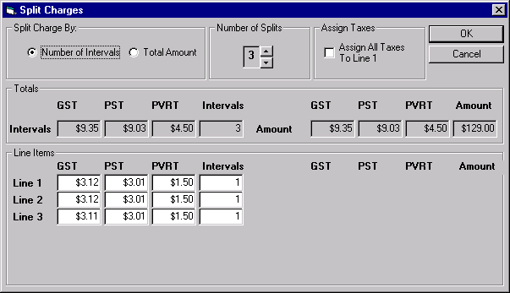

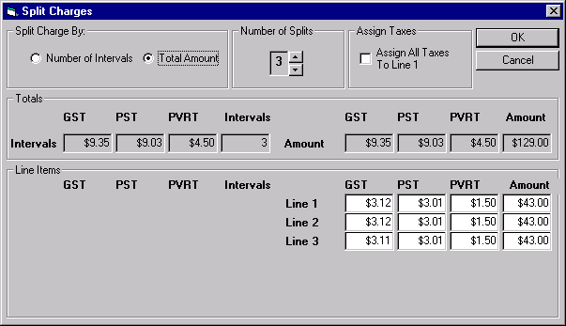
Purpose
This screen is used to split or reconsolidate the charges for a rental charge billing item by time period units (number of hours, days, weeks, etc.) or by amount. Once the splits are defined on this screen and the user returns to the Rental Charge Billing screen, each split will appear as a separate charge line in calculated charge item grid on the Rental Charge Billing screen. Split items from the same original charge item always remain related so that they may be reconsolidated.
Navigation
N/A
Functions
N/A
Controls
Req*: Y – always mandatory
N – always optional
S – sometime optional (see Comments for details)
D – display only
Field | Source | Req* | Validation | Comments
Split Charge By |  | Y | Number of Intervals/  Total Amount | Determines how the charge will be divided.
Number of Splits |  | Y | Cannot be > number of units for the billing item if Split Type is Number of Intervals. | Default: 1
Assign All Taxes to Line 1 |  | N |  | Assigns PST, GST, and PVRT to the first split line.
Totals - Intervals |  |  |  | Displays the total amount, GST, PST, PVRT and intervals for the charge item being split.
Totals - Amounts |  |  |  | Displays the total amount, GST, PST, PVRT and intervals for the charge item being split.
Line Items - Intervals |  |  |  | Only visible when the charge item is being split by intervals. The number of lines displayed is equal to the number of splits.
GST |  | N | Currency  Total for all lines must match total GST for the charge item
PST |  | N | Currency  Total for all lines must match total PST for the charge item
PVRT |  | N | Currency  Total for all lines must match total PVRT for the charge item
Intervals |  | N | Numeric  Total for all lines must match total intervals the charge item
Line Items - Amount |  |  |  | Only visible when the charge item is being split by amount. The number of lines displayed is equal to the number of splits.
GST |  | N | Currency  Total for all lines must match total GST for the charge item
PST |  | N | Currency  Total for all lines must match total PST for the charge item
PVRT |  | N | Currency  Total for all lines must match total PVRT for the charge item
Amount |  | N | Currency  Total for all lines must match total amount for the charge item

Deposit/Refund Record Screen
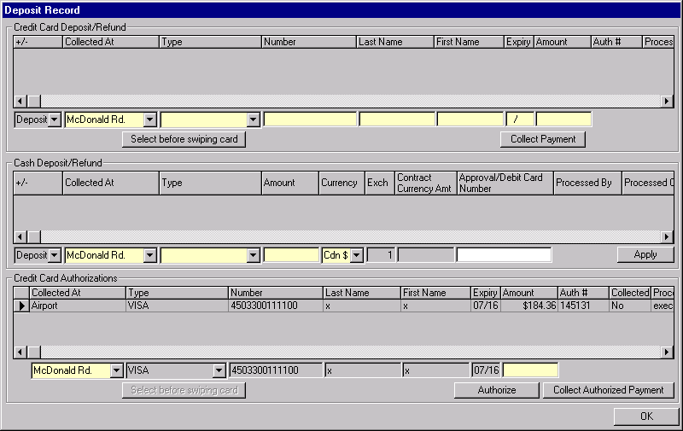
Purpose
This screen is used to perform credit card deposits and refunds, cash deposits and refunds, additional credit card authorizations and to display the history of deposits, refunds and credit card authorizations performed for a contract. Credit card authorizations can only be done against the credit card used to authorize the rental. Other credit cards can only be used to take deposits.
Credit card and cash deposits and refunds displayed on this tab are also reflected in the deposits/refunds field on the Payment tab of the Contract Open/Check Out, Changes During Rental, Check In and Adjustment screens and reduce the balance owing and the authorization amount required. Any reservation deposit collected will show on this sub-tab as soon as the screen is opened.
Credit card authorizations displayed on this tab reduce the authorization amount required on the Payment tab of the Contract Open/Check Out, Changes During Rental, Check In and Adjustment screens. The credit card authorization history is not visible when this screen is opened from Contract Open/Check Out.
Navigation
N/A
Functions
Authorize: Perform a credit card authorization for the credit card and authorization
amount specified. For details on the credit card authorization process, see the Credit Card Authorization function description in this document.
If the automated authorization facility is not available or the credit card type has no automatic authorization, opens the Manual Credit Card Transaction screen and populates it with the credit card and authorization amount information from this tab. After the screen is closed, the authorization number returned will be displayed on this tab.
Collect Collect a payment for the credit card from the selected authorization using
Authorized the authorization number from the most recently completed authorization for
Payment: that credit card. GIS will sum the dollar amounts of all authorizations for that credit card that have not yet been collected against. A prompt will then ask the user if they want to collect this amount. The user may decrease or increase the collection amount up to 20% more than the sum calculated by GIS. The collected at location will be set by the location selected in the Collected At field in the new Credit Card Authorization section. For details on the credit card payment process, see the Credit Card Collect Authorized Payment function description in this document.
Generate Accounting Interface entries for the payment. For details, see the section on Accounting Interface Entries.

Collect Collect a payment for the credit card and deposit amount specified. For
Deposit: details on the credit card payment process, see the Credit Card Payment function description in this document.
If the automated payment facility is not available or the credit card type has no automatic payment, opens the Manual Credit Card Transaction screen and populates it with the credit card and deposit amount information from this tab. After the screen is closed, the authorization number returned will be displayed on this tab.
If the rental was authorized with a credit card and LDW was declined with a reason of Credit Card a warning will be issued if the credit card information entered does not match the credit card used to authorize the rental.
Generate Accounting Interface entries for the deposit. For details, see the section on Accounting Interface Entries for Contract Open/Check Out.
Issue Refund: Issue a refund for the credit card and deposit amount specified. For
details on the credit card payment process, see the Credit Card Refund function description in this document
If the automated payment facility is not available or the credit card type has no automatic payment, opens the Manual Credit Card Transaction screen and populates it with the credit card and refund amount information from this tab. After the screen is closed, the authorization number returned will be displayed on this tab.
If the rental was authorized with a credit card and LDW was declined with a reason of Credit Card a warning will be issued if the credit card information entered does not match the credit card used to authorize the rental.
Generate Accounting Interface entries for the refund. For details, see the section on Accounting Interface Entries for Contract Open/Check Out.
Controls
Req*: Y – always mandatory
N – always optional
S – sometime optional (see Comments for details)
D – display only
Field | Source | Req* | Validation | Comments
Credit Card Deposit/Refund |  |  |  | If LDW is declined for the contract and the reason is Credit Card Coverage, the credit card information for all new entries will default from the Payment tab of the invoking screen. If the credit card information is changed, a warning will be issued.  A list of credit card deposits & refunds that have already been processed is displayed above the fields for entering new deposits & refunds.
+/- |  |  |  | Indicates whether the transaction is a deposit or a refund.
Collected At | Contract Payment Item, Collected At Location ID | Y | Value controlled by Location table. Only the user’s current location and foreign locations are displayed. | Location name is displayed.  Defaults to user’s current location.
Type | Credit Card Payment, Credit Card Key  Credit Card, Credit Card Type | Y | Value controlled by Credit Card Type table. | Populated from credit card swipe (if done).
Number | Credit Card Payment, Credit Card Key  Credit Card, Credit Card Number | Y |  | Populated from credit card swipe (if done).
Last Name | Credit Card Payment, Credit Card Key  Credit Card, Last Name | Y |  | Populated from credit card swipe (if done).
First Name | Credit Card Payment, Credit Card Key  Credit Card, First Name | Y |  | Populated from credit card swipe (if done).
Expiry | Credit Card Payment, Credit Card Key  Credit Card, Expiry | Y | Date (month and year)  Must be >= current month and year. | Populated from credit card swipe (if done).
Amount | Contract Payment Item, Amount | Y
Authorization # | Credit Card Payment, Authorization Number | D |  | Populated only when deposit/refund is completed.
Processed By | Contract Payment Item, Collected By | D |  | Populated only when deposit/refund is completed. User ID of the person who processed the deposit/refund.
Processed On | Contract Payment Item, Collected On | D |  | Populated only when deposit/refund is completed. Date and time when the deposit/refund was processed.
Cash Deposit/Refund |  |  |  | A list of cash deposits & refunds that have already been processed is displayed above the fields for entering new deposits & refunds.
+/- |  |  |  | Indicates whether the transaction is a deposit or a refund.
Collected At | Contract Payment Item, Collected At Location ID | Y | Value controlled by Location table. Only the user’s current location and foreign locations are displayed. | Location name is displayed.  Defaults to the user’s current location.
Type | Cash Payment, Cash Payment Type | Y | Selection only  Value controlled by Cash Payment Type table or by Cash Refund Type table (depending on whether the transaction is a deposit or a refund).
Amount | Cash Payment, Foreign Currency Amount Collected | Y
Currency | Cash Payment, Currency ID | Y | Selection only  Value controlled by Currency table  Must be Cdn $ if Type is Mail Refund (validated on Apply). | Currency Name is displayed.  Defaults to Cdn $
Contract Currency Amt | Contract Payment Item, Amount | D |  | Converted from Amount into Contract Currency.
Exchange | Cash Payment, Exchange Rate | D |  | Defaults to current exchange rate for Currency
Approval/Debit Card # | Cash Payment, Identification Number | N
Processed By | Contract Payment Item, Collected By | D |  | Populated only when deposit/refund is completed. User ID of the person who processed the deposit/refund.
Processed On | Contract Payment Item, Collected On | D |  | Populated only when deposit/refund is completed. Date and time when the deposit/refund was processed.
Credit Card Authorization |  |  |  | Not visible if this screen is opened from Contract Open/Check Out or if the rental was not authorized with a credit card.  A list of credit card authorizations that have already been processed is displayed above the fields for entering new authorizations and collecting against existing authorizations.
Collected At | Credit Card Authorization, Authorized At Location ID | Y | Value controlled by Location table. Only the user’s current location and foreign locations are displayed. | Location name is displayed.  Defaults to user’s current location.
Type | Credit Card Authorization, Credit Card Key  Credit Card, Credit Card Type | D
Number | Credit Card Authorization, Credit Card Key  Credit Card, Credit Card Number | D
Last Name | Credit Card Authorization, Credit Card Key  Credit Card, Last Name | D
First Name | Credit Card Authorization, Credit Card Key  Credit Card, First Name | D
Expiry | Credit Card Authorization, Credit Card Key  Credit Card, Expiry | D
Amount | Credit Card Authorization, Amount Authorized | Y
Auth # | Credit Card Authorization, Authorization Number | D |  | Populated only when authorization completed.
Collected | Credit Card Authorization, Collected Flag | D |  | Set by GIS. Set to Yes when a payment is collected against the authorization.
Processed By | Credit Card Authorization, Authorized By | D |  | Populated only when authorization completed. User ID of the person who processed the authorization.
Processed On | Credit Card Authorization, Authorized On | D |  | Populated only when authorization completed. Date and time when the authorization was processed.
Technical Notes
When calculating the exchange rate for cash deposits in foreign currency, use the exchange rate for the location if there is one, otherwise use the standard exchange rate.

Discount / Reimbursement Screen
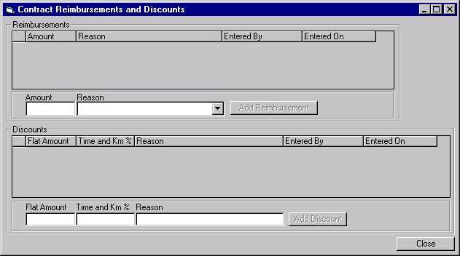
Purpose
This screen is used to record reimbursements and discounts that will reduce the rental charges being billed.
If there are any reimbursements to be recorded, the CSR will enter the reimbursement amount and the reason.
Discounts can be an amount or a percentage. Percentage discounts are applied to the time and km charges only. Manager or Supervisor override will be required to add discounts to the rental.
Any reimbursement or discount applied to the contract will be used to reduce the charges billed to the party authorizing the rental, not the charges billed to an alternate payment organization.
Navigation
N/A
Functions
Add Reimbursement: Adds a new reimbursement entered by the CSR.
Add Discount: Prompts for user id and password before allowing access to add discounts to the rental.
Controls
Req*: Y – always mandatory
N – always optional
S – sometime optional (see Comments for details)
D – display only
Field | Source | Req* | Validation | Comments
Reimbursements |  |  |  | Contract Reimbursement and Discount, Type = Reimbursement
Amount | Contract Reimbursement and Discount, Flat Amount | D
Reason | Contract Reimbursement and Discount, Reimbursement Reason | D
Entered By | Contract Reimbursement and Discount, Entered By | D
Entered On | Contract Reimbursement and Discount, Entered On | D
Add Reimbursement
Amount | Contract Reimbursement and Discount, Flat Amount | S |  | Required if adding a reimbursement.
Reason | Contract Reimbursement and Discount, Reimbursement Reason | S | Value controlled by Reimbursement Reason table | Required if adding a reimbursement.
Discount |  | D |  | Contract Reimbursement and Discount, Type = Discount
Flat Amount | Contract Reimbursement and Discount, Flat Amount | D
Time and Km % | Contract Reimbursement and Discount, Percentage | D
Reason | Contract Reimbursement and Discount, Reason | D
Entered By | Contract Reimbursement and Discount, Entered By | D
Entered On | Contract Reimbursement and Discount Entered On | D
Add Discount
Flat Amount | Contract Reimbursement and Discount, Flat Amount | S |  | Only one of Amount and % can be entered.  Required if discount added.  The discount that is actually applied will be the Flat Amount or the Rental Charges displayed on the Payment tab, whichever is less.
Time and Km % | Contract Reimbursement and Discount, Percentage | S | Must be <= 100 | Only one of Amount and % can be entered.  Required if discount added.
Reason | Contract Reimbursement and Discount, Discount Reason | S |  | Required if discount added.

Extension History Screen
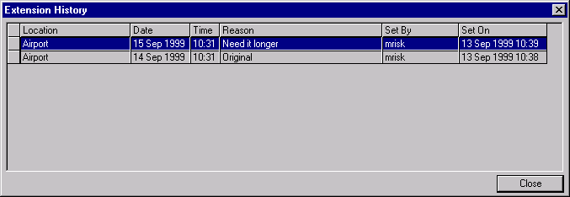
Purpose
This screen allows the CSR to view all drop off time and location changes that have occurred during the life of the current contract. The screen is invoked from the Changes During Rental, the Contract Check In, and the Adjustments screens.
Navigation
N/A
Functions
N/A
Controls
Field | Source | Req* | Validation | Comments
Extension History
Location | Drop Off History, Drop Off Location | D |  | Location name is displayed.
Date, Time | Drop Off History, Drop Off On | D |  | Date/Time
Reason | Drop Off History, Reason | D
Set By | Drop Off History, Changed By | D
Set On | Drop Off History, Changed On | D |  | Date/Time

Vehicle Replacement History Screen
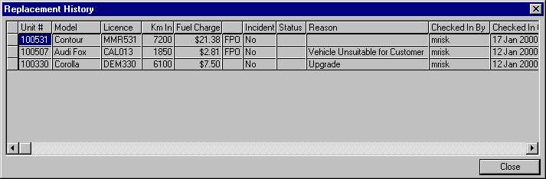
Purpose
This screen allows the CSR to view information about all vehicles that have been checked out and/or checked in during the life of the current contract. The screen is invoked from the Changes During Rental and the Contract Check In screens.
Navigation
N/A
Functions
N/A
Controls
Field | Source | Req* | Validation | Comments
Vehicle Replacement History |  |  |  | Show for all Vehicle On Contract entries for the current contract.
Unit # | Vehicle On Contract, Unit Number | D
Model | Vehicle, Vehicle Model ID | D |  | For Unit Number from selected Vehicle On Contract record. Model Name is displayed
Licence | Vehicle Licence History, Licence Plate Number | D |  | For Unit Number from selected Vehicle On Contract record.  The vehicle licence plate that was in effect (attached) when the vehicle was on the Vehicle On Contract (vehicle check in)
Km | Vehicle On Contract, Km In | D
Fuel Charge |  | D |  | Calculated by GIS. See Fuel Charge function description.
(FPO) | Vehicle On Contract, FPO Purchased | D |  | ‘FPO’ if Vehicle On Contract, FPO Purchased is Yes, blank otherwise.
Incident |  | D | Yes/No | Yes if Vehicle Support Incident exists for the vehicle.
Status | Vehicle Support Incident, Status | D |  | Status = Outstanding if any of the Vehicle Incidents for the vehicle have a status of unresolved, otherwise resolved. If no vehicle incident for the vehicle on contract then leave blank.
Reason | Vehicle On Contract, Check in Reason | D
Checked In By | Vehicle On Contract, Checked in By | D
Checked In On | Vehicle On Contract, Actual Check In | D

Coverage History
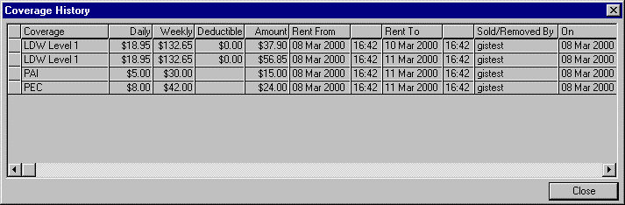
Purpose
This screen allows the CSR to view all changes that have occurred to the applied coverages during the life of the current contract.
Navigation
N/A
Functions
N/A
Controls
Field | Source | Req* | Validation | Comments
Coverages |  |  |  | Display all optional extras with type = LDW, Buydown, PAI, PEC, Cargo Insurance. Current and terminated records.
Coverage | Contract Optional Extra, Optional Extra ID | D |  | Optional Extra name is displayed.
Daily | Contract Optional Extra, Daily Rate | D |  | Rate will not vary with quantity.
Weekly | Contract Optional Extra, Weekly Rate | D |  | Rate will not vary with quantity.
Deductible | LDW Deductible, LDW Deductible. | D |  | For Optional Extra and Vehicle Class.
Amount |  | D |  | Calculated based on rental period and quantity. Displays cheapest combination of daily and weekly rates.
Rent From | Contract Optional Extra, Rent From | D
Rent To | Contract Optional Extra, Rent To | D
Sold or Removed By/On/At | Contract Optional Extra, Sold/Removed By & Sold/  Removed On & Sold At Location ID | D |  | Location Name is displayed for Sold At Location ID

Currency Calculator Screen
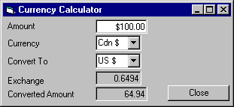
Purpose
The Currency Calculator screen allows the CSR to convert amounts from one currency to another. This screen is for information purposes only and does not process any payments or refunds. The Currency Calculator may be invoked from the Payment tab of the Check In, Foreign Check In, and Adjustments screens. The Amount and Currency fields default to the balance owing and contract currency from the Payment tab of the invoking screen. The exchange rate used is that of the location from the invoking screen. If the location does not have any exchange rates defined then the default exchange rate is used.
Navigation
N/A
Functions
N/A
Controls
Field | Source | Req* | Validation | Comments
Amount |  | Y |  | Default to Balance Owning in Payment tab of invoking screen.
Currency |  | Y | Must be one of currency or voucher currency in look up table. | Default to Contract Currency of contract in invoking screen.
Convert To |  | Y | Must be one of currency or voucher currency in look up table.
Exchange | Location Exchange Rate, Rate or Exchange Rate, Rate | D |  | Use Location Exchange Rate if exists otherwise use Exchange Rate.
Converted Amount |  | D |  | Calculated by GIS, see Technical Notes below.
Technical Notes
Calculating the Converted Amount:
When calculating the converted amount, first convert the Amount to $Cdn, then convert the $Cdn amount to the Convert To currency.

Functions

Calculate Pre-Authorization Amounts & Cash Rental Deposits
- Credit Card Pre-Authorization
- The pre-authorization amount will be the expected charges for the entire rental (including optional extras, sales accessories, drop charges, taxes, etc.) plus a flat rental deposit amount which is not related to the length of the rental. This amount is currently $100.00. It will be stored in a system values table. The following amounts will be subtracted from the pre-authorization amount:
- All contract reimbursements and contract discounts.
- Any credit card or cash deposits already collected for the reservation that have not been forfeited.
- The sum of any deposits and refunds that have been collected for the contract.
- Any credit card amounts already authorized against the renter’s credit card.
- If part of the contract is being billed to an alternate payment method (prepaid voucher, loss of use, etc.), the amount being billed to the alternate payment organization will be subtracted from the pre-authorization amount. Before this is done, all approval requirements for the alternate payment billing (loss of use form from ICBC, PO from shop, etc.) must be met.
- The amount will be authorized against the renter’s credit card
- Direct Bill Pre-Authorization
- The pre-authorization amount will calculated in the same way as for a credit card pre-authorization. The following amounts will be subtracted from the pre-authorization amount:
- All contract reimbursements and contract discounts.
- Any credit card or cash deposits already collected for the reservation that have not been forfeited.
- The sum of any deposits and refunds that have been collected for the contract.
- If part of the contract is being billed to an alternate payment method (prepaid voucher, loss of use, etc.), the amount being billed to the alternate payment organization will be subtracted from the pre-authorization amount. Before this is done, all approval requirements for the alternate payment billing (loss of use form from ICBC, PO from shop, etc.) must be met.
- The amount will be checked against the available credit for the company being billed for the rental.
- Cash Rental Deposit
- The cash rental deposit will be calculated using a flat amount, plus an amount for every day of the rental period (including the first day). These amounts are currently $250.00 for the flat amount and $100.00 for every day of the rental (including the first day). There will be separate amounts for cars and trucks and these amounts will be stored in a system values table. The following amounts will be subtracted from the pre-authorization amount:
- All contract reimbursements and contract discounts.
- Any credit card or cash deposits already collected for the reservation that have not been forfeited.
- The sum of any deposits and refunds that have been collected for the contract.
- If part of the contract is being billed to an alternate payment method (prepaid voucher, loss of use, etc.), the amount being billed to the alternate payment organization will be subtracted from the cash rental deposit. Before this is done, all approval requirements for the alternate payment billing (loss of use form from ICBC, PO from shop, etc.) must be met.

Calculate Rental Charges
Assumptions
- If there is a Rate Time Period with a Time Period of Flat and a Type of Regular (as opposed to Late), there will not be any other Rate Time Periods with a Type of Regular
- If there is a Rate Time Period with a Time Period of Flat and a Type of Regular the rate will have a restriction for the maximum number of days
- For trucks, if there are Rate Time Periods with a Time Period of AM, PM and/or OV and a type of Regular (as opposed to Late), there will not be any other Rate Time Periods with a Type of Regular
- Rate Time Periods with a Type of Late will only have the Time Periods ‘Hour’ and ‘Day’
- GST Rate and PST Rate are percentages
- PVRT Rate is a flat daily charge by rental day. It is only charged on contracts whose duration is less than or equal to the Maximum PVRT Days set in the lookup table and where the vehicle class is not PVRT exempt.
- Other additional driver charges will have daily and/or weekly amounts, but no other amounts
- If any of the kilometre caps for any of the Rate Time Periods within a rate is unlimited, all the km caps for that rate will be unlimited
- All rates will have tour class N/A, gross and net will not be used
- The rental period for truck rentals using time blocks will not cover more than two time blocks. Longer rentals will use a daily rate.
- Day Amounts are always less than or equal to 24 x Hour Amounts
- Week Amounts are always less than or equal to 7 x Day Amounts
- Month Amounts are always less than or equal to 30 x Day Amounts
- Regular Hourly and Regular Daily amount may be zero only when there are no other time periods defined for the same rental duration (no overlapping rate definitions regardless of time period type – hour, day, week, month)
Calculate Length of Rental Period
- When calculating the length of the rental period for a certain time period (months, weeks, days, hours) always round up. For example, 62 minutes is 2 hours, not 1 hour
- For contract open and check out, calculate the length of the rental period from the check out time and the expected drop off time
- For changes during rental, calculate the length of the rental period from the check out time for the first vehicle check out where the check out was not voided (i.e. first vehicle on contract checked back in at the same time) and the current expected drop off time
- For contract check in and close, calculate the length of the rental period from the check out time for the first vehicle check out where the check out was not voided (i.e. first vehicle on contract checked back in at the same time) and the actual drop off time
- Subtract the grace period for the location from the rental period for the purpose of checking rate restrictions and calculating time charges only, not for calculating charges for additional drivers, optional extras, or any other charges.
Determine Vehicle Rate to Use
Note: The original rate for the original vehicle class checked out on the contract will be used for the entire rental period, even if a vehicle replacement is done and the new vehicle is of a different vehicle class. If the vehicle class is upgraded at the customer’s request, the CSR will add a daily upgrade charge to the contract. If the vehicle class is downgraded, the CSR has the option of applying a discount to the contract.
- If the contract rate has a violation rate
- Determine if any restrictions for the original contract rate have been violated:
  - If there is a restriction: “Saturday night stayover required” and the rental period does not include a Saturday night.
  - If there is a restriction “day minimum rental” and rental period is less than the number of days associated with the restriction
  - If there is a restriction “day maximum rental” and rental period is greater than the number of days associated with the restriction
  - If there is a restriction :”Cannot be picked up before” and the pick up time (hours and minutes) is less than the time associated with the restriction
  - If there is a restriction :”Must be returned by” and the drop off time (hours and minutes) is greater than the time associated with the restriction
  - If there is a restriction: “Must be returned by drop off time on contract” and the actual drop off time is greater than the expected drop off time
  - If there is a restriction: “minimum hour rental” and rental period is less than the number of hours associated with the restriction
- If so, switch to the violation rate and rate level specified on the Rate tab and use that rate for all rental charge calculations (set the Apply Violation Rate Flag on in the contract record).
- Once a contract is opened inclusions are attached to the contract not the rate (since inclusions are not necessarily taken). Therefore if a violation rate does not have the same inclusions, it does not affect the inclusions already assigned to the contract. If the CSR wishes to charge for the inclusions then manual charges will be used
- If the CSR manually invokes the violation rate in the Check In screen, then use the violation rate and level specified on the Rate tab and use that rate for all rental charge calculations.
Calculate Time Charges
- If the regular Rate Time Period is flat:
- Calculate the vehicle time charges from the flat rate amount and the cheapest combination of late charges (use the expected drop off time to determine whether any late charges apply).
- If the rate has different rate time periods:
- Calculate the vehicle time charges using the cheapest combination of monthly, weekly, daily and hourly charges. When calculating the cheapest combination use the following rules:
- When late rates exist in a rate:
Late time charges and regular time charges will be calculated independently.
Late rates will be used for all late time.
Regular rates will be used for all regular time.
The cheapest combination of regular rates will be used for regular time while the cheapest combination of late rates will be used for late time.
- When no late rates exist in a rate:
Regular rates will be used for the entire rental.
No distinction will be made between regular time and late time.
The cheapest combination of regular rates will be used for rental time.
- If the rate has AM, PM or overnight time periods:
- Calculate the vehicle time charges using the time block rates for the rental period. For rental durations that span partial time periods, round up to the whole time period. For regular time, charge regular charges; for late time, charge late charges.
- If selected rate does not have sufficient time periods defined to cover the entire rental period then display a warning message to the user so that they may enter a manual charge to cover the uncharged period.
- Apply Grace Period to vehicle time and km charges as follows:
- Applied at the expected drop off time:
If the actual drop off time falls within the grace period following the expected drop off time, then no additional charges will be applied for the extra time past the expected drop off time.
If expected drop off time < or = actual drop off time < or = expected drop off time + the grace period, then no additional charges will be applied for the extra time past the expected drop off time.
This application of the grace period will be applied to contracts in the following circumstances:
- when the actual drop off is greater than the expected drop off.
- Applied at each 24 hour interval measured from the pick up time:
If the actual drop off time falls within the grace period following a 24-hour interval measured from the pick up time, then no additional charges will be applied for the extra time past the 24-hour interval.
If pick up time + (x)24 hours < actual drop off time < pick up time + (x)24 hours + grace period then no additional charges will be applied for the extra time past (x)24 hours.
This application of the grace period will be applied to contracts in the following circumstances:
- when the actual drop off is less than the expected drop off
- when the actual drop off is greater than the expected drop off and no late rates exist.
This application of the grace period will not apply to the contract in the following circumstances:
- when the actual drop off is greater than the expected drop off and late rates exist.
- Applied at each 24 hour interval measured from the expected drop of time:
If the actual drop off time falls within the grace period following a 24-hour interval measured from the expected drop off time, then no additional charges will be applied for the extra time past the 24-hour interval. This will only apply when the rate being used has late periods defined.
If expected drop off time + (y)24 hours < actual drop off time < expected drop off time + (y)24 hours + grace period then no additional charges will be applied for the extra time past (y)24 hours.
This application of the grace period will be applied to contracts in the following circumstances:
- when the actual drop off is greater than the expected drop off and late rates exist.
This application of the grace period will not apply to contracts in the following circumstances:
- when the actual drop off is less than the expected drop off
- when late rates do not exist.
- Create a separate rental charge billing item for each rate time period used to calculate the rental charges. For example, if the rental period is 2 days and 2 hours, and the cheapest combination of regular charges is the daily regular charge and the hourly regular charge, two rental charge billing items will be generated, one for 2 days at the daily regular charge and one for 2 hours at the hourly regular charge.
- If there is a flex discount for the contract, create a separate rental charge billing item for the flex discount percentage
- If there is a member discount for the contract, create a separate rental charge billing item for the member discount percentage
- If there is a flat surcharge for the rate and pick up location, create a separate rental charge billing item for the flat surcharge
- If there is a daily surcharge for the rate and pick up location, create a separate rental charge billing item for the daily surcharge for each rental charge billing item as follows:
- Set the surcharge eligible days to the lesser of:
- The number of days covered by this rental charge billing item
- The length of the rental period (before subtracting the grace period) minus the number of days where the surcharge has already been calculated
This is to avoid charging the daily surcharge for more days than are actually in the rental period
- Set the surcharge amount to the surcharge eligible days * the daily surcharge amount and add the surcharge amount to the billing item
- Calculate the taxes for each rental charge billing item as follows (use the tax rates in effect at the start of the rental period):
- If the rate includes GST:
- Calculate GST Included Amount
- Set GST Included to Yes
- Else if the contract is GST exempt
- Set GST Exempt to Yes
- Else
- Set the GST Amount to the rental charge amount * the GST tax rate
- If the rate includes PST:
- Calculate PST Included Amount
- Set PST Included to Yes
- Else if the contract is PST exempt
- Set PST Exempt to Yes
- Else
- If there is a PST tax rate for the most recent vehicle model checked out on the contract, then use that PST rate, otherwise use the standard PST tax rate
- Set the PST Amount to the rental charge amount * the PST tax rate
- If the rental duration is greater than MaxPVRTDays in the Lookup table or if the vehicle class for the most recent vehicle on contract is PVRT exempt (entries stored in the Lookup table) then do not calculate PVRT (set to 0)
- Else If the rate includes PVRT or if the current rental charge billing item is for a location flat fee, a rate/location flat surcharge or a rate/location daily surcharge:
- Calculate PVRT Included Amount
- Set PVRT Included to Yes
- Else
- Set the PVRT eligible days to the lesser of:
- The number of days covered by this rental charge billing item
- The length of the rental period (before subtracting the grace period) minus the number of days where PVRT has already been calculated
This is to avoid charging PVRT for more days than are actually in the rental period
- Set the PVRT amount to the PVRT eligible days * the PVRT rate
Calculate Kilometre Charges
- If the rate has an override kilometre cap for the pick up location
- Set Free Km to the override kilometre cap for the rate and pick up location
- Else
- If the kilometre cap for the rate is unlimited
- Set Free Km to 999,999
- Else
- Set Free Km to sum of the kilometre caps for every rate time period used to calculate rental charges
For example, if the rate has a weekly time period and a daily time period and the rental period is two weeks and three days, set Free Km to 2 times the weekly kilometre cap plus 3 times the daily kilometre cap
- Set Km Driven to the sum of the kilometres driven for every Vehicle on Contract
- If Km Driven > Free Km
- Create a rental charge billing item for the kilometre charges. If the rate has an override kilometre charge for the pick up location, use that, otherwise use the kilometre charge for the rate level and vehicle class.
- Calculate GST and PST in the same way as described for vehicle rate
- Create separate rental charge billing items for flex discount and member discount in the same way as described for vehicle rate
Calculate Fuel Charges and FPO Charges
Note: the fuel prices stored for each location already include all applicable taxes
- Fuel charges are only calculated at or after check in
- For each vehicle checked out on the contract
- If FPO was sold with this vehicle check out, or with a prior vehicle check out
- If this is the last vehicle check out for the contract and first vehicle check out where FPO was sold:
- If we have fuel tank information for the vehicle model and the pick up location for that vehicle is a BRAC location, set FPO Charge to the FPO fuel price for the vehicle’s pick up Location times the fuel tank size for the vehicle model. If the vehicle model uses gasoline, use the gasoline fuel price, otherwise use the diesel fuel price.
- If we do not have fuel tank information for the vehicle model or the vehicle’s pick up location is a foreign pick up location, use the FPO Charge manually entered by the user.
- Create a separate rental charge billing item for the FPO.
- Else (more than one vehicle on contract with FPO purchased for this contract):
- If we know the pick up location FPO fuel price per litre.
- If the vehicle model uses gasoline, use the gasoline fuel price for the pick up location for that vehicle, otherwise use the diesel fuel price.
- If the vehicle model’s fuel tank information is known:
              - If Fuel Added (litres) was entered, set FPO Charge to Fuel Added (litres) times the FPO fuel price for the vehicle’s pick up location
              - If none of the above were entered and Litres of Fuel Remaining was entered, set FPO Charge to (fuel tank size for the vehicle model minus Litres of Fuel Remaining) times the FPO fuel price for the vehicle’s pick up location
              - If none of the above were entered and Fuel Tank Level was entered, translate Fuel Tank Level into Fuel Tank % Empty. Set FPO Charge to Fuel Tank Size for the vehicle model times FPO fuel price for the vehicle’s pick up location times Fuel Tank % Empty.
              - If none of the above were entered, use Km Driven. Set FPO Charge to (Km Driven divided by Km per Litre for the vehicle model) times the FPO fuel price for the vehicle’s pick up location
              - Fuel Added ($) will not be available for entry and will not be used in these calculations.
- If the vehicle model’s fuel tank information is not known:
              - If Fuel Added (litres) was entered, set FPO Charge to Fuel Added (litres) times the FPO fuel price for the vehicle’s pick up location
              - If none of the above were entered and and Fuel Tank Level was entered, translate Fuel Tank Level into Fuel Tank % Empty. Set FPO Charge to FPO price manually entered on screen * Fuel Tank % Empty.
              - Fuel Added ($), Litres of Fuel Remaining and Km Driven will not be available for entry and will not be used in this calculation.
- Else (we don’t know the pick up location FPO fuel price per litre)
- If the vehicle model’s fuel tank information is known:
              - If Fuel Added (litres) was entered, set Fuel Tank % Empty to (Fuel Added (litres) divided by Fuel Tank Size for the vehicle model). Set FPO Charge to Fuel Tank % Empty times the FPO Charge manually entered by the user.
              - If none of the above were entered, and Litres of Fuel Remaining was entered, set Fuel Tank % Empty to 1 minus (Litres of Fuel Remaining divided by Fuel Tank Size for the vehicle model). Set FPO Charge to Fuel Tank % Empty times the FPO Charge manually entered by the user.
              - If none of the above were entered and Fuel Tank Level was entered, translate Fuel Tank Level into Fuel Tank % Empty. Set FPO Charge to Fuel Tank % Empty times the FPO Charge manually entered by the user.
              - Km Driven and Fuel Added ($) will not be available for entry and will not be used in these calculations.
- If the vehicle model’s fuel tank information is not known:
              - If Fuel Added (litres) was entered, set FPO Charge to Fuel Added (litres) times the FPO fuel price for the vehicle’s pick up location
              - If none of the above were entered and and Fuel Tank Level was entered, translate Fuel Tank Level into Fuel Tank % Empty. Set FPO Charge to FPO price manually entered on screen * Fuel Tank % Empty.
              - Fuel Added ($), Fuel Added (litres), Litres of Fuel Remaining and Km Driver will not be available for entry and will not be used in this calculation.
- Create a separate rental charge billing item for the FPO.

- Else (FPO was not sold either with this vehicle or with any vehicle checked out prior to this vehicle)
- Determine the Fuel Charge as follows.
- If the Check In Location is a BRAC Location:
- If the vehicle is a BRAC vehicle:
        - If the vehicle model uses gasoline, use the gasoline fuel price for the location, otherwise use the diesel fuel price.
        - If Fuel Added ($) was entered, use it for the Fuel Charge
        - If none of the above were entered and Fuel Added (litres) was entered
Set Fuel Charge to Fuel Added (litres) times the check in fuel price per litre for the Check In Location
        - If none of the above were entered and Litres of Fuel Remaining was entered
Set Fuel Charge to (fuel tank size for the vehicle model minus Litres of Fuel Remaining) times the check in fuel price per litre for the Check In Location
        - If none of the above were entered and Fuel Tank Level was entered:
Translate Fuel Tank Level into Fuel Tank % Empty
Set Fuel Charge to Fuel Tank Size for the vehicle model times Fuel Tank % Empty times the check in fuel price per litre for the Drop Off Location
        - If none of the above were entered, use Km Driven
Set Fuel Charge to (Km Driven divided by Km per Litre for the vehicle model) times the check in fuel price per litre for the Drop Off Location
- If the vehicle is a Foreign vehicle use only points (a), (b), and (c) above. Note that Fuel Remaining (litres), Fuel Tank Level, and Km Driven will be disabled on the screens in this case.
- If the Check In Location is a Foreign Location use only point (b) - Fuel Added ($). Note that all other fuel fields will be disabled on the screen.
- If Fuel Charge is not zero
- Create a rental charge billing item for the fuel charge.

Calculate Drop Charges
- For contract open and check out and for changes during rental:
- For contract open and check out, use the expected drop off location
- For changes during rental, use the current expected drop off location
- If Vehicle Rate.Km Drop Off Charge is Yes then Drop Charge is ‘by Km’
- If the drop off location is an authorized drop off location for the rate and pick up location (see notes on determining whether a drop off location is authorized below):
- If the drop off location is included in the rate (do this check only when Rate Location Set.Allow All Authorized Drop Off Locations is false)
- Don’t calculate a drop off charge
- Else
- Create a rental charge billing item for the drop charge using the authorized drop charge for the pick up/drop off location pair
- Set the GST Amount to the rental charge amount * the GST tax rate
- Set the PST Amount to the rental charge amount * the PST tax rate

- Else (the drop off location is an unauthorized drop off location for the rate and pick up location, note that this is not relevant for Contract Open/Check Out):
- Create a rental charge billing item for the drop charge using the unauthorized drop charge for the pick up/drop off location pair
- Set the GST Amount to the rental charge amount * the GST tax rate
- Set the PST Amount to the rental charge amount * the PST tax rate

- For contract check in and close
- If the actual drop off location is not the same as the current expected drop off location:
- Create a rental charge billing item for the drop charge using the unauthorized drop charge for the pick up/drop off location pair
- Set the GST Amount to the rental charge amount * the GST tax rate
- Set the PST Amount to the rental charge amount * the PST tax rate

Determining whether a Drop Off Location is authorized for the specified Pick Up Location (for contract open/check out and changes during rental):
- If Rate Location Set.Allow All Authorized Drop Off Locations is checked on then
- If Pick Up/Drop Off Location.Authorized is Yes for the selected Pick Up and Drop Off Locations then the Drop Off Location is Authorized
- If Pick Up/Drop Off Location.Authorized is No for the selected Pick Up and Drop Off Locations then the Drop Off Location is Unauthorized
- If Rate Location Set.Allow All Authorized Drop Off Locations is not checked on then
- If Rate Drop Off Location exists for the Pick Up Location and Drop Off Location combination then the Drop Off Location is Authorized.
- Check value of Rate Drop Off Location.Included In Rate
- If Rate Drop Off Location does not exist for the Pick Up Location and Drop Off Location combination then the Drop Off Location is Unauthorized.
Calculate Upgrade Charges
- For each Vehicle On Contract where the Upgrade Charge is not null or zero:
- Set Upgrade Period to the number of 24 hour days covered by Checked Out and Actual or Expected Check In (use Actual Check In if present, otherwise use Expected Check In)
- Set the total upgrade charge amount to the Upgrade Period times the Upgrade Charge
- Create separate rental charge billing item for the total upgrade charge
- Set the GST Amount to the rental charge amount * the GST tax rate
- Set the PST Amount to the rental charge amount * the PST tax rate

Calculate Optional Extra Charges
- For each Optional Extra sold with the contract:
- Set Optional Extra Rental Period to the number of 24 hour days covered by Rent From and Rent To
- Calculate the vehicle rate using the Optional Extra Rental Period and the cheapest combination of weekly and daily Optional Extra charges
- Create a separate rental charge billing item for each rate time period used to calculate the optional extra charges.
- If the Optional Extra is not GST exempt, set the GST Amount to the rental charge amount * the GST tax rate
- If the Optional Extra is not PST exempt, set the PST Amount to the rental charge amount * the PST tax rate

Calculate Additional Driver Charges
- For each Additional Driver with a type of ‘Other’ where the ‘No Charge’ flag is not on:
- Set Additional Driver Rental Period to the number of 24 hour days covered by Additional Driver Valid From and Additional Driver Valid To
- Calculate the vehicle rate using the Additional Driver Rental Period and the cheapest combination of weekly and daily Additional Driver charges
- Create a separate rental charge billing item for each rate time period used to calculate the additional driver charges.
- Set the GST Amount to the rental charge amount * the GST tax rate
- Set the PST Amount to the rental charge amount * the PST tax rate
Calculate Sales Accessory Charges
- For each Sales Accessory sold with the contract:
- Find the Location Sales Accessory Price for the contract pick up date time
- If none is found
- Find the Sales Accessory Price for the contract pick up date/time
- Create a rental charge billing item for the sales accessory price times the number of units sold
- If the Sales Accessory is not GST exempt, set the GST Amount to the rental charge amount * the GST tax rate
- If the Sales Accessory is not PST exempt, set the PST Amount to the rental charge amount * the PST tax rate

Calculate Location Fees
Location fees will not be charged for any items on any contract where the GIS Rate, Maestro rate or foreign rate includes location fees.
If there is a flat location fee for the pick up location, create a separate rental charge billing item for the flat charge.
If there is a percentage location fee for the pick up location:
- Look up each charge item type in the Charge Parameter table to determine whether location fees should be charged on the item. The flag in the Charge Parameter table will apply to each charge type, regardless of what charge category that charge type is used for. For example, Vehicle Time is a charge type. It can be used in the charge categories of Calculated Charges, Rent Back Charges, Manual Charges and Adjustments. If the location fee flag is set on for Vehicle Time charges, location fees will be calculated for every Vehicle Time charge on the contract, regardless of whether it is a calculated charge, a rent back charge, a manual charge or an adjustment.
- Create a Rental Charge Billing Item for the automatically calculated charge items.
- Create a Manual Charge Item for the manual charge items. The location fees that are calculated on manual charge items will show up in the list of manual charge items on the contract screens, but the user will not be able to remove them. Once Location Fee items charged on manual charges have been created, GIS will only remove the location fee if the manual fee is removed. To update the location fees automatically calculated on manual charges, following a change that affects the location fee (ie rate inclusion flag or pick up location), the user must delete and re-add the manual charges to update the location fees charged on the manual charges.
- Create an adjustment of type location fee for each set (session) of adjustments added by the user (if subject to location fees)

Accounting Interface Entries for Contracts
This section describes the accounting entries to be generated for each type of contract transaction. Accounting entries are posted for deposits, refunds, payments and revenue, where revenue includes discounts and reimbursements.
Budget BC and Foreign Contracts
These terms are used throughout this section to identify differences in posting for the two types of contracts. The following defines what is a Budget BC contract and a foreign contract.
- Budget BC contract – any contract where the pick up location is a Budget BC rental location.
- Foreign contract – all other contracts (i.e. ones where the pick up location is a foreign location.
Contract Currency and Deposit/Payment Currency
For all deposits and payments, the amount collected is recorded as the Foreign Currency Deposit/Payment Amount. The currency of the deposit or payment is also recorded and the payment is converted into the Deposit/Payment Amount which is in the currency of the contract. Therefore the Foreign Currency Deposit/Payment Amount is only foreign in terms of the contract currency. If the contract currency is in US $ it is possible to have a deposit or payment where the Foreign Currency Deposit/Payment Amount is in Cdn $ and the Deposit/Payment Amount is in US $.

Accounting Interface Entries for Contract Open/Check Out
For each Contract Open/Check Out, a Business Transaction will be written to the GIS database along with a number of G/L and/or A/R Transactions containing the accounting information for the Open/Check Out. This accounting information is posted to the G/L and A/R on a nightly basis following close of the business day.
G/L and A/R Transactions will be generated from the Contract Open/Check Out screen for each of the following payment/refunds made at a Budget BC location.
- Credit Card Deposits made at a Budget BC Location
- Credit Card Refunds made at a Budget BC Location
- Cash Payments made at a Budget BC Location
- Cash Refunds made at a Budget BC Location
G/L and A/R Transactions will be generated from the Contract Open/Check Out screen for each of the following payments/refunds made at a foreign location for a Budget BC Contract. This is unlikely to happen from the Contract Open/Check Out screen, but it is possible as the Deposit/Refund screen allows it.
- Credit Card Deposits made at a Foreign Location
- Credit Card Refunds made at a Foreign Location
- Cash Payments made at a Foreign Location
- Cash Refunds made at a Foreign Location
No G/L or A/R Transactions will be generated from the Contract Open/Check Out screen for any deposits or refunds made at a foreign location when the contract pick up location is also a foreign pick up location.
Note that no accounting transactions are required for Credit Card Authorisations.
The amount in either transaction is output as positive if it is a debit, negative if it is a credit.
The Business Transaction for the Contract Check Open/Check Out will have:
- RBR Date = current RBR date
- Transaction Date = current date
- Transaction Type = “CON”
- Transaction Description = “Open” if Open only, otherwise = “Check Out”
- Contract Number = current Contract Number
- Confirmation Number = null
- Sales Contract Number = null
- Location ID = ID of location where Open/Check Out entered
- User ID = User ID of user who entered Open/Check Out
- Entered On Handheld = no
- Signature Required = no when a pre-write for a contract opened from a Maestro reservation which is Fastbreak, Executive Action or Applicant Status, yes otherwise.
In the following specifications, unless specified otherwise, all A/R Transactions will have:
- Must Be Invoice = off
- Purchase Order Number = null
- Loss Of Use Claim Number = null
- Adjuster First Name = null
- Adjuster Last Name = null
- Credit Card Key = null
- Authorization Number = null
- Total Contract Amount = null
- Total Contract Taxes = null
- Budget Claim Number = null
- Ticket Number = null
- Issuing Jurisdiction = null
- Credit Card Deposits made at a Budget BC Location
Inputs:
- Credit Card Type
- Credit Card Number
- Credit Card First Name
- Credit Card Last Name
- Credit Card Expiry Date
- Deposit Amount

Create accounting transactions for each credit card deposit as follows:

Post | When | Field Values
To |  | DB/CR | Amount | Account (Source) | Other
G/L | Budget BC Contracts | Credit | Deposit Amount | G/L Deposit Account  (System Values)
G/L | Foreign Contracts | Credit | Deposit Amount | G/L Canadian Interbranch Clearing Account  (System Values)
G/L | Always | Debit | Deposit Amount | G/L Receivables Clearing Account  (System Values)
A/R | Always | Debit | Deposit Amount | A/R Payment Account  (Credit Card Type) | See Note 1 below
Note 1: For other credit cards (i.e. not major credit cards – ones not electronically authorized) and for lease cards:
- Set the Credit Card Key to the key of the credit card used for the deposit being posted and Authorization Number to the authorization number entered for the deposit.
- Set Total Contract Amount to null.
- Set Total Contract Taxes to null.
- Credit Card Refunds made at a Budget BC Location
Generate the same entries as for a Credit Card Deposit with Debits and Credits reversed.
- Cash Deposits made at a Budget BC Location
Inputs:
- Contract Currency (will be Cdn $ or US $)
- Deposit Amount
- Cash Payment Method
- Currency (will be Cdn $ or US $)
- Foreign Currency Deposit Amount

When contract currency and payment currency is the same, create accounting transactions for each cash deposit as follows:

Post | When | Field Values
To |  | DB/CR | Amount | Account (Source) | Other
G/L | Budget BC Contracts | Credit | Deposit Amount | G/L Deposit Account  (System Values)
G/L | Foreign Contracts where Contract Currency is Cdn $ | Credit | Deposit Amount | G/L Canadian Interbranch Clearing Account  (System Values)
G/L | Foreign Contracts where Contract Currency is US $ | Credit | Deposit Amount | G/L US Interbranch Clearing Account  (System Values)
G/L | Always | Debit | Foreign Currency Deposit Amount | G/L Receivables Clearing Account  (System Values)
A/R | Currency is Cdn $ & Cash Payment Method = ‘Debit Card’ | Debit | Foreign Currency Deposit Amount | A/R Debit Card Account  (System Values)
A/R | Currency is Cdn $ & Cash Payment Method not = ‘Debit Card’ | Debit | Foreign Currency Deposit Amount | A/R Canadian Cash Account  (System Values)
A/R | Currency is US $ | Debit | Foreign Currency Deposit Amount | A/R US Cash Account  (System Values)

When contract currency is Canadian$ and payment currency is US$, create accounting transactions for each cash deposit as follows:

Post | When | Field Values
To |  | DB/CR | Amount | Account (Source) | Other
G/L | Budget BC Contracts | Credit | Deposit Amount | G/L Deposit Account  (System Values)
G/L | Foreign Contracts | Credit | Deposit Amount | G/L Canadian Interbranch Clearing Account  (System Values)
G/L | Always | Debit | Foreign Currency Deposit Amount | G/L Receivables Clearing Account  (System Values)
G/L | Always | See Note 1 below | See  Note 2 below | G/L US Exchange Account  (System Values)
A/R | Always | Debit | Foreign Currency Deposit Amount | A/R US Cash Account  (System Values)

Note 1: Debit if Foreign Currency Deposit Amount < Deposit Amount, Credit otherwise
Note 2: The absolute value of Deposit Amount minus Foreign Currency Deposit Amount

When contract currency is US$ and payment currency is Canadian$ (can only happen with foreign contracts), create accounting transactions for each cash deposit as follows:

Post | When | Field Values
To |  | DB/CR | Amount | Account (Source) | Other
G/L | Always | Credit | Deposit Amount | G/L US Interbranch Clearing Account  (System Values)
G/L | Always | Debit | Foreign Currency Deposit Amount | G/L Receivables Clearing Account  (System Values)
G/L | Always | See Note 1 below | See  Note 2 below | G/L US Exchange Account  (System Values)
A/R | Cash Payment Method = ‘Debit Card’ | Debit | Foreign Currency Deposit Amount | A/R Debit Card Account  (System Values)
A/R | Cash Payment Method not = ‘Debit Card’ | Debit | Foreign Currency Deposit Amount | A/R Canadian Cash Account  (System Values)

Note 1: Debit if Foreign Currency Deposit Amount < Deposit Amount, Credit otherwise
Note 2: The absolute value of Deposit Amount minus Foreign Currency Deposit Amount
- Cash Refunds made at a Budget BC Location
Inputs:
- Contract Currency (will be Cdn $ or US $)
- Deposit Amount
- Cash Payment Method (Direct Refund or Mail Refund)
- Currency (will be Cdn $ or US $)
- Foreign Currency Deposit Amount

When contract currency and payment currency is the same, create accounting transactions for each cash deposit as follows:

Post | When | Field Values
To |  | DB/CR | Amount | Account (Source) | Other
G/L | Budget BC Contracts | Debit | Deposit Amount | G/L Deposit Account  (System Values)
G/L | Foreign Contracts where Contract Currency is Cdn $ | Debit | Deposit Amount | G/L Canadian Interbranch Clearing Account  (System Values)
G/L | Foreign Contracts where Contract Currency is US $ | Debit | Deposit Amount | G/L US Interbranch Clearing Account  (System Values)
G/L | Currency is Cdn $ & Cash Payment Method not = ‘Mail Refund’ | Credit | Deposit Amount | G/L Receivables Clearing Account  (System Values)
G/L | Currency is Cdn $ & Cash Payment Method = ‘Mail Refund’ | Credit | Deposit Amount | G/L Cash Refund Payables Clearing Account  (System Values)
G/L | Currency is US $ (Cash Payment Method can only be ‘Direct Refund’) | Credit | Payment Amount | G/L Receivables Clearing Account  (System Values)
A/R | Currency is Cdn $ & Cash Payment Method not = ‘Mail Refund’ | Credit | Foreign Currency Deposit Amount | A/R Canadian Cash Account  (System Values)
A/R | Currency is US $ | Credit | Foreign Currency Deposit Amount | A/R US Cash Account  (System Values)

When contract currency is Canadian$ and payment currency is US$, create accounting transactions for each cash deposit as follows:

Post | When | Field Values
To |  | DB/CR | Amount | Account (Source) | Other
G/L | Budget BC Contracts | Debit | Deposit Amount | G/L Deposit Account  (System Values)
G/L | Foreign Contracts | Debit | Deposit Amount | G/L Canadian Interbranch Clearing Account  (System Values)
G/L | Always | Credit | Foreign Currency Deposit Amount | G/L Receivables Clearing Account  (System Values)
G/L | Always | See Note 1 below | See  Note 2 below | G/L US Exchange Account  (System Values)
A/R | Always | Credit | Foreign Currency Deposit Amount | A/R US Cash Account  (System Values)

Note 1: Credit if Foreign Currency Deposit Amount < Deposit Amount, Debit otherwise
Note 2: The absolute value of Deposit Amount minus Foreign Currency Deposit Amount

When contract currency is US$ and payment currency is Canadian$ (can only happen with foreign contracts), create accounting transactions for each cash deposit as follows:

Post | When | Field Values
To |  | DB/CR | Amount | Account (Source) | Other
G/L | Always | Debit | Deposit Amount | G/L US Interbranch Clearing Account  (System Values)
G/L | Cash Payment Method not = “Mail Refund” | Credit | Foreign Currency Deposit Amount | G/L Receivables Clearing Account  (System Values)
G/L | Cash Payment Method = “Mail Refund” | Credit | Foreign Currency Deposit Amount | G/L Cash Refund Payables Clearing Account  (System Values)
G/L | Always | See Note 1 below | See  Note 2 below | G/L US Exchange Account  (System Values)
A/R | Cash Payment Method not = ‘Mail Refund’ | Credit | Foreign Currency Deposit Amount | A/R Canadian Cash Account  (System Values)

Note 1: Credit if Foreign Currency Deposit Amount < Deposit Amount, Debit otherwise
Note 2: The absolute value of Deposit Amount minus Foreign Currency Deposit Amount
- Credit Card Deposits for a Budget BC Contract made at a Foreign Location
Inputs:
- Deposit Amount

Create accounting transactions for each credit card deposit as follows:

Post | When | Field Values
To |  | DB/CR | Amount | Account (Source) | Other
G/L | Always | Credit | Deposit Amount | G/L Deposit Account  (System Values)
G/L | Always | Debit | Deposit Amount | G/L Canadian Interbranch Clearing Account  (System Values)

- Credit Card Refunds for a Budget BC Contract made at a Foreign Location
Generate the same entries as for a Credit Card Deposit with Debits and Credits reversed.
- Cash Deposits for a Budget BC Contract made at a Foreign Location
Inputs:
- Deposit Amount
- Currency (will be Cdn $ or US $)
- Foreign Currency Deposit Amount
Note: the Contract Currency will always be Cdn $.

When payment currency is Cdn $, create accounting transactions for each cash deposit as follows:

Post | When | Field Values
To |  | DB/CR | Amount | Account (Source) | Other
G/L | Always | Credit | Deposit Amount | G/L Deposit Account  (System Values)
G/L | Always | Debit | Deposit Amount | G/L Canadian Interbranch Clearing Account  (System Values)

When payment currency is US$, create accounting transactions for each cash deposit as follows:

Post | When | Field Values
To |  | DB/CR | Amount | Account (Source) | Other
G/L | Always | Credit | Deposit Amount | G/L Deposit Account  (System Values)
G/L | Always | Debit | Foreign Currency Deposit Amount | G/L US Interbranch Clearing Account  (System Values)
G/L | Always | See Note 1 below | See  Note 2 below | G/L US Exchange Account  (System Values)

Note 1: Debit if Foreign Currency Deposit Amount < Deposit Amount, Credit otherwise
Note 2: The absolute value of Deposit Amount minus Foreign Currency Deposit Amount

- Cash Refunds for a Budget BC Contract made at a Foreign Location
Generate the same entries as for a Cash Deposit with Debits and Credits reversed.

Accounting Interface Entries for Changes During Rental
The accounting interface entries generated from the Changes During Rental screen will be exactly the same as those generated by the Contract Open/Check Out Screen except for the following.
The Business Transaction for Contract Changes will have:
- Transaction Description = “Change”
- Location ID = ID of location where Change entered
- User ID = User ID of user who entered Change
- Signature Required = yes if signature required message displayed to user on contract changes screen, no otherwise

Accounting Interface Entries for Contract Check In/Foreign Check In
For each Contract Check In, a Business Transaction will be written to the GIS database along with a number of G/L and/or A/R Transactions containing the accounting information for the Check In. This accounting information is posted to the G/L and A/R on a nightly basis following close of the business day.
G/L and A/R Transactions will be generated from the Contract Check In screen for each of the following when a Budget BC contract and the deposit or refund was taken at a Budget BC location:
- Credit Card and Cash Deposits and refunds taken prior to Check In
- Amounts Billed through Interim Billing Prior to Check In
G/L and A/R Transactions will be generated from the Check In screen for each of the following payments/refunds made at a foreign location for a Budget BC contract.
- Credit Card Deposits made at a Foreign Location prior to or at Check In
- Credit Card Refunds made at a Foreign Location prior to or at Check In
- Cash Deposits made at a Foreign Location prior to or at Check In
- Cash Refunds made at a Foreign Location prior to or at Check In
G/L and A/R Transactions will be generated from the Check In screen for each of the following payments/refunds made at a Budget BC location.
- Credit Card Payments made at a Budget BC Location prior to or at Check In
- Credit Card Refunds made at a Budget BC Location prior to or at Check In
- Cash Payments made at a Budget BC Location prior to or at Check In
- Cash Refunds made at a Budget BC Location prior to or at Check In
G/L and A/R Transactions will be generated from the Contract Check In screen for each of the following for Budget BC contracts:
- Direct Bill Payments
- Direct Bill Refunds
- Revenue and Taxes
- Reimbursements
- Discounts
Note that uncollected contract payments will be entered as direct bill alternate payments and accounting entries will be generated as for other direct bill payments and refunds.
Note that no accounting transactions are required for Credit Card Authorisations.
The amount in either transaction is output as positive if it is a debit, negative if it is a credit.
The Business Transaction for the Contract Check In will have:
- RBR Date = current RBR date
- Transaction Date = current date
- Transaction Type = “CON”
- Transaction Description = “Foreign Check In” if foreign check in, “Check In” otherwise.
- Contract Number = current Contract Number
- Confirmation Number = null
- Sales Contract Number = null
- Location ID = ID of location where Check In entered
- User ID = User ID of user who entered Check In
- Entered On Handheld = yes if check in completed on a handheld, no otherwise
- Signature Required = yes if contract was voided, or if a change in payment method and payment made at a Budget BC location *, or if a direct refund and refund processed at a Budget BC location, no otherwise
* The change of payment methods included are:
- No authorizing credit card at check out and payment made with a credit card at check in at the check in location.
- There was authorizing credit card at check out and payment made with a different credit card at check in at the check in location.
- Contract was authorized on a direct bill and payment made with a credit card at check in at the check in location.
In the following specifications, unless specified otherwise, all A/R Transactions will have:
- Must Be Invoice = off
- Purchase Order Number = null
- Loss Of Use Claim Number = null
- Adjuster First Name = null
- Adjuster Last Name = null
- Credit Card Key = null
- Authorization Number = null
- Total Contract Amount = null
- Total Contract Taxes = null
- Budget Claim Number = null
- Ticket Number = null
- Issuing Jurisdiction = null
- Credit Card and Cash Deposits and Refunds Processed Prior to Check In
This applies to all deposits and refunds collected at Budget BC locations for Budget BC contracts only.
a) Credit Card and Cash Deposits
Inputs:
- Deposit Amount

Create accounting transactions for each deposit as follows:

Post | When | Field Values
To |  | DB/CR | Amount | Account (Source) | Other
G/L | Always | Debit | Deposit Amount | G/L Deposit Account  (System Values)
b) Credit Card and Cash Refunds
Inputs:
- Refund Amount

Create accounting transactions for each refund as follows:

Post | When | Field Values
To |  | DB/CR | Amount | Account (Source) | Other
G/L | Always | Credit | Refund Amount | G/L Deposit Account  (System Values)
- Amounts Billed through Interim Billing Prior to Check In
This applies to Budget BC contracts only
Inputs:
- Interim Bill Amount

Create accounting transactions for each interim billing as follows:

Post | When | Field Values
To |  | DB/CR | Amount | Account (Source) | Other
G/L | Always | Debit | Interim Bill Amount | G/L Deposit Account  (System Values)

- Credit Card Deposits/Payments made at a Foreign Location prior to or at Check In
This only applies to Budget BC contracts. It covers deposits made at foreign locations prior to check in, which may not yet have been recorded on GIS and payments made at check in when the check in location is foreign.
Inputs:
- Deposit Amount (will be a Payment Amount at Check In)

Create accounting transactions for each credit card deposit as follows:

Post | When | Field Values
To |  | DB/CR | Amount | Account (Source) | Other
G/L | Always | Debit | Deposit Amount | G/L Canadian Interbranch Clearing Account  (System Values)
- Credit Card Refunds made at a Foreign Location prior to or at Check In
This only applies to Budget BC contracts. It covers refunds made at foreign locations prior to check in, which may not yet have been recorded on GIS and refunds made at check in when the check in location is foreign.
Generate the same entries as for a Credit Card Deposit with Debits and Credits reversed.
- Cash Deposits made at a Foreign Location prior to or at Check In
This only applies to Budget BC contracts. It covers deposits made at foreign locations prior to check in, which may not yet have been recorded on GIS and payments made at check in when the check in location is foreign.
Inputs:
- Deposit Amount (will be a Payment Amount at Check In)
- Currency (will be Cdn $ or US $)
- Foreign Currency Deposit Amount (will be a Payment Amount at Check In)
Note: the Contract Currency will always be Cdn $.

When deposit currency is Cdn $, create accounting transactions for each cash deposit as follows:
Post | When | Field Values
To |  | DB/CR | Amount | Account (Source) | Other
G/L | Always | Debit | Deposit Amount | G/L Canadian Interbranch Clearing Account  (System Values)

When deposit currency is US$, create accounting transactions for each cash deposit as follows:
Post | When | Field Values
To |  | DB/CR | Amount | Account (Source) | Other
G/L | Always | Debit | Foreign Currency Deposit Amount | G/L US Interbranch Clearing Account  (System Values)
G/L | Always | See Note 1 below | See  Note 2 below | G/L US Exchange Account  (System Values)

Note 1: Debit if Foreign Currency Deposit Amount < Deposit Amount, Credit otherwise
Note 2: The absolute value of Deposit Amount minus Foreign Currency Deposit Amount
- Cash Refunds made at a Foreign Location prior to or at Check In
This only applies to Budget BC contracts. It covers refunds made at foreign locations prior to check in, which may not yet have been recorded on GIS and refunds made at check in when the check in location is foreign.
Generate the same entries as for a Cash Deposit with Debits and Credits reversed.
- Credit Card Payments made at a Budget BC Location prior to or at Check In
This covers deposits made at Budget BC locations prior to check in, which have not yet been recorded on GIS and payments made at check in when the check in location is a Budget BC location.
Inputs:
- Credit Card Type
- Credit Card Number
- Credit Card First Name
- Credit Card Last Name
- Credit Card Expiry Date
- Payment Amount

Create accounting transactions for each credit card payment as follows:

Post | When | Field Values
To |  | DB/CR | Amount | Account (Source) | Other
G/L | Foreign Contracts only  (for Foreign contracts only Cdn $ contracts can have credit card payments) | Credit | Payment Amount | G/L Canadian Interbranch Clearing Account  (System Values)
G/L | Always | Debit | Payment Amount | G/L Receivables Clearing Account  (System Values)
A/R | Always | Debit | Payment Amount | A/R Payment Account  (Credit Card Type) | See Note 1. Below.
Note 1: For other credit cards (i.e. not major credit cards – ones not electronically authorized) and for lease cards:
- Set the Credit Card Key to the key of the credit card used for the payment being posted and Authorization Number to the authorization number entered for the payment.
- Set Total Contract Amount to total charges and taxes from the Payment tab
- Set Total Contract Taxes to the total taxes from the Payment tab
- Credit Card Refunds made at a Budget BC Location prior to or at Check
This covers refunds made at Budget BC locations prior to check in, which have not yet recorded on GIS and refunds made at check in when the check in location is a Budget BC location..
Generate the same entries as for a Credit Card Payment except amounts will be Credits instead of Debits.
- Cash Payments made at Check In made at a Budget BC Location prior to or at Check In
This covers deposits made at Budget BC locations prior to check in, which have not yet been recorded on GIS and payments made at check in when the check in location is a Budget BC location.
Inputs:
- Contract Currency (will be Cdn $ or US $)
- Payment Amount
- Cash Payment Method
- Currency (will be Cdn $ or US $)
- Foreign Currency Payment Amount

When contract currency and payment currency is the same, create accounting transactions for each cash deposit as follows:

Post | When | Field Values
To |  | DB/CR | Amount | Account (Source) | Other
G/L | Foreign Contracts where Contract Currency is Cdn $ | Credit | Payment Amount | G/L Canadian Interbranch Clearing Account  (System Values)
G/L | Foreign Contracts where Contract Currency is US $ | Credit | Payment Amount | G/L US Interbranch Clearing Account  (System Values)
G/L | Always | Debit | Foreign Currency Payment Amount | G/L Receivables Clearing Account  (System Values)
A/R | Currency is Cdn $ & Cash Payment Method = ‘Debit Card’ | Debit | Foreign Currency Payment Amount | A/R Debit Card Account  (System Values)
A/R | Currency is Cdn $ & Cash Payment Method not = ‘Debit Card’ | Debit | Foreign Currency Payment Amount | A/R Canadian Cash Account  (System Values)
A/R | Currency is US $ | Debit | Foreign Currency Payment Amount | A/R US Cash Account  (System Values)
When contract currency is Canadian$ and payment currency is US$, create accounting transactions for each cash payment as follows:

Post | When | Field Values
To |  | DB/CR | Amount | Account (Source) | Other
G/L | Foreign Contracts | Credit | Payment Amount | G/L Canadian Interbranch Clearing Account  (System Values)
G/L | Always | Debit | Foreign Currency Payment Amount | G/L Receivables Clearing Account  (System Values)
G/L | Always | See Note 1 below | See  Note 2 below | G/L US Exchange Account  (System Values)
A/R | Always | Debit | Foreign Currency Payment Amount | A/R US Cash Account  (System Values)

Note 1: Debit if Foreign Currency Payment Amount < Payment Amount, Credit otherwise
Note 2: The absolute value of Payment Amount minus Foreign Currency Payment Amount

When contract currency is US$ and payment currency is Canadian$ (can only happen with foreign contracts), create accounting transactions for each cash payment as follows:

Post | When | Field Values
To |  | DB/CR | Amount | Account (Source) | Other
G/L | Always | Credit | Payment Amount | G/L US Interbranch Clearing Account  (System Values)
G/L | Always | Debit | Foreign Currency Payment Amount | G/L Receivables Clearing Account  (System Values)
G/L | Always | See Note 1 below | See  Note 2 below | G/L US Exchange Account  (System Values)
A/R | Cash Payment Method = ‘Debit Card’ | Debit | Foreign Currency Payment Amount | A/R Debit Card Account  (System Values)
A/R | Cash Payment Method not = ‘Debit Card’ | Debit | Foreign Currency Payment Amount | A/R Canadian Cash Account  (System Values)

Note 1: Debit if Foreign Currency Payment Amount < Payment Amount, Credit otherwise
Note 2: The absolute value of Payment Amount minus Foreign Currency Payment Amount
- Cash Refunds made at a Budget BC Location prior to or at Check In
This covers refunds made at Budget BC locations prior to check in, which have not yet been recorded on GIS and refunds made at check in when the check in location is a Budget BC location.
Inputs:
- Contract Currency (will be Cdn $ or US $)
- Payment Amount
- Cash Payment Method (Direct Refund or Mail Refund)
- Currency (will be Cdn $ or US $)
- Foreign Currency Payment Amount

When contract currency and payment currency is the same, create accounting transactions for each cash payment as follows:

Post | When | Field Values
To |  | DB/CR | Amount | Account (Source) | Other
G/L | Foreign Contracts where Contract Currency is Cdn $ | Debit | Payment Amount | G/L Canadian Interbranch Clearing Account  (System Values)
G/L | Foreign Contracts where Contract Currency is US $ | Debit | Payment Amount | G/L US Interbranch Clearing Account  (System Values)
G/L | Currency is Cdn $ & Cash Payment Method not = ‘Mail Refund’ | Credit | Payment Amount | G/L Receivables Clearing Account  (System Values)
G/L | Currency is Cdn $ & Cash Payment Method = ‘Mail Refund’ | Credit | Payment Amount | G/L Cash Refund Payables Clearing Account  (System Values)
G/L | Currency is US $ (Cash Payment Method can only be ‘Direct Refund’) | Credit | Payment Amount | G/L Receivables Clearing Account  (System Values)
A/R | Currency is Cdn $ & Cash Payment Method not = ‘Mail Refund’ | Credit | Foreign Currency Payment Amount | A/R Canadian Cash Account  (System Values)
A/R | Currency is US $ | Credit | Foreign Currency Payment Amount | A/R US Cash Account  (System Values)
When contract currency is Canadian$ and payment currency is US$, create accounting transactions for each cash payment as follows:

Post | When | Field Values
To |  | DB/CR | Amount | Account (Source) | Other
G/L | Foreign Contracts | Debit | Payment Amount | G/L Canadian Interbranch Clearing Account  (System Values)
G/L | Always | Credit | Foreign Currency Payment Amount | G/L Receivables Clearing Account  (System Values)
G/L | Always | See Note 1 below | See  Note 2 below | G/L US Exchange Account  (System Values)
A/R | Always | Credit | Foreign Currency Payment Amount | A/R US Cash Account  (System Values)

Note 1: Credit if Foreign Currency Payment Amount < Payment Amount, Debit otherwise
Note 2: The absolute value of Payment Amount minus Foreign Currency Payment Amount

When contract currency is US$ and payment currency is Canadian$ (can only happen with foreign contracts), create accounting transactions for each cash payment as follows:

Post | When | Field Values
To |  | DB/CR | Amount | Account (Source) | Other
G/L | Always | Debit | Payment Amount | G/L US Interbranch Clearing Account  (System Values)
G/L | Cash Payment Method not = “Mail Refund” | Credit | Foreign Currency Payment Amount | G/L Receivables Clearing Account  (System Values)
G/L | Cash Payment Method = “Mail Refund” | Credit | Foreign Currency Payment Amount | G/L Cash Refund Payables Clearing Account  (System Values)
G/L | Always | See Note 1 below | See  Note 2 below | G/L US Exchange Account  (System Values)
A/R | Cash Payment Method not = ‘Mail Refund’ | Credit | Foreign Currency Payment Amount | A/R Canadian Cash Account  (System Values)

Note 1: Credit if Foreign Currency Payment Amount < Payment Amount, Debit otherwise
Note 2: The absolute value of Payment Amount minus Foreign Currency Payment Amount
- Direct Bill Payments
Accounting Entries will only be generated for direct bill payments on Budget BC contracts. There will be no accounting entries for direct bill payments entered for foreign contracts.
Inputs:
- Payment Amount
- Customer Code (from Contract Billing Party)
- PO Number (from Direct Bill Primary Billing or Direct Bill Alternate Billing)
- Claim Number (from Loss of Use Alternate Billing)
- Adjuster Last Name (from Loss of Use Alternate Billing)
- Adjuster First Name (from Loss of Use Alternate Billing)

Create accounting transactions for each direct bill payment (includes Direct Bill Primary, Direct Bill Alternate, Voucher Alternate, Loss of Year Alternate) as follows:

Post | When | Field Values
To |  | DB/CR | Amount | Account (Source) | Other
G/L | Always | Debit | Payment Amount | G/L Receivables Clearing Account  (System Values)
A/R | Always | Debit | Payment Amount | Customer Account | See Note 1 below

Note 1: Purchase Order Number = PO Number (may be null) for Primary and Alternate direct billing, null otherwise
Loss Of Use Claim Number = Claim Number for Loss of Use, null otherwise
Adjuster First Name = Adjuster First Name for Loss of Use, null otherwise
Adjuster Last Name = Adjuster Last Name for Loss of Use, null otherwise
- Direct Bill Refunds
Accounting Entries will only be generated for direct bill refunds on Budget BC contracts. There will be no accounting entries for direct bill refunds entered for foreign contracts.
Inputs:
- Payment Amount (will be negative)
- Customer Code (from Contract Billing Party)
- PO Number (from Direct Bill Primary Billing or Direct Bill Alternate Billing)
- Claim Number (from Loss of Use Alternate Billing)
- Adjuster Last Name (from Loss of Use Alternate Billing)
- Adjuster First Name (from Loss of Use Alternate Billing)

Create accounting transactions for each direct bill payment (includes Direct Bill Primary, Direct Bill Alternate, Voucher Alternate, Loss of Year Alternate) as follows:

Post | When | Field Values
To |  | DB/CR | Amount | Account (Source) | Other
G/L | Always | Credit | Absolute value of Payment Amount | G/L Receivables Clearing Account  (System Values)
A/R | Always | Credit | Absolute value of Payment Amount | Customer Account | See Note 1 below

Note 1: Purchase Order Number = PO Number (may be null) for Primary and Alternate direct billing, null otherwise
Loss Of Use Claim Number = Claim Number for Loss of Use, null otherwise
Adjuster First Name = Adjuster First Name for Loss of Use, null otherwise
Adjuster Last Name = Adjuster Last Name for Loss of Use, null otherwise
- Revenue and Taxes
Inputs:
- Charge Type
- Vehicle Type
- Amount
- GST Amount
- PST Amount
- PVRT Amount
- PVRT Days
- GST Amount Included
- PST Amount Included
- PVRT Amount Included
Accounting entries will only be generated for revenue and taxes on Budget BC contracts. They will not be generated for revenue and taxes on foreign contracts.
Create G/L transactions for each contract charge item that was not generated for a reimbursement or discount. The following G/L accounts will be used for these charge items. The accounts to be used for taxes are shown at the end. While PVRT will only be charged on Vehicle Time, GST and PST may be taxed on any charge item.

Charge Type | Amount | Account (Source)
Optional Extra (charge type 12) | Amount | G/L Revenue Account (Optional Extra G/L for Optional Extra & Vehicle Type)
Sales Accessory (charge type 13) | Amount | G/L Revenue Account (Sales Accessory)
Location Fee(Flat or Percentage) (charge types 30 and 35) | Amount | G/L Fees Payables Clearing Account (Location)
Parking Ticket (charge type 16) | Amount | G/L Ticket Payables Clearing Account (System Values)
All other charge types (Vehicle Km. Vehicle Time, Location Surcharge, etc.) | Amount | G/L Revenue Account (Charge G/L for Charge Type and Vehicle Type)
 | GST Amount | Payables Clearing Account (Tax Rates)
 | PST Amount | Payables Clearing Account (Tax Rates)
 | PVRT Amount | Payables Clearing Account (Tax Rates)

Note: For each Charge Item:
- When posting the amount for each charge, any included taxes must be removed from the amount (i.e. use Amount – (GST Amount Included + PST Amount Included + PVRT Amount Included).
- For each tax amount (GST, PST, PVRT) to be posted, use the tax amount or included tax amount whichever is non-zero (e.g. for GST, GST Amount or GST Amount Included).

Reimbursements
Inputs:
- Amount
- Reimbursement Reason
Accounting entries will only be generated for reimbursements on Budget BC contracts. They will not be generated for reimbursements on foreign contracts.
Create G/L transactions for each reimbursement (i.e. each Contract Discount/Reimbursement with Type ‘Reimbursement’) as follows:

Amount | Debit/Credit | Account (Source)
Amount | Debit | G/L Reimbursement Account (Reimbursement Reason)
- Discounts
Inputs:
- Charge Type
- Amount
- GST Amount
- PST Amount
- PVRT Amount
- PVRT Days
- GST Amount Included
- PST Amount Included
- PVRT Amount Included
Accounting entries will only be generated for discounts on Budget BC contracts. They will not be generated for discounts on foreign contracts.
Create G/L transactions for each Contract Charge Item that was generated for a discount. The following G/L accounts will be used for discounts. GST and PST may be credited on any type of discount.
Charge Type | Amount | Account (Source)
Flex Discount (charge type 50) | Amount | G/L Discount Account (Vehicle Type)
Member Discount (charge type 51) | Amount | G/L Discount Account (Vehicle Type)
Contract Discount (Flat or Percentage) (Charge type 52) | Amount | G/L Discount Account (Vehicle Type)
 | GST Amount | Payables Clearing Account (Tax Rates)
 | PST Amount | Payables Clearing Account (Tax Rates)

Note: For each Charge Item:
- When posting the amount for each charge, any included taxes must be removed from the amount (i.e. use Amount – (GST Amount Included + PST Amount Included + PVRT Amount Included).
For each tax amount (GST, PST, PVRT) to be posted, use the tax amount or included tax.

Accounting Interface Entries for Contract Adjustments
The accounting interface entries generated from the Contract Adjustments screen will be exactly the same as those generated by the Contract Check In Screen. The only differences are that groups 1. through 6. will never apply and the following:
The Business Transaction for Contract Adjustments will have:
- Transaction Description = “Adjustments”
- Location ID = ID of location where Adjustment entered
- User ID = User ID of user who entered Adjustment
- Entered On Handheld = no
- Signature Required = yes if adjustment processed at a Budget BC location on the same business day as the check in and a direct refund processed as part of the adjustment, no otherwise

Accounting Interface Entries for Interim Billing
For each Interim Billing, a Business Transaction will be written to the GIS database along with G/L and/or A/R Transactions containing the accounting information for the Interim Billing. This accounting information is posted to the G/L and A/R on a nightly basis following close of the business day.
The Business Transaction for the Interim Billing will have:
- RBR Date = current RBR date
- Transaction Date = current date
- Transaction Type = “CON”
- Transaction Description = “Interim Billing”
- Contract Number = current Contract Number
- Confirmation Number = null
- Sales Contract Number = null
- Location ID = ID of location where interim billing performed
- User ID = name of process which performs interim billing
- Entered On Handheld = no
- Signature Required= no
The A/R Transactions for the Interim Billing will have:
- Must Be Invoice = on
- Loss Of Use Claim Number = null
- Adjuster First Name = null
- Adjuster Last Name = null
- Credit Card Key = null
- Authorization Number = null
- Total Contract Amount = null
- Total Contract Taxes = null
- Budget Claim Number = null
- Ticket Number = null
- Issuing Jurisdiction = null
Create accounting transactions under the Business Transaction for each Interim Billing as follows:
Inputs:
- Charge Type
- Contract Billing Party ID
- Interim Bill Date
- Interim Bill Amount
- Customer Code (from Contract Billing Party)
- PO Number (from Direct Bill Primary Billing)

Post | When | Field Values
To |  | DB/CR | Amount | Account (Source) | Other
G/L | Always | Credit | Interim Bill Amount | G/L Deposit Account  (System Values)
G/L | Always | Debit | Interim Bill Amount | G/L Receivables Clearing Account  (System Values)
A/R | Always | Debit | Interim Bill Amount | Customer Code

Note 1: Purchase Order Number = PO Number (may be null)

Assumptions: Reimbursements and discounts will not be included in interim billing.
Interim bill amounts will be treated as deposits and will not be posted to revenue until check in.

Accounting Interface Entries for Separate Sales Accessory Sales and Refunds
The accounting interface entries generated from the separate Sales Accessory Sales screen will be exactly the same as those generated by the Contract Check In Screen. The only difference is that groups 1. through 6. will never apply and there will never be a foreign sales accessory sale contract.
The Business Transaction for the Separate Accessory Sales will have:
- RBR Date = current RBR date
- Transaction Date = current date
- Transaction Type = “SLS”
- Transaction Description = “Sale” or “Refund”
- Contract Number = null
- Reservation Confirmation Number = null
- Sales Contract Number = Sales Contract Number
- Location ID = ID of location where Sales Accessory Sale or Refund entered
- User ID = User ID of user who entered Sales Accessory Sale or Refund
- Entered On Handheld = no
- Signature Required = yes
In the following specifications, unless specified otherwise, all A/R Transactions will have:
- Must Be Invoice = off
- Purchase Order Number = null
- Loss Of Use Claim Number = null
- Adjuster First Name = null
- Adjuster Last Name = null
- Credit Card Key = null
- Total Contract Amount = total charges from the Sales Accessory screen
- Total Contract Taxes = sum of GST and PST from the Sales accessory screen
- Budget Claim Number = null
- Ticket Number = null
- Issuing Jurisdiction = null

Test Scenario List
Contract test scenarios are defined in the Contracts Test Scripts document, currently located on SVBHQ007\BRAC\Projects Current\Development\System Test\Contracts.

Controls & Audit Trail
Control of access to contract screens and functions is documented in the GIS Security business design document. The user ID and date/time are recorded for all database transactions requiring an audit trail. Where required, the location ID is also recorded. The reporting required for controls and audit trails is documented in the GIS Reports business design.

Security Requirements
The security requirements for all of GIS (including contracts) are documented in the GIS Security business design document.

Business Transaction Volumes
Not determined at time of publication.

Tables without Maintenance Screens
- Turndown Reason
- Other ID Type
- BC Driver Licence Class
- Driver Licence Jurisdiction
- Province/State
- Country
- Cash Payment Method
- Cash
- Debit Card
- Certified Cheque
- Tele-Cheque
- Traveller’s Cheque
- Cash Refund Method
- Direct Refund
- Mail Refund
- Alternate Payment Method
- Loss of Use
- Voucher
- Direct Bill
- Voucher Description
- Contract Standard Comments
- Contract Internal Standard Comments
- LDW Declined Reason
- Credit Card
- ICBC
- Roadstar
- Other Insurance
- No Coverage
- Reimbursement Reason
- Turndown Reason
- Upgrade Charge
- Check In Reason

Lookup Table Entries
- Additional driver charge (daily, weekly, etc.)
- Car Rental Deposit Amount – the deposit amount to be added to the expected rental charges for all car rentals where the pre-authorization method is not cash (credit card, direct bill)
- Truck Rental Deposit Amount – the deposit amount to be added to the expected rental charges for all truck rentals where the pre-authorization method is not cash (credit card, direct bill)
- Car Cash Rental flat deposit amount – a deposit amount to be used for all car rentals where the pre-authorization method is cash
- Car Cash Rental daily deposit amount – a deposit amount to be added to the flat deposit amount for each day of the rental for all car rentals where the pre-authorization method is cash
- Truck Cash Rental flat deposit amount – a deposit amount to be used for all truck rentals where the pre-authorization method is cash
- Truck Cash Rental daily deposit amount – a deposit amount to be added to the flat deposit amount for each day of the rental for all truck rentals where the pre-authorization method is cash
- Minimum Age for Optional LDW (cars only)
- Maximum Drivers – the maximum number of drivers for a contract at any one time, not including other company drivers
- No Show Time Limit – the maximum number of hours following the reservation pick up time that the reservation may be used to open a contract.
- Reservation Pick Up Warning Cutoff – the number of minutes between the reservation pick up date/time and the contract pick up date/time beyond which a warning will be generated
- Maximum PVRT Days – the maximum rental length where PVRT will still be calculated on a contract
- Standard Drop Off Comment – a standard print comment that will automatically be added to all contracts when the drop off time or location is changed.
- Minimum Age Override BCD – The BCD number of the organization that has been set up to hold the minimum age overrides that can be applied to contracts without any other BCD number.

Data Model

Data Model –Billing, Charges & Payment

Data Model – Everything Except Billing, Charges & Payment

Revision History

Version 2.00
- Clean up documentation and make consistent with the GIS standards.

